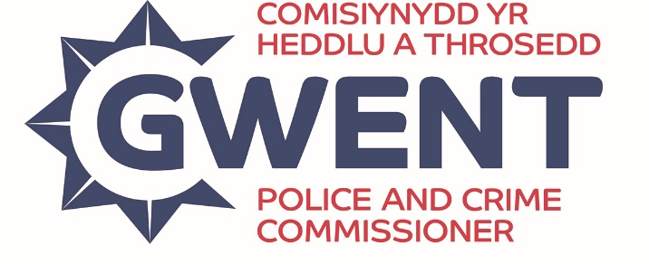

GWENT POLICE & CRIME COMMISSIONER’S

COMMUNITY Partnership fund

CRITERIA AND GUIDANCE

FUND OVERVIEW

The Police and Crime Commissioner (PCC) Community Partnership Fund is an opportunity to support grassroots initiatives that make a real difference in Gwent. With £50,000 available annually, this fund is designed to support short-term, positive initiatives that help deliver the priorities of the Police Crime and Justice Plan.
Grants of up to £1,000 are available to support community-led activities, one-off costs and local initiatives that contribute to building safer, more resilient neighbourhoods across Gwent.
There is no deadline – applications are accepted on a rolling basis but once the Fund is fully allocated it will close until the next financial year. We aim to notify applicants of decisions within 4 weeks of submission.

WHO CAN APPLY

The Fund is open to not-for-profit organisations working to improve lives and safety in their communities. Eligible applicants include:
- Registered charities;
- Voluntary organisations, community groups or associations;
- Educational Establishments (not primarily funded by the Local Authority);
- Faith organisations (not for religious promotion);
- Charitable Incorporated Organisation (CIO);
- Community Interest Companies (CIC);
- Companies limited by guarantee; and
- Social enterprises.
Unfortunately, Public bodies and statutory organisations, Registered Social Landlords / Housing Associations, Educational establishments primarily funded by Local Authorities and individuals are not eligible to apply.

WHAT CAN BE FUNDED

We’re looking to support short term, one-off projects and costs that align with the Police, Crime and Justice Plan priorities, including:
- Community safety and crime prevention;
- Promoting safer neighbourhoods;
- Reducing harm and vulnerability; and
- Supporting victims.

Examples of the types of activities and costs that may be funded through this Fund include the below, but this is not an exhaustive list and we’re looking to hear from you as to how this funding could make a difference in your community.
- Awareness days;
- Information materials;
- Community or wellbeing events;
- Workshops;
- Equipment and resources;
- Advice and support; and
- Creating safe spaces.

To ensure the fund delivers maximum community benefit, the following will not be funded:
- Political groups or activities promoting political beliefs;
- Projects that begin before the funding is confirmed;
- Assets or services that benefit individual or private companies;
- Statutory services (e.g. Local Authorities or NHS);
- Internal payment for accommodation or facilities;
- Large capital projects (e.g. buildings, vehicles, landscaping);
- Individual sponsorship (e.g. sponsored run/walk);
- CCTV / alarm systems; and
- Ongoing costs like rent, utilities or permanent salaries.

Please note - we also have our two other grant funds available:
- PCC’s Community Engagement Fund - supports events and initiatives promoting community cohesion and engagement and the objectives of the Commissioners Strategic Equality Plan.
- PCC’s Community Fund – offers small grants (up to £10,000) and large grants (£10,001 - £50,000) for larger scale and longer-term projects which create long lasting change across Gwent.

COMMUNITY PARTNERSHIP FUND APPLICATION FORM

SECTION 1 – Main Applicant Details

Q1: Name of main contact
Q2: Main contacts phone number
Q3: Main contacts email address
Q4: Job title or role

SECTION 2 – Lead Organisation Details

Q5: Name of organisation
Q6: Organisation phone number
Q7: Organisation Email address
Q8: Organisation’s registered address
Q9: Organisation website and/or social media pages
Q10: Registered charity and/or company number

SECTION 3 – Project Details And Activity
Q11: Project name
Q12: How many people will directly benefit from your activity/service?

Q13: Which local authority area(s) will the activity take place? |  | ☐ Blaenau Gwent ☐ Caerphilly  ☐ Monmouthshire ☐ Newport  ☐ Torfaen ☐ Gwent wide/Pan Gwent
Q14: Please select ONE primary priority that your project is aiming to deliver against. |  | ☐ Preventing Crime & ASB  ☐ Making Our Communities Safer  ☐ Protecting the Vulnerable  ☐ Putting Victims First  ☐ Reducing Reoffending
Q15: Please select ONE primary outcome your project will be aiming to achieve. |  | ☐ Enhanced Health & Wellbeing  ☐ Improved Positive Relationships  ☐ Improved Skills & Knowledge  ☐ Increased Community Trust & Confidence  ☐ Greater Enriched Life Choices  ☐ Better Able to Cope & Recover  ☐ Increased Feelings of Safety
Q16: Provide a detailed description of the project you are requesting funding for and where relevant explain and evidence what issues / needs your project is seeking to address.

500 words max

SECTION 4 – Funding Request

Q17: How much funding are you requesting from the OPCC? |  | £
Q18: Please provide in the table below the expenditure you are applying for.

Description (please itemise as appropriate e.g. specify equipment, volunteer costs, etc, please also add as many rows as needed) | Amount
 | £
 | £
 | £
 | £
 | £
 | £
TOTAL | £

DECLARATION

- I am authorised to submit this application on behalf of the organisation / activity.
- I certify that the information provided in this application and all supporting documentation is correct.
- I confirm that acceptance of funding offered will not result in duplicate funding in any aspect of the budget requested.
- If the information in the application changes in any way I will inform Gwent OPCC immediately.
- I give permission for Gwent OPCC to record the information in this form electronically and to contact my organisation by phone, mail or email with information about its activities and about funding opportunities; and
- I agree to participate in monitoring, auditing and evaluation related to this funding stream.
Signed
Print Name
Date
Position in Organisation

Once complete please send the completed form for consideration to PCCFunding@gwent.police.uk

