Delivery Plan 2025-2029
CHIEF OFFICER TEAM REPORT
March 2025

- PURPOSE AND RECOMMENDATION

  - The purpose of this report is for a decision to agree and launch the Chief Constable’s Delivery Plan.

- INTRODUCTION & BACKGROUND
The Police, Crime and Justice Plan for 2025 - 2029 links the issues affecting the people of Gwent with consideration for the broader challenges facing policing. The plan is developed through extensive public engagement, capturing the views of the diverse communities across Gwent.
The Commissioner sets out five priorities for 2025 - 2029
- Preventing Crime and ASB
- Making our Communities Safer
- Protecting the Vulnerable
- Putting Victims First
- Reducing Reoffending

This report provides the Chief Constables plan to deliver the Police, Crime and Justice Plan for the four years. It will be reviewed and reported upon annually through established governance mechanisms and performance frameworks. It is intended as a guide to the force’s action to deliver against the five priorities and it is also intended to provide the necessary reassurance to the Police and Crime Commissioner of the force’s commitment to achieving these over the coming four years.
The force provides its service within a budget of £184 million pounds per year and continues its work in improving efficiency, releasing cashable savings and improving productivity. The Chief Constable vision is to improve Trust and Confidence, as one team that puts the communities it serves at the heart of everything it does. To deliver this the force has undertaken a comprehensive review of its operational model. During 2025 we have moved to a functional model of policing which retains and builds upon a strong Neighbourhood approach within the local geographic areas but with supporting workstreams of Response and Crime to deliver policing for the communities of Gwent. This work is enabled by the Government Neighbourhood Policing Pledge and the delivery of this will see investment within Neighbourhood Policing and supporting services to release officers to front line policing duties. The programme of work to fully embed the new model and ensure all our systems and processes are fully aligned will continue during 2025-26.
The force will continue to invest in its employees and build a talented, resilient workforce that is more representative of the community it serves. The force is determined that Gwent will be an inclusive, caring, connected organisation providing outstanding service for the communities of Gwent.
The force will prioritise equality and diversity in all its initiatives by further developing and investing in the Strategic Equality Plan. This will be the backbone of our decision making in recruitment, retention and public engagement. We will make our workforce better reflect our community by continuing to encourage people from underrepresented groups to join the organisation. We will seek to build a positive workplace culture that attracts, selects and retains talented people and which provides them with opportunities for career progression. We will embed our culture strategy and deliver the culture action plan to address concerns of legitimacy and embed ethical leadership strategies.

We will continue to deliver our Greener Gwent Sustainability strategy and implement our de-carbonisation plan in our aim to deliver net zero emissions by 2030. We will engage with our workforce to ensure that sustainability becomes business as usual, and we will contribute on an organisational level to reducing our carbon footprint.

- ISSUES FOR CONSIDERATION

The Chief Constable aims to deliver on the Police, Crime and Justice Plan 2025 – 2029 with the following delivery plan that is focused on improving trust and confidence in policing.
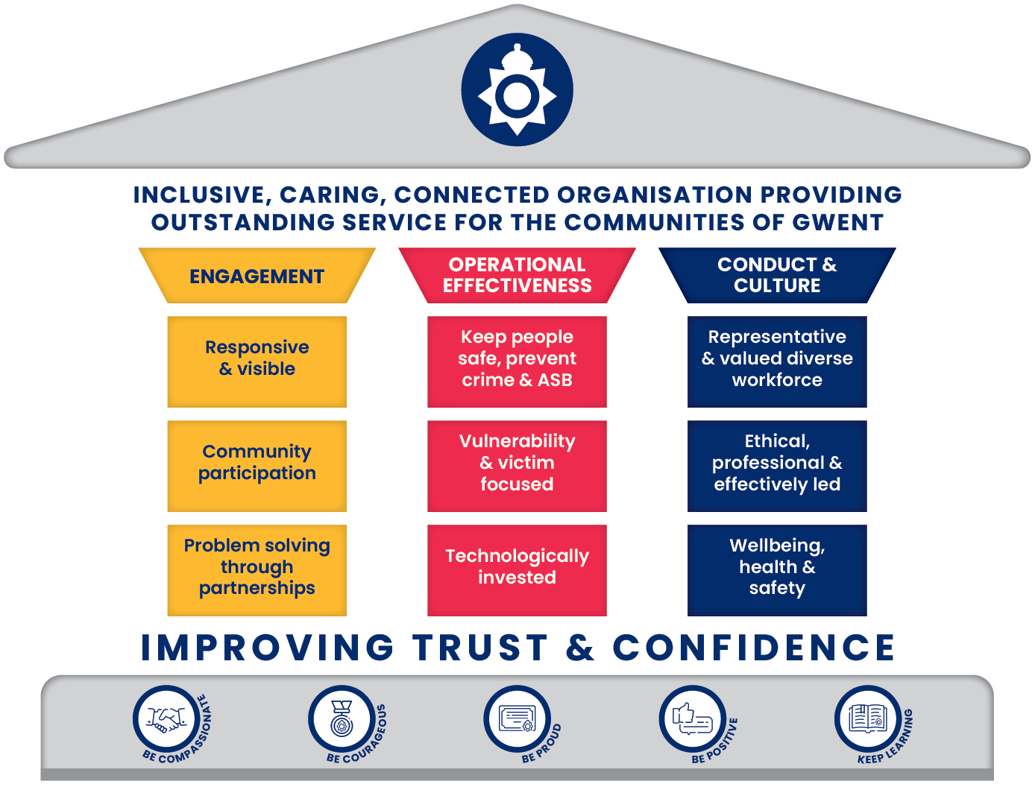

Preventing Crime and ASB

The force will continue current progress to reduce and prevent crime whilst striving to record it ethically and in accordance with the Home Office Counting Rules, the force is performing well in crime data integrity and ensuring that all crime is recorded in an ethical and timely manner.

Our priority will be reducing crime and incidents of anti-social behaviour with particular focus upon reducing acquisitive crime through Neighbourhood Policing Partnerships our problem-solving approach and the introduction of Community Action Teams into Hot Spot areas identified through data analysis and supported through the Government Hot Spot Funding (Operation Lumley). This fund has allowed focus on the reduction of ASB in communities through 2024-25 and the force is pleased to see its continuance into 2025-26. Neighbourhood Policing will work closely with Roads Policing Specialist Operations Team which under the new Operational Model will see a joint management team and closer working to ensure that specialist support is aligned to Neighbourhood Policing Priorities. This specialist unit will continue to police the road networks of Gwent and be a key tool in our crime reduction strategy.

The introduction of Community Action Teams in 2025 will work in targeted areas of concern identified through data analysis and support Neighbourhood Teams to improve visibility and reduce and prevent crime and ASB.

Making our Communities Safer

The force will enhance visibility and presence within communities and continue to implement proactive crime prevention strategies and community engagement initiatives. The force will work in partnership with local authorities and community groups to problem solve and address root causes of issues impacting communities. This will be supported by the refreshed Neighbourhood Policing Strategy agreed in 2024 and measured within the Neighbourhood Policing Performance Framework.

Alongside our Neighbourhood Policing Pledge the force has reviewed its engagement strategy and will strengthen partnerships with local authorities and to create safer communities, building on the Safer Streets initiatives. The force will utilise technology wherever possible to increase productivity and improve engagement opportunities with our communities.

The force will support the government pledge to reduce harm and restore public confidence in policing and the Criminal Justice System and use a targeted policing approach supported through the Government Hotspot funding.

Gwent Police will continue its focus on actively addressing the challenges posed by knife crime, serious violence and robbery within our communities. Our comprehensive approach includes working with strategic partners, evidence-based problem-solving and community engagement to ensure the safety and well-being of our residents.

The changes in the dangerous dog’s act legislation on 31 December 2023 has had a noticeable increase in intelligence and reports of non-compliance and the impact on our communities has been significant. Gwent Police remains steadfast in our commitment to making our communities safer by addressing the challenges posed by dangerous dogs. Through a combination of enforcement, education, and community engagement, we aim to reduce the risk of harm and promote a safer environment for all residents. Our ongoing efforts and proactive measures will continue to be a cornerstone of our strategy to uphold the principles of the Dangerous Dogs Act and protect our communities.

Protecting the Vulnerable

Gwent Police is committed to safeguarding the most vulnerable members of our community, and this commitment remains unwavering. It is imperative that we prioritise those most at risk and Gwent Police will ensure the individuals who are at risk, including victims of crime, those experiencing domestic abuse and other vulnerable groups receive the support and protection they need.

We will work with partners to create an environment where vulnerable individuals feel safe and supported, including timely and effective assistance to victims, ensuring they have access to necessary resources and support systems. We are committed to achieving this through a combination of proactive measures, collaborative efforts and a focus on continuous improvement.

We will build trust and confidence between women and girls and the police, and we will do this through our Violence Against Women and Girls (VAWG) Strategy and delivery framework which aligns and connects our actions and activity with the NPCC VAWG National Framework and the Welsh VAWDASV National Strategy. We will continue to review processes and implement the Soteria operational model and ensure service improvement for victims. VAWG has been declared a national emergency by police chiefs across England and Wales. The Home Secretary’s revised Strategic Policing Requirement (SPR) now includes VAWG as a national threat, alongside terrorism and serious and organised crime.

Gwent Police are also committed to protecting our diverse communities by addressing hate crime and implementing the Police Race Action Plan (PRAP). The PRAP is integral to our efforts to address racial disparities and built trust within our communities. The plan includes workstreams to address culture, vulnerability, engagement and aligns to our Strategic Equality Plan.

Our engagement approach will include targeted initiatives through regular engagement and transparent communication with vulnerable groups and include working in collaboration with community organisations to bridge gaps in service delivery.

Protecting the vulnerable is not just a priority but a moral imperative and by adopting a comprehensive and compassionate approach we will lead the way in creating a safer, more inclusive community for all.

Putting Victims First

At the heart of our policing strategy is a steadfast commitment to putting victims first. We recognise that the experiences and needs of victims must be central to our approach, ensuring that their voices are heard, and their well-being is prioritised throughout the entire investigative process.

From the outset of every investigation, we will listen to victims of crime and capture what matters most to them. Our officers and staff will be trained to ask the right questions to understand the unique needs and concerns of each victim.

The 2025 Operational Model review has seen the introduction of a strategic lead for victims at Superintendent level and this role will play a vital part in ensuring that our victims offer and services operate effectively and efficiently. The post holder will also have the portfolio for quality of investigation bringing these two elements together into one strategic position.

Our Victim Care Unit will play a crucial role in providing continuous support, following up after the initial response phase and offering additional services in line with the victim’s wishes. There will be an unrelenting focus on improving our interaction with victims, we will engage with survivors and victims’ to better understand their experiences and shape our services. We will safeguard the vulnerable through further enhancing the work of our multi-agency Safeguarding Hubs.

Our commitment to putting victims first extends beyond individual cases. We will work collaboratively with partners across the public, private and third sectors to deliver a comprehensive support system for victims. This will include embedding trauma-informed practice, building multi-agency collaborations and engaging victims and witnesses through their journey.

By prioritising the needs and voices of victims we aim to build trust and confidence in our policing services ensuring that every victim feels heard, supported, and empowered. Together, we will create a safer and more just community for all.

Reducing Reoffending

We recognise that breaking the cycle of reoffending is essential for creating safer communities and improving the quality of life for all residents.

Our Integrated Offender Management scheme will continue to play a vital role in managing adult offenders, particularly those persistently committing acquisitive crimes. By working closely with other agencies, we aim to reduce reoffending rates and the associated costs of crime during and after intervention. We will also focus on prevention teams, problem solving and communities and partnership working to deliver targeted interventions to reduce reoffending.

Our Youth Offending Teams are embedded within local authority areas and work in partnership to prevent children offending and reoffending by providing support to those at risk of entering the criminal justice system. Through targeted intervention services and measures, we will continue to engage in this vital work to reduce the numbers of children entering the criminal justice system.

We will focus on reducing the demand and impact upon communities caused by repeat offenders through effective offender management and we will improve the services we provide to our repeat victims.

Improve Public Confidence

Public confidence in policing is a cornerstone of effective law enforcement and community safety. Nationally, the UK faces significant challenges in maintaining public trust and confidence in the police and this is exacerbated by high-profile instances of police offending and misconduct. These incidents have eroded public trust and highlighted issues within police forces. The Casey report, published in March 2023 further highlighted these issues and made recommendations for improvement.

Gwent Police has not been immune to these challenges and public confidence fell to 61% in March 2023, its lowest recorded level. However, Gwent Police is committed to addressing these challenges and improving public confidence in its services. It is recognised that high levels of public trust enable better cooperation between the police and the communities, leading to more effective crime prevention and resolution.

Gwent Police is dedicated to rebuilding public confidence through a comprehensive strategy that focuses on engagement, operational effectiveness, culture and conduct. Key initiatives include.

Ethical leadership and professional standards: Gwent Police will foster a culture of ethical leadership and professional standards. This includes robustly tackling misconduct and ensuring that all officers and staff adhere to the highest standards of behaviour.

Community Engagement and Transparency: The force will enhance its community engagement efforts to build trust and transparency. This includes initiatives such as the Ride-Along Scheme, which allows members of the public to observe police work firsthand, thereby increasing their understanding and confidence in the police.

Addressing Misconduct and Offending: Gwent Police is committed to addressing instances of misconduct and offending within the force. This involves thorough investigations, appropriate disciplinary actions, and implementing recommendations from reports like the Casey Report to prevent future occurrences.

Training and Development: Continuous training and development programs are being implemented to ensure that all officers and staff are equipped with the skills and knowledge necessary to service the community effectively and ethically.

Technology and Data: The approach will be underpinned with effective and efficient use of technology and data. We will work to ensure that our data is accurate, recorded in a timely manner and informs our decisions. We will ensure our officers and staff are equipped with the correct technology and systems to undertake their roles and that they are efficient in its use.

Representative workforce and retention: Our commitment to fostering a representative workforce and enhancing retention is central to our Strategic Equality Plan and action plan. By prioritising diversity and inclusion, we aim to create a workforce that reflects the communities we serve. Our Strategic Equality Plan outlines specific actions to recruit, develop, and retain talent from diverse backgrounds, ensuring that all individuals have equal opportunities to thrive. We are dedicated to implementing targeted initiatives that address barriers to progression and promote a culture of respect and belonging. Through continuous engagement and support, we will enhance employee satisfaction and retention, ultimately leading to a more effective and representative police force.

Wellbeing, Health and Safety: Our commitment to health and safety, welfare, and wellbeing is paramount in ensuring a resilient and effective police force. We prioritise the physical and mental health of our officers and staff through comprehensive support and proactive initiatives. Our strategic approach includes regular health assessments, access to mental health resources, and robust training programs focused on safety and wellbeing. By fostering a supportive environment, we aim to reduce workplace stress and enhance overall job satisfaction.

In conclusion, Gwent Police recognises the critical importance of improving public confidence in its services. By addressing the challenges identified both nationally and locally, and through a commitment to ethical leadership, transparency and community engagement, the force aims to rebuild trust and ensure that it provides the highest standard of service to the communities it serves.

- COLLABORATION

We will continue to strengthen our collaborative partnerships in delivering the objectives of the Police, Crime and Justice Plan during the delivery plan period and beyond. Our commitment to collaboration, improving services and working in partnership continues to develop and delivery for the communities of Gwent.

- NEXT STEPS

- For agreement and decision.
- Performance reports will be reviewed and updated in line with the delivery plan.

- FINANCIAL CONSIDERATIONS

No Cost associated with this paper beyond those laid out in the force’s financial strategy and funding requirements presented to the Policing Crime Panel.

- PERSONNEL CONSIDERATIONS

None identified in this paper beyond metrics in place to monitor progress through force governance boards.

- LEGAL CONSIDERATIONS

None identified in this paper beyond Joint Legal Services governance of contracts.

- EQUALITIES & HUMAN RIGHTS CONSIDERATIONS

This report has been considered against the general duty to promote equality, as stipulated under the Strategic Equality Plan and has been assessed not to discriminate against any group.

In preparing this report, consideration has been given to requirements of the Articles contained in the European Convention on Human Rights and the Human Rights Act 1998.

- RISK

There are no organisational risks identified in this paper beyond those recorded in force risk register.

- PUBLIC INTEREST

In producing this report, has consideration been given to ‘public confidence’? Yes

Are the contents of this report, observations and appendices necessary and suitable for the public domain? Yes

- REPORT AUTHOR

Karen Thomas, Senior Manager, Continuous Improvement

- LEAD CHIEF OFFICER

Chief Constable Mark Hobrough

- ANNEXES

- Delivery Plan Graphical Representation

- GOVERANANCE BOARD CHIEF OFFICER APPROVAL

15.1 This report has been presented to the following Chief Officer Board:
Meeting chaired by:
Meeting date:
- Actions and amendments arising from board:

15.2 This report has been presented to the Scrutiny Executive Board:
Meeting chaired by:
Meeting date:

- Actions and amendments arising from board:

15.3 I confirm this report has been discussed and approved at a formal Chief Officers’ meeting.

- I confirm this report is suitable for the public domain / is not suitable for the public domain for the reasons stated in 11.3. (delete as appropriate)

Signature: (Insert CO electronic signature)

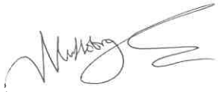

Mark Hobrough
Chief Constable

Date:08/04/2025

