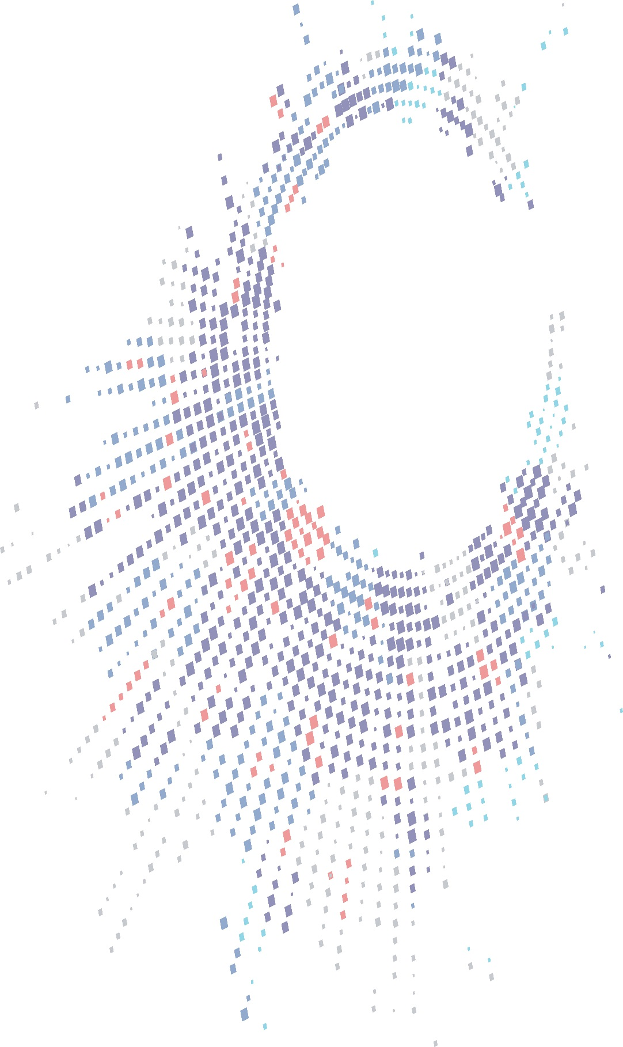

|  |  |
| --- | --- |
|  |  |

**FINAL**

|  |  |
| --- | --- |
|  | **Police and Crime Commissioner for Gwent and the Chief Constable Gwent Police** |
|  | **Summary Internal Controls Assurance (SICA) Report** |
|  | **2022/23** |

**June 2023**



**Summary Internal Controls Assurance**

**Introduction**

1. This summary controls assurance report provides the Joint Audit Committee with an update on the emerging Governance, Risk and Internal Control related issues and the progress of our work at Police and Crime Commissioner for Gwent and the Chief Constable Gwent Police as at 5th June 2023.

**Future of Internal Audit (IA)- Digital drivers**

**Use of Data analytics by TIAA**

1. TIAA is always adopting new ways of working and methodologies including innovative approaches for delivering internal audits. This is part of our continuous improvement programme which facilitates improvements in efficiency, effectiveness, and the quality of the work we deliver. We currently use data analytics as part of our work in relevant areas to test against full data sets, spot hidden risks, to target our testing and to provide ‘proof in total’ assurance; this adds credibility and value to the reports we produce. Data Analytics helps us to analyse large volumes of data to identify trends, patterns, and anomalies that may indicate potential risks or opportunities for improvement.

**How will Artificial Intelligence (AI) enhance the delivery Internal Audit of the future?**

1. We believe that the way internal audits are delivered will change significantly in the next 3 to 5 years through the use of AI, through the use of auditing tools which contribute towards a process of continuous audit assurance, a wider use of predictive analytics to allow auditors to provide reports that are far more forward looking, and robotic process automation which will help remove much of the manual data collection work, thereby allowing Internal Audit more time to provide value-added analysis. Another branch of AI, Natural Language Processing (NLP), has the potential of also enabling auditors to analyse text in a large number of documents.
2. In addition to the use of Data Analytics, TIAA is actively exploring, as part of our vision for the future, the use of AI, automation and other digital tools to streamline the audit process, inform planning, reduce manual effort, and enhance the quality of audit results. Automated data collection and analysis will help reduce the time required to complete audits and improve the accuracy and consistency of audit results. Innovative ways of using and integrating artificial Intelligence in the delivery of audits in response to the exponential growth in data, and how it is analysed and used in the context of Internal Audit, is part of TIAA’s innovation strategy. We will also as part of our strategy be investigating more opportunities to not only use AI, but also to develop the capabilities to audit AI and the associated ethical considerations.

**Audits completed since the last SICA report to the Joint Audit Committee**

1. The table below sets out details of audits finalised since the previous meeting of the Joint Audit Committee.

*Audits completed since previous SICA report.*

|  |  | **Key Dates** | | | **Number of Recommendations** | | | |
| --- | --- | --- | --- | --- | --- | --- | --- | --- |
| **Review** | **Evaluation** | **Draft issued** | **Responses Received** | **Final issued** | **1** | **2** | **3** | **OEM** |
| Fleet Management – IR3 Telematics System | Advisory | 6th January 2023 & 10th February 2023 | 21st March 2023 | 21st March 2023 | - | 6 | 1 | 1 |
| Local Policing – Property and Cash | Limited | 3rd April 2023 | 4th April 2023 | 6th April 2023 | 4 | 8 | 2 | 2 |
| Payroll | Substantial | 20th February 2023 | 19th April 2023 | 20th April 2023 | - | - | 1 | - |
| Vehicle Recovery | Advisory | 13th April 2023 | 26th April 2023 | 26th April 2023 | - | - | - | 4 |
| Fleet Management Strategy | Substantial | 24th November 2022 | 28th April 2023 | 28th April 2023 | - | - | 3 | 3 |
| Data Quality | Advisory | 23rd February 2023 | 2nd May 2023 | 4th May 2023 | - | - | - | 1 |
| Counter Fraud (Anti-Fraud Procurement) | Substantial | 14th February 2023 | 16th May 2023 | 19th May 2023 | - | - | - | 1 |

1. There are no issues arising from these findings which would require the annual Head of Audit Opinion to be qualified.

**Progress against the 2022/23 Annual Plan**

1. Our progress against the Annual Plan for 2022/23 is set out in Appendix A.

**Progress in actioning priority 1 recommendations**

1. We have made four Priority 1 recommendations (i.e. fundamental control issue on which action should be taken immediately) since the previous SICA.

**Root Cause Indicators**

1. The Root Cause Indicators (RCI) have been developed by TIAA to provide a strategic rolling direction of travel governance, risk and control assessment for Police and Crime Commissioner for Gwent and the Chief Constable Gwent Police. Each recommendation made is analysed to establish the underlying cause of the issue giving rise to the recommendation (RCI). The analysis needs to be considered over a sustained period, rather than on an individual quarter basis. Percentages, rather than actual number of reviews/recommendations made permits more effective identification of the direction of travel. A downward arrow signifies a positive reduction in risk in relation to the specific RCI since the previous quarter.

*RCI – Direction of Travel Assessment*

| **Root Cause Indicator** | **2021/22** | **Qtr. 1 (2022/23)** | **Qtr. 2 (2022/23** | **Qtr. 3 (2022/23** | **Qtr. 4 (2022/23** | **Medium term Direction of Travel** | **Audit Observation** |
| --- | --- | --- | --- | --- | --- | --- | --- |
| **Directed** |  |  |  |  |  |  |  |
| Governance Framework | 22% (5) | - | - | 33.3% (1) | 12% (3) |  | The majority of recommendations relate to compliance which is consistent with last year. |
| Risk Mitigation | 4% (1) | - | - | 33.3% (1) | - |  |
| Control Compliance | 57% (13) | 100% (1) | - | 33.3% (1) | 76% (19) |  |
| **Delivery** |  |  |  |  |  |  |
| Performance Monitoring | 13% (3) | - | - | - | 4% (1) |  |
| Financial Constraint | - | - | - | - |  | ↔ |
| Resilience | 4% (1) | - | - | - | 8% (2) |  |

**Frauds/Irregularities**

1. We have not been advised of any frauds or irregularities in the period since the last SICA report was issued.

**Other Matters**

1. We have issued a number of briefing notes and fraud digests, shown in Appendix B, since the previous SICA report. The actions taken by Police and Crime Commissioner for Gwent and the Chief Constable Gwent Police are summarised below:

|  |
| --- |
| **Briefing Note** |
| Failure to prevent fraud offence |

|  |
| --- |
| **Anti-Crime Alert** |
| Fraud Alert Spring 2023 |

**Responsibility/Disclaimer**

1. This report has been prepared solely for management's use and must not be recited or referred to in whole or in part to third parties without our prior written consent. The matters raised in this report not necessarily a comprehensive statement of all the weaknesses that exist or all the improvements that might be made. No responsibility to any third party is accepted as the report has not been prepared, and is not intended, for any other purpose. TIAA neither owes nor accepts any duty of care to any other party who may receive this report and specifically disclaims any liability for loss, damage or expense of whatsoever nature, which is caused by their reliance on our report.

**---------------**

**Appendix A**

**Progress against Annual Plan**

| **System** | **Planned Quarter** | **Current Status** | **Comments** |
| --- | --- | --- | --- |
| Vehicle Recovery | 1 | Final report issued 26th April 2023 | Was previously Contract Management – changed to Q4  Presented to June 2023 JAC |
| Social Media | 2 | Final report issued 22 September 2022 | Presented to October 2022 JAC |
| General Ledger | 2 | Final report issued 26th January 2023 | Presented to February 2023 JAC |
| Service Improvement Board | 2 | Draft report issued 31st May 2023 | Changed to Q4 |
| Estates Strategy | 3 | Draft report issued 2nd June 2023 | Changed to Q4 |
| Local Policing – Property and Cash | 3 | Final report issued 6th April 2023 | Presented to June 2023 JAC |
| Follow Up | 4 | Draft report issued 12th May 2023 |  |
| Contingency | 1-4 | N/A |  |
| Collaborative Audits | | | |
| Data Quality | 1 | Final report issued 4th May 2023 | Presented to June 2023 JAC |
| Expenses and Additional Payments | 2 | Final report issued 16th January 2023 | Presented to February 2023 JAC |
| Uncertainty Management – Mitigating Risk | 2 | Final report issued 16th January 2023 | Presented to February 2023 JAC |
| Fixed Assets | 2 | Draft report issued 15th May 2023 |  |
| Creditors | 2 | Final report issued 9th November 2022 | Presented to February 2023 JAC |
| Payroll | 3 | Final report issued 20th April 2023 | Presented to June 2023 JAC |
| Capital Programme | 3 | Final report issued 5th January 2023 | Presented to February 2023 JAC |
| Counter Fraud (Anti-Fraud Procurement) | 3 | Final report issued 19th May 2023 | Presented to June 2023 JAC |
| Fleet Management – IR3 Telematics System | 3 | Final report issued 21st March 2023 | Presented to June 2023 JAC |
| Fleet Management - Strategy | 3 | Final report issued 28th April 2023 | Presented to June 2023 JAC |
| HR – Use of OLEOO | 4 | Fieldwork ongoing | Review delayed at request of the lead Force (NWP) |
| Annual Plan | 1 | Final plan issued 22nd May 2022 |  |
| Annual Report | 4 |  |  |
| Management | 1-4 |  |  |

**KEY:**

|  |  |  |  |  |  |  |  |  |  |  |
| --- | --- | --- | --- | --- | --- | --- | --- | --- | --- | --- |
|  | To be commenced |  |  | Site work commenced |  |  | Draft report issued |  |  | Final report issued |

**Appendix B**

**Briefings on developments in Governance, Risk and Control**

TIAA produces regular briefing notes to summarise new developments in Governance, Risk, Control and Anti-Crime which may have an impact on our clients. These are shared with clients and made available through our Online Client Portal. A summary list of those CBNs and Anti-Crime Alerts issued in the last three months which may be of relevance to Police and Crime Commissioner for Gwent and the Chief Constable Gwent Police is given below. Copies of any CBNs are available on request from your local TIAA team.

**Summary of recent Client Briefing Notes (CBNs)**

| **CBN Ref** | **Subject** | **Status** | **TIAA Comments** |
| --- | --- | --- | --- |
| CBN - 23006 | Failure to prevent fraud offence |  | **No Action Required**  This briefing note has been provided for information only. |

**Summary of recent Fraud Alerts**

| **Ref** | **Subject** | **Status** | **TIAA Comments** |
| --- | --- | --- | --- |
| Spring 2023 | Fraud Stop |  | **No Action Required**  This alert provides information and advice to staff about fraud and economic crime that may occur during the COVID-19 emergency, and the risks associated with it. If you or your organisation has fallen victim to fraud you should report it to your Local Counter Fraud Specialist or to the NHS CFA on 0800 028 4060. |