



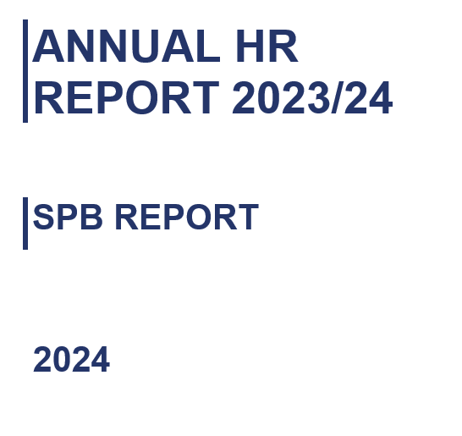

1. PURPOSE AND RECOMMENDATION

1.1 The purpose of this report is for monitoring.

1.2 There are no recommendations made requiring a decision.

2. INTRODUCTION & BACKGROUND

2.1 This report provides an overview of the actions to support the delivery of the People Services Strategy and force priorities. (Appendix 1)

2.2 The People Services Strategy included learning and development, which is now part of Continuous Improvement. An updated Human Resources Strategy will be development during 24/25.

The Foundation and Pillars- People Services Strategy
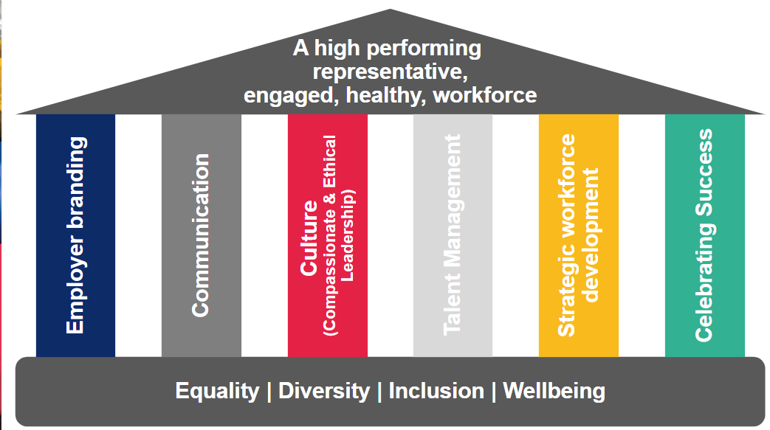

3. UPDATES

OCCUPATIONAL HEALTH AND WELLBEING

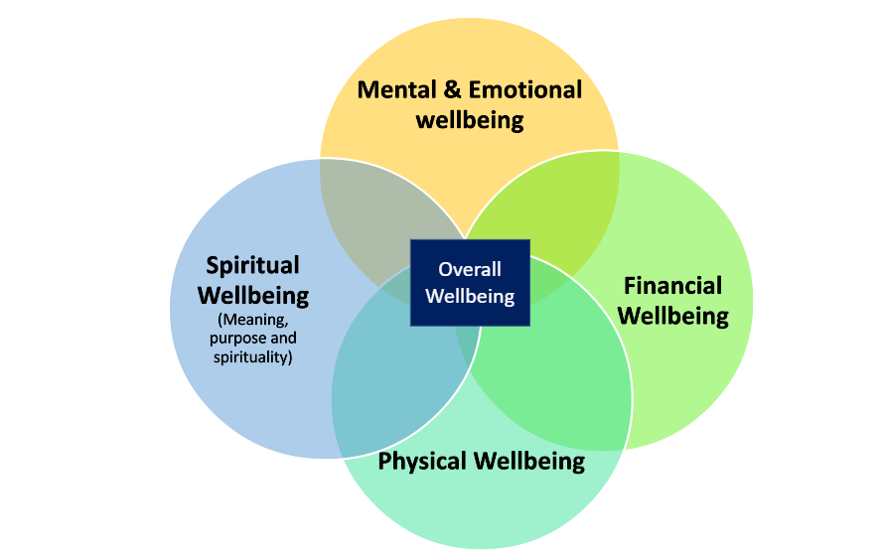
3.1 The aim of a OHU and Wellbeing team to support the physical, psychological, and social wellbeing of police officers and staff. This includes:

- Promoting the wellbeing agenda to build the skills and abilities of the workforce in relation to wellbeing.
- Preventing ill health among the workforce with a focus on improving wellbeing at work and building individual resilience
- Detecting and supporting early signs of physical, psychological, and financial ill health among the workforce, ensuring that support, advice, and guidance are available.
- Providing tailored support to signpost to treatment and aid recovery.

3.2 Research was undertaken to respond to an Area For Improvement to identify the causes sickness absence in the force and how to improve our workforce's wellbeing. The report included a data from local focus groups, other forces, benchmarking and Employee Opinion Survey. This led to a chief officer-led group to examine the factors that affect sickness and wellbeing of our staff. The main areas identified were:

3.2.1 Effective supervision, honest conversations through meaningful 121 meetings. Animation has been developed to illustrate to line managers best practices for reporting and managing sickness absence. An in person event will run later this year to engage the first-line leaders effective absence and performance management, explaining the benefits, increasing their confidence and promote the leadership offer.

3.2.2 Return to work procedures. A review of return to work interviews processes and training has been undertaken. Outcomes have included updating the GRS module, creating a quick reference guide and expediting the frontline supervisor’s course

3.2.3 Small team communications - The group addressed the perception that the small teams have a disproportionate level of experienced officers and their contributions are not understood.

3.2.4 Effective use of attendance and performance management. Revised the guides and procedures for UPP and UAP have been developed again these will be supported through the in person event.

3.2.5 Eradicating hindrance blockers – Improvements in the audit and reporting mechanisms for devices, equipment, and estates have been implemented. Enhancements in the communication and engagement with the enabling departments have been addressed.

3.2.4 The group also agreed to the introduction of rapid improvement events which seek to provide targeted and collaborative support to the areas where high sickness levels have been identified, using cross-functional teams and employee engagement. Whilst this work is still ongoing, at the time of writing this report, it will shape our plans for 2024/25.

3.3 We have launched various support to assist with physical, psychological and financial health.

3.3.1 A mental health nurse became fully embedded within OHU signposting to provide early support and specialist counsellors, where necessary. In the financial year 2023/2024 the registered mental health nurse made 143 external counselling referrals at an accrued cost of £56,345.45 to assist officers and staff.
3.3.2 Bio stress research commenced in November 2023 within the FCC. This will allow us to understand common stressors that can then be mitigated and assist the participants with personalised tools to reduce and manage stress responses.
3.3.3 Dyslexia screenings continue to be offered to new and current employees to identify if any reasonable adjustments are needed to support them undertake their role. In 2023, 349 individuals were assessed for dyslexia, 75 were provided with appropriate reasonable adjustments.
3.3.4 This year saw a further increase in demand for more complex mental health support requiring specialist external referrals relating to CBT/ EMDR. This support requires an average of 12-18 sessions for individuals before securing a return to work or retention in the workplace.
3.3.5 Referrals overall to Occupational Health increased by 13% in 2023 a trend that is forecast to continue to 2027.
3.3.6 In relation to physical health, OHU received 171 referrals. Supporting early intervention, 12 referrals in the form of private consultations, scans and physical therapies were approved at a cost £5306.00.
3.3.7 In 2023, the wellbeing team handled 733 support requests, compared to 502 in 2022.
3.3.8 Over 260 people across multiple sites attending the winter wellbeing event in 2023, with guests from Police Mutual, Unison, OH and the National Health Service, providing information and advice on psychological, physical, and financial health.
3.3.9 A range of training inputs have been undertaken where 77.6 % of feedback strongly agreed the courses benefited their role. These courses included;
    - Retrain (Resilience to traumatic incidents),
    - Wellbeing Ambassador training
    - Mental Health First Aid.
    - Line managers’ wellbeing training - created and delivered to support line managers and their team’s wellbeing.
    - Stress Management packages – undertaken in focussed departments where sickness levels were high, high workload and reduced resources. E.g. Protective Services. The sessions provided useful tools on managing stress and reframing thoughts using CBT techniques. It also educates on signs and symptoms of declining health and where to get support.
    - Mental Health First Aid - including PSD to help support the mental health of those undergoing investigations.
    - Wellbeing attended Force Control Room ensure the teams were aware of the support available, psychoeducation and initiatives they can access.
    - Staff trained to identify compassion fatigue, which can make them tired/stressed or indifferent to incidents. This was delivered to teams including the mental health triage team, professional standards and HR. We are looking into offering this to more frontline/operational staff and including it in the disciplinary/complaints process.
3.3.10 Recruits are made aware on induction, training days and wellbeing drop in sessions of their routes to support, including employee assistance programme, wellbeing resources, ambassadors, wellbeing team and occupational health. This has resulted in a reduction in mental health referrals for new officers with less than 12 months service.
3.3.11 Gym programmes have been created with QR codes to demonstrate good practice on machinery to support with gym anxiety. These programmes are designed aid in the prevention of MSK conditions.
3.3.12 We have new contracted to VivUp an employee assistance programme offering a six-session model of telephone or face to face counselling with access to advice and guidance on work related and personal issues .
3.3.13 We have provided access to affordable private healthcare through Benenden, which helps to reduce the waiting time for treatment, which aims to support faster interventions for staff. Private Healthcare through the North of England Healthcare Scheme is also available to provide choice for our workforce.

3.4 We continue to work closely with Oscar Kilo, using the Blue Light Framework (BLF), to ensure a best practice approach. As of December 2023, 100% of the BLF has evidence submitted. In 2023 the Wellbeing Team won the Osca Kilo national award for their approach in providing support for psychological ill health to the workforce.

3.5 OHU reactive work has been reduced this year due to the abstraction of clinical resources and the ability to source qualified occupational health advisors. Retention issues and the additional officers recruited through the Over Recruitment Scheme have increased demand on the team. The support of our colleagues in other forces has ensured our ability to respond to these demands effectively. Additional, demand for the team for 2023/24 has included the successful implementation of a new patient management system and the tri force procurement tender process for occupational health services.

3.6 The Oscar Kilo psychological surveillance programme was introduced in 2022 to 16 departments that were deemed higher risk. In 2022-2023, this programme was made mandatory improving the uptake of these procedures to ensure declining health is picked up before individuals become unwell. In 2023, we issued 279 screenings. Engagement (completion rate) in 2023 at 78% was significantly higher than 2022 (52%) and above the programme benchmark of 73%. Fitness notes issued from online screening increased to 80% (vs 70% 2022). All received follow up support. There are a number of nationally high risk roles linked to the risk of burnout and fatigue. This is primarily linked to the psychological impact on officers and staff working on in roles such as the identification and investigation of online child abuse.

3.8 In addition to the annual psychological screening programme, individuals are encouraged to engage with occupational health and wellbeing team for early support. The data following the psychological monitoring assisted in the prioritisation of station drop ins and focused support based on areas of concern or psychological health decline from the year previous. In relation to the investigation of online child abuse, to mitigate the impact and promote staff welfare and wellbeing, we follow the guidance set out in the College of Policing’s ‘Supporting the wellbeing of Internet Child Abuse Teams.’

3.9 TRiM has been in place since 2017 but was reviewed and relaunched in 2022 resulting in access to the service increasing by 59.93% between 2022 and 2023.

4. WORKFORCE PLANNING

4.1 We have developed a workforce plan that provides data on vacancy levels and retention risks. The National Leavers Frameworks and revised exit interview process was implemented this year, with the aim to address any identified issues and improve overall retention levels. A Strategic Workforce Planning Board has been established to ensure the force is able to enhance effective financial workforce optimisation, accurate budget forecasting and effective and efficient deployments.

4.2 The delivery of the strategic workforce plan requires the ability to access data and analysis to forecast effectively. This is currently challenging as current data analysis systems are not configured to provide this and work to rectify this is ongoing. Data analytics will be key to understanding current and future capacity, skills and capability, identifying our talent for the future and enable the force to make best use of the resources we have.

4.3 We must have the ability to effectively manage skills, capability and capacity, assess if we have the right skill base and that we are posting people in the right place, at the right time. Understanding the capacity and capability of our workforce in a strategic and proactive way will ensure we use the skills of our people in an effective way to meet demand. This will ensure that workforce skills are aligned to roles, and this contributes to staff feeling valued for the work they undertake. This is currently identified as an issue and is currently on the issues/Risk Register, with an action plan in place.

4.4 The learning management system is not yet able to support our understanding of the skills the current workforce has, where they are and how many are needed to support effective delivery of the service to the public. This work in ongoing with L&D, DSD and our Qlikview team to ensure the analytics are available to support our understanding of our current deployment position to predict future demand.

4.5 A CID workforce plan has been developed, which coordinates these force resources and provide focus in the strategy areas of – establishment, accreditation, recruitment and retention, reward and recognition, wellbeing and continuous professional development. A monthly meeting is in place chaired by the head of protective services and includes representatives from CID SMT, Learning and Development, HR, Communications team, Wellbeing and Continuous Improvement. This ensures a coordinated approach addressing the key areas. Detective constable forecasting is discussed at this meeting which includes the Detective Now and Direct Entry Detective figures along with projected retirements. Investment in these programmes has provided the force with much needed additional detective resources, to compliment those joining CID through the internal recruitment route. A detective succession plan is in place to address the long-term detective shortage. Whilst improvements are noted, this will remain a priority into 2024/25.

4.6 HR Business Partners continue to provide strategic support with talent identification, succession planning and ensuring the business area has the right capability and capacity to deliver the service.

4.7 A comprehensive review of the accuracy of establishment and rota data over the last 12 months has taken place. This issue sits on the risk and issue register but significant improvements have been made on data accuracy, which is supporting better informed decisions around deployability and resource prioritisation.

4.8 We have set up a retention plan incorporating best practice. This has included a review of each stage of the employment life cycle from attraction, recruitment, on boarding, training, employee experience and exiting the force.

4.9 From March 2023 to March 2024, the percentage of officers who left the organisation (excluding retirements) reduced from 5.30%in 2022/23 to 4.80% in 2023/24.

Year | Attrition -Inc R/ments | Attrition Exc R/ments
2020/21 | 6.09% | 3.65%
2021/22 | 9.07% | 4.93%
2022/23 | 7.82% | 5.30%
2023/24 | 7.74% | 4.80%

Comparing Gwent to the national attrition rate (which only includes resignations) Gwent has remained stable with there being a slight increase in the national figure.

Year | Region | Gwent | National
22/23 | Gwent | 3.5 | 3.3%
23/24 | Gwent | 3.5 | 3.4

4.10 Our strategic intention is to reduce attrition by 1%. Given that we need to attract on average 10 candidates for one successful new officer recruit. The impact of a 1% improved retention would result in the recruitment team not having to process 150 applications to achieve an additional 15 new recruits. Achieving this reduction would also impact demand reductions on other areas including; direct recruitment costs in terms of assessment centres, drug testing; OHU time to undertake medicals; time to conduct vetting checks; uniform and equipment; additional training, tutoring and supervision to support new officers; HR support/performance, sickness, wellbeing and exit interviews.

4.11 To improve the retention of officers who are departing the organisation, the following actions have been taken.

4.11.1 Focus groups set up with students at one years' service to gain an insight into their journey and what changes we can be made.

4.11.2 Enhanced the information for recruitment/attraction in relation to the academic expectations required of officers from the outset. We have focused our support on ensuring first line managers’ support to students. We have changed the training programme to incorporate an immersion period in the initial learning phase to consolidate learning.

4.11.3 Introduced ‘stay interviews’ to capture any officer/staff member considering leaving the service. This has been positive with interventions put in place to support officers/staff and aid retention.

4.11.4 Implementation of a National Leavers Framework and reviewed exit interview form ensures the feedback provided at these interviews are acted upon to address overt and underlying cultural issues within the force.

4.11.5 A new starter survey has also been introduced at six weeks and six months. This has been introduced to better understand recruitment experiences, on boarding, training, culture, and wellbeing.

4.12 Feedback from this for 2023/24 will be utilised to continually improve processes. In addition to retention, we have reviewed our ability to deploy officers to complete full operational duties once abstractions (excluding annual leave and training) have been accounted for.

4.13 HR operations provide strategic direction and oversight to the workforce and line managers in relation to establishment control, sickness absence, performance issues, grievances, learning from feedback mechanisms and facilitating business change. HR business partners provide strategic support with talent identification, succession planning and ensuring the business area has the right capability and capacity to deliver the service. The team works jointly with the resource management team to ensure the accuracy and audit of our establishment.

5. HR OPERATIONS

5.1 During 2023, HR teams were also actively engaged within significant organisational change programmes. This necessitated additional support and advice with regards to job evaluation, redeployment, consultation and communication with those affected. The demand requirements included:

5.1.1 39 - job evaluations supporting business change and evaluation
requests
5.1.2 15 - staff redeployment support cases.
5.1.3 17 - business change case support functions.
5.1.4 22 – Fairness at Work

5.2 HR business partners play a fundamental role in supporting senior management teams within business areas. Their role is intended to be proactive and strategic, but this has been limited due to the elevated level of demand for support and abstractions within the team. This has been resolved in the main, through the development of the HR Officers (HRO) to fully support force sickness absence and be the first point of contact support including for maternity and establishment was identified. Following a period of development and shadowing these activities have become part of the HRO officer role, allowing capacity for the HRBP’s and development for the HR Officers.

5.3 Demand for HR advice and support has increased in line with PUP. Demand is expected to remain higher than pre-PUP levels due to the support required for a young in-service workforce. The department has seen increased demand for queries and support from attendance and performance management, wellbeing perspective.

5.4 The focus upon attendance management and improving overall sickness rates has resulted in additional demand upon HR resources in support line managers through attendance standards and the management of complex cases.

5.5 Ongoing effective support and management of restricted duties, including the impact of the revised officer safety training (PPST) has been a focus, with this noted on the risk and issues register. It will continue to be a focus in 2024/25, ensuring we are maximising the skills of all officers and staff and supporting early return to work.

5.6 We have the second youngest workforce in UK policing. 39% of our constables and 17% of our detective constables are within their probation period, with 44.5% of all officers at constable rank having less than five years’ service. This particularly affects our constable and sergeant ranks. Supporting new leaders whether acting, temporary or newly promoted has been a key focus of the HR Operations team and they continue to deliver this through the embedded First Line Leaders Programme.

6. RECUITMENT AND ENGAGEMENT

6.1 The Recruitment and Engagement team are responsible for co-ordinating the recruitment of officers, staff, volunteers and apprentices across the force, including recruitment, promotion and positive action.

6.2 During 2023 the force ran three police officer campaigns and recruited 123 police officers. The force met its PUP and Over Recruitment Scheme officer establishment numbers for 2023/24. Elevated levels of leavers, however, particularly in student officers within the first two years of service, has placed additional pressure on the team in meeting not just the baseline officer level but the 21 officers as part of the over recruitment scheme. Growing the Special Constabulary has allowed the force to increase by a further 21 Special Constables.

6.3 In additional to new police officers, the following additional recruitment took place:
6.3.1 107 new police staff were recruited across the force
6.3.2 13 Community support officers
6.3.3 35 volunteers
6.3.4 63 police cadets

6.4 In line with other many other forces Gwent faces a particular challenge increasing the number of investigators and detective constables, particularly in high-risk areas such as public protection unit and the rape investigation team. Through developing and using a wide range attraction routes, (e.g., Direct Entry Detectives) this allowed us to focus on detective recruitment (40% of our new recruits were detectives in 2023/24) resulting in the force only having a 3.6% vacancy factor for detective constables at 31.03.24.

6.5 The department have introduced a process to ensure that an assessment is completed when advertising an existing or new role to ensure that Welsh language needs have been considered. We have moved away from the use of ‘Welsh desirable’ in job advertisements and in areas where there are no staff with Welsh language skills, advertisement of posts within these areas must state ‘Welsh essential.’

6.6 Supported by the Welsh Language Police Lead, we have embedded additional routes to attract Welsh Language speakers and declare their language skill. Our Welsh language skills have improved from 27 to 73 officers, which helps us respond to the public in Welsh better, to meet our goals in the Welsh Language Standards and be more diverse.

6.7 Chief Supt, Supt, Chief Inspector, Inspector and two sergeant promotion processes were run during 2023/24. This involved over 120 people going through a promotion process. A revised temporary promotion process was introduced to ensure transparency and fairness. We also introduced positive action support sessions for those from under representative areas. Feedback from promotion boards has overall been positive and learning from previous boards has resulted in improvements to the appeals process. Further work will be completed to understand confidence levels within the wider promotion opportunities and process.

Positive Action (Engagement)

6.8 There continues strong commitment to equality, diversity, and inclusion, both to our officers, staff, and volunteers and to the communities that we serve. We are focused and taking active steps to continue to improve our representation so that our workforce more accurately reflects the communities we serve.

6.9 The recruitment and positive action team has supported this increase by guiding and developing candidates who want to join the service and help the force achieve workforce diversity.

6.10 According to the 2021 census data, our ethnic heritage communities have grown from 3.9% to 5.6% of the population in Gwent. During 2023/24 we recruited 109 new police officers, 13 Community Support Officers and 107 police staff. During this period, 6.4% of officers and 23.1% of CSO’s, were from an ethnic heritage background. This is above the Gwent 2021 census data. Whilst recruitment figures are encouraging regarding diverse ethnic heritage, this will take time to be reflected across senior ranks.

6.11 This work has resulted in an increased female representation by over 1.5% and continue to increase the number of women joiners through the direct entry route.

6.12 As part of the ‘safe to say’ campaign, we have encouraged new starters to disclose their protected characteristics so we can better understand our workforce composition and the work needed to address any underrepresentation. We are aiming to reduce the ‘prefer not to say’ and ‘not stated’ categories though awareness and education . We are supporting the professional development for underrepresented groups within the workforce. This work has achieved improvements in female representation at sergeant, inspector, and chief inspector rank. This includes:

6.12.1. Representative workforce sessions for those seeking promotion and officer ‘checks ins’ for new starters throughout their first 12 months.
6.12.2 Support for all women applying to become officers including mock interviews and mock bleep tests. We hold women-only engagement and discovery events throughout the year.

6.13 The positive action team have built a number of strong partnerships, over the last 12 month, with diverse community groups to improve engagement. The team have built an alliance and partnership with College Gwent, as part of the Employers pledge in Gwent.

6.14 The Recruitment team have also worked hard in strengthening the forces support with the Armed services. The force was awarded a Silver Award in the Armed Services Covenant demonstrating our support to armed services and the local community.

6.15 The Gender Pay Gap report was completed (Appendix 2) which is one way in which Gwent Police can monitor progress to attract, recruit, and develop and retain females to increase the representative and decrease the gender gap. The mean pay gap for 2022/23 showed a decreases year on year and the work undertaken has supported the force closing the gap between men and women. Whilst we recognise that, although our police officer pay gap is reducing year on year, we still have work to do to further extend the reduction in the pay. Areas of identified focus include:

6.15.1 Family Friendly - We will continue to review our family friendly policies (those that balance and benefit work and family life) to ensure they are inclusive, both in application and development.
6.15.2 Family Hub - Launch the Family Hub (internal resource encompassing pregnancy, IVF treatment, maternity, kit days, shared parental leave and return to work), to help us to attract and recruit females into the Gwent Police.
6.15.3 Direct Entry Detectives - Utilise the success of the Direct Entry Detective recruitment scheme to support females joining the service as police officers and improve our officer workforce representation.

6.16 This is the first time we have produced the Ethnicity Pay Gap (Appendix 3) report and our data for 2022/23 provided an indication of how the force is performing and helped understand where we need to make changes for the future to bridge any pay gaps between White and Ethnic Heritage personnel. Aeras of focus identified included:

16.16.1 Research - Undertaking further research to better understand perceived and real barriers to progression and attraction.
16.16.2 Eliminating recruitment bias - Continue to explore ways to eliminate bias during the recruitment process; including exploring ways to make policing in Gwent a more attractive career choice for all.
16.16.3 Development of attraction and retention - Continued review and development of our attraction, selection, engagement and progression activities.

7. HEALTH AND SAFETY

7.1 The Health and Safety team co-ordinate services across force, including fire safety, inspection, health and safety training. They undertake health and safety audits and provide specialist advice on the completion of incident investigations and legislative requirements. The team report all RIDDOR to the Health and Safety Executive.

7.2 During 2023 a new incident management system was implemented within H&S, which has improved compliance, the user experience and has allowed each business area the opportunity to review their current H&S position. During 2023, 436 incidents were recorded, which required an investigation. The team has reviewed the quality of each investigation and supported training or one to one feedback. This is to ensure we achieve compliance with H&S legislation and support the health, safety and wellbeing of our workforce.

7.3 During 2023 site audits were completed and work undertaken to embed inspection and audit into business-as-usual activities. These site audits have action plans and work is ongoing to deliver these plans.

7.4 The team have been providing ongoing support to enable line managers to effectively use the incident management system. The monthly H&S heads of department meetings have focussed on compliance, the investigation of incidents, actions progressed following H&S audits and improved understanding of their responsibility for H&S.

7.5 The team have been supporting business areas to improve the quality of and consistencies of the six-monthly inspections completed by department.

7.6 The team have implemented a process to ensure we capture and all assaults on police, using NICHE, are documented. Actions are coordinated through a dedicated Operation Hampshire governance structure where H&S play a key role in ensuring learning supports prevention going forward.

8 WELSH LANGUAGE

8.1 The Welsh Language Standards Annual Report 2022/23 was produced (Appendix 3) demonstrating the ongoing commitment to the Welsh Language Standards, but also to developing sustainable improvements in the availability of our service in Welsh and in the opportunities to learn Welsh with the force.

8.2 The Welsh Language team is a collaborative portfolio with South Wales Police that provides advice and guidance on Welsh language to officers and staff across both organisations. It ensures compliance to the Welsh Language Standards, contributes to the development of wider policy and practice across both organisations and promotes the use of the Welsh language.

8.3 The collaborative arrangements commenced in December 2023 and the new Welsh Language Policy Lead is currently working on delivering collaborative priorities and supporting individual force needs. Governance to manage these collaborative arrangements is in place, and a review of the success of these arrangements will continue into 2024.

8.4 Welsh Language is currently identified as a issue on the risk and issues register. The risk moved from high to low in 2024. The issues identified that prevent full compliance with the Welsh language standards are now being addressed and the current plan in place should see this issue removed from the Risk/Issues Register by October 2024. Actions have taken place to share good practice across to both forces to support meeting the Welsh language standards, increase Welsh language speakers and learners and improve the service we provide to those who interact with us and request a service in the medium of Welsh. This is reviewed through the Welsh Language Meeting.

8.5 During 23/24 there was a continual growth in the number of employees that have developed their Welsh language skills, as a result of our mandatory training and other opportunities put in place.

8.6 In the last year demand on the Welsh language team has seen 1729 translation requests. The percentage of Welsh language demand from the FCC for 101 and switch board calls has averaged at 13 calls received per month, where in the previous year the force averaged 16 calls per month.

10. Key Priorities 24/25

Department | Objective
Central | - Complete the HR Review  - Develop and updated People Services Strategy and aligned departmental strategies and delivery plans.  - Embed an improved HR Operating Model, drive out inefficiencies and reducing bureaucracy to provide a HR service that supports force priorities.  - Using data and learning to inform action.  - Identify all Wales collaboration opportunities to support improved delivery opportunities e.g. psychological screening.
Workforce Planning | - Understand our gaps through the Strategic Workforce Planning Continuous Improvement Self-Assessment Matrix.  - Embedding workforce planning to deliver workforce requirements and capability now and into the future.  - Robust workforce data with the analytical capability to understand and make sense of the data to support effective workforce development.
HR Operations | - Making the best use of our limited duties officers utilising their skills, knowledge and experience to support key priority delivery areas.  - To conclude the work of the sickness task and finish group to support improved sickness and the wellbeing of our workforce.  - Delivery family friendly support for the workforce.
Recruitment and Engagement | - Maintaining Uplift officer numbers in a competing market and with the additional routes into policing.  - Improving our workforce representation, recording of our workforce representative data and learning from the ‘Safe to Say’ Campaign.  - Retaining the skills and experience through a retention strategy that is aligned to insights about the push factors/reasons causing staff to leave the service.
HR Operations | - Making the best use of our limited duties officers utilising their skills, knowledge and experience to support key priority delivery areas.
OHU and Wellbeing | - Improvements to the TRiM database to enable improved understanding of data and have the ability to identify individuals or business areas at risk.  - Trauma resilience training embedded into student officers within their year 3 training.  - Delivering further efficiencies and data analysis through the patient management system to be proactive in our support to the workforce and reduce sickness absence.  - Work with the National Police Wellbeing Service to further embed the Police Covenant, Leavers Toolkit and Operational Hampshire, to develop data on assaults linked with the overall wellbeing strategy and local wellbeing practices.
Health and Safety | - Ensuring we have a robust system in place managing the contractor control within Gwent Police premises.  - Automation of data collection and enhanced data reporting to support analysis and address areas of risk.
Welsh Language | - Development of a revised Welsh Language Strategy  - Increased Welsh Language speakers

12. FINANCIAL CONSIDERATIONS

12.1 Financial considerations will be considered as part of the HR Review.

13. PERSONNEL CONSIDERATIONS

13.1 In relation to the departments referenced within this section there have been capacity issues within all business areas due to ill health and vacancies not being fill due to the HR Review.
13.3 The project initiation of the HR review was approved at SIB in September 2023 and since that point there has been significant work to understand and model processes, understand and capture demand and provide the leads with information to inform future options both on processes and subsequent structures.

13.2 Should recommendations be agreed the project will move to implementation stages which will include streamlined processes, use of automation where appropriate and clear roles and responsibilities for staff members. The focus of this review has been ‘process’ improvement, identifying duplication and non-value added activities and the use automation to simplify processes and increase productivity where possible.

14. LEGAL CONSIDERATIONS

14.1 None

15. EQUALITIES & HUMAN RIGHTS CONSIDERATIONS

15.1 This report has been considered against the general duty to promote equality, as stipulated under the Joint Strategic Equality Plan and has been assessed not to discriminate against any particular group.

15.2 In preparing this report, consideration has been given to requirements of the Articles contained in the European Convention on Human Rights and the Human Rights Act 1998.

16. RISK

16.1 Current issues are recorded on the Risk and Issues Register within the reporting period 2023/24 is as follows:
11.1.1 PPST – Medium
11.1.2 Establishment Accuracy – Medium
11.1.3 Welsh Language – Low
11.1.4 Strategic Workforce Planning - High

17. PUBLIC INTEREST

17.1 In producing this report, has consideration been given to ‘public confidence’? Yes

17.2 Are the contents of this report, observations and appendices necessary and suitable for the public domain? Yes

17.3 If you consider this report to be exempt from the public domain, please state the reasons: not applicable
17.3.1 n/a
17.4 Media, Stakeholder and Community Impacts:
17.4.1 None identified

FORCE SCRUTINY
This report has been scrutinised in People and Culture Board and has been discussed and approved at Formal Chief Officer by Chief Constable Hobrough.

There are no actions or amendments arising from force governance.

18. REPORT AUTHOR

18.1 Alisa Quartermaine, Head of HR

19. LEAD CHIEF OFFICER

19.1 Deputy Chief Constable Brain

20. ANNEXES

21.1 Appendix 1 – People Services Strategy
21.2 Appendix 2 - Gender Pay Gap
21.3 Appendix 3 - Ethnicity Pay Gap
21.4 Appendix 4 – Welsh Language Standards Monitoring Report

21. GOVERNANCE BOARD AND CHIEF OFFICER APPROVAL
I confirm this report has been discussed and approved at a formal Chief Officers’ meeting.
Meeting chaired by: Chief Constable Hobrough.
Meeting date: 15/08/2024
Signature:
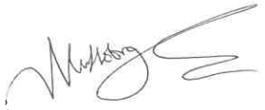
Date: 21/08/2024

