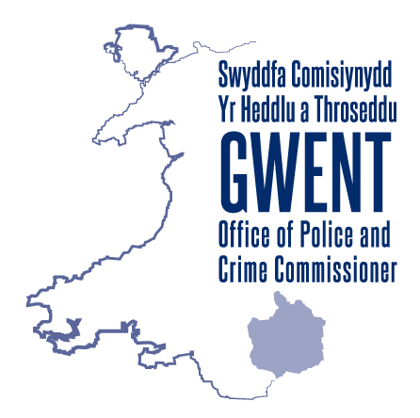
GWENT POLICE AND CRIME COMMISSIONER’S POLICE COMMUNITY FUND

PRE QUALIFICATION QUESTIONNAIRE

FOR THE FINANCIAL YEAR 2021 – 2022

Pre-Qualification Questionnaire (PQQ) - Application Checklist

Part One: What we would like to see demonstrated within your application:

Please select each of the statements below to confirm that you can demonstrate each of them in your application. You can only proceed if you select every statement.

Your project will be mainly targeted at children and young people or vulnerable adults under the age of 25 who may be in danger of entering the criminal justice system, are involved in the criminal justice system or have become victims of crime

You can provide evidence that beneficiaries have participated in the development of your proposed project/activity

You can demonstrate an awareness of similar work that is already taking place within the county or your local area and that you have explored the possibility of working together to share learning and resources

You are willing to work with your local PCSOs / Neighbourhood Policing Teams etc, as part of your project

You have a clear plan as to how you intend the project to become sustainable beyond the lifetime of any funding grants you may receive from the Police and Crime Commissioner

You have a clear plan on how you will measure and evaluate the impact your project has had against the Police and Crime Plan priorities and will be able to evidence this

Your organisation / group must have a presence in Gwent (or be willing to establish one) and 100% of the funding must be spent for the benefit of Gwent and its residents

If you have selected every statement above please continue to Part Two.

Part Two: Please check your organisations eligibility to apply to the fund:

Please select one of the below. You can apply if your organisation is a not-for-profit organisation which takes one of the following legal forms:

Charitable Incorporated Organisation (CIO))

Constituted Community Group, Voluntary Organisation or Club

Community Interest Company (CIC)

Company limited by guarantee / Company limited by shares

School (on the proviso that the funding purpose requested should not be funded via other statutory avenues e.g. Education)

Public or Statutory body (town council, parish, county council etc) Please note that any funding requested from these sources must be clearly evidenced as to why the statutory body is unable to provide the funding

Part Three: Please confirm that you project meets the essential application criteria by selecting the statements below:

Your project supports one or more of the five police and crime plan priorities (select each that are appropriate)

Crime Prevention

Supporting Victims

Community Cohesion

Tackling Anti-Social Behaviour

You have a UK bank account in your organisation / group’s name

Part Four: Please complete the following questionnaire to help us assess whether you are eligible to apply to the Police and Crime Commissioner’s Police Community Fund:

Organisation Name: | Project Name:
Lead Applicant’s Name: | Contact Number:
Email Address: | Organisation Address:
Which language would you prefer we use when we communicate with you?
Welsh English
Brief Description of the project you are hoping to apply for (max 500 words):

Please indicate an estimate of how much you wish to apply for:

Which local authority area(s) will the activity take place?

Where appropriate, which organisations will your project work with to receive referrals from / deliver additional services?

Part Five: Please select the check boxes to confirm your organisation / group is able to evidence and comply with the below
Appropriate insurances are in place, including Public liability Insurance
Risk assessments have been completed (if appropriate)
The organisation / group is General Data Protection Regulations (GDPR) compliant
The bank account for the organisation/ group has a proven financial history
The relevant Welsh Language Standard will be adhered to and the Welsh Language will be treated equally with the English Language
Where staff need to be recruited, the selection process for staff and volunteers is fair and transparent
Your organisation / group has a constitution that you are able to provide a copy of upon request
Where your proposed project is to work with / receive referrals from outside of your organisation, you have clearly identified the organisations these will be from and have established with them in advance of submitting this PQQ that they have agreed to provide referrals and/or additional services

Your organisation / group are able to provide two letters of support (one of which should be from a statutory partner where relevant and /or from an organisation you receive referrals from)

Part Six: Where the organisation/ group works directly with children, young people or vulnerable adults please select the check boxes to confirm your organisation/ group is able to evidence the following:

A safeguarding policy is in place
The safeguarding policy is reviewed annually (at minimum)
All staff members at set up and recruitment are Disclosure and Barring Service (DBS) checked. Ensuring that these are kept up to date and reviewed in a timely manner
Follow statutory or best practice guidance on appropriate ratios for staff or volunteers to children, young people and vulnerable adults
Provide, where necessary, child protection and health and safety training or guidance for staff and volunteers

Declaration:
- I am authorised to submit this Pre Qualification Questionnaire on behalf of the organisation / project; and
- I certify that the information provided is correct.
Signed: | Print Name:
Position in Organisation: | Date:

Once complete please send this form for consideration to PCCPoliceCommunityFund@gwent.pnn.police.uk

