|  |
| --- |
| Fleet Services |
|  |
| Annual Report 2023/24 |
|  |

**PURPOSE AND RECOMMENDATION**

The report presents the annual outturn relating to the delivery of Fleet Services within Gwent Police.

There are no recommendations made requiring a decision.

**INTRODUCTION & BACKGROUND**

This report is to present the Fleet Services Department provision for financial year ending March 2024 which seeks to provide services that are fit for purpose, safe, reliable, and cost effective, enabling Gwent Police to deliver optimum policing services.

The services provided by the Fleet Services Department include:

* Vehicle procurement and disposal.
* Vehicle conversion, commissioning, and decommissioning.
* Vehicle recovery.
* Pool and hire vehicle provision.
* Associated Fleet administration.
* Through life vehicle service, maintenance, and repair

|  |
| --- |
| Fleet Services forms part of the Resource Directorate and provides service to the force in the form of marked and unmarked vehicles as well as pool vehicles which were introduced some 11 years ago as a cost saving opportunity to reduce business mileage**.**  The department has worked to deliver value for money by seeking to reduce the costs associated with the services provided, developing collaborative opportunities, and introducing both new and innovative ways of working.  The Updated Gwent Police Fleet Strategy was approved at the Strategy and Performance Board (SPB) in April 2024 and provides a three-year framework (to March 2027) upon which the Fleet Services Department delivers effective service provision to the force. |
| **AREAS FOR CONSIDERATION**  **HEALTH AND SAFETY**  The Fleet Services Department had an accident-free year ending March 2024. The department was subject to two inspections from which a plan was put in place to correct any identified observations. |

**VEHICLE PROVISION**

The provision of vehicles to support both operational and non-operational requirements of the force continued to be reviewed through year ending March 2024; identifying efficiencies and proposing recommendations that where possible contribute towards fleet optimisation. This process enables scrutiny of the current vehicle provision. A summary of fleet provision since 2020 to year ending 2024 is detailed within Table A.

**Table A**



Although the fleet footprint has increased year on year since 2016, most notably to support the Police Officer uplift initiative that resulted in more than two hundred additional Police Officers joining the force; 18 assets have been removed this year and not replaced.

Vehicle users’ ability to monitor the utilisation of vehicles has improved with the introduction of the telematics solution that enables scrutiny of daily use of the vehicles within their control. The contract for a telematic solution was awarded as a result of a joint tender exercise through the collaborative Digital Services Division.

The installation of telematic units into the Gwent Police vehicle fleet is complete with baseline data available to users to make informed decisions.

The Continuous Improvement Analytics team are currently exploring telematics data for potential opportunities that could be realised such as cross department car sharing at some locations.

**MILEAGE COVERED**

The distance covered by vehicles is dictated by force operational requirements. An increase in distance covered impacts all areas of the Fleet Services Department resulting in increased fuel expenditure and more frequent servicing. The mileage of every vehicle is monitored and recorded by the Fleet Services Department through the monthly analysis of the fuel card system, workshop jobs and vehicle checks.

Table B summarises the distance travelled in the last five financial years.

**Table B**



The table details that the total distance travelled by the force to the year ending March 2024 was 4,928,000 miles, a reduction of 41,000 miles on the previous year.

The cost of fuel to year ending March 2024 was £776,000, a reduction of £95,000 compared to year ending March 2023. There was a 32,000 litre increase of fuel purchased to year ending March 2024 compared to the previous year, with the average pence per litre of fuel costing £0.21 less than the previous year.

The impact of Brexit, Ukraine and UK inflation impacting fuel costs in 2022/23 eased with the price of fuel, on average, reducing. The fleet is covering less distance per litre which we surmise is driven by the operational use of vehicles throughout the year.

The force continues to promote through internal communication initiatives whereby officers and staff are encouraged to refuel at fuel outlets that offer best value; including discounted fuel sites which is expected to deliver additional future savings in the years ahead.

**MILEAGE CLAIMS**

Relating to travel undertaken by officers and staff in their own vehicles whereby the costs are reclaimed through expenses. There are two types of travel expenses for those reimbursed when an individual uses their own car:

1. the casual user and
2. the essential user arrangements.

**Table C**



The use of business mileage is monitored by the Finance Department to ensure the force is maintaining control over the costs of service. To year ending March 2024, 570 officers and staff claimed casual user travel reimbursement, a reduction of 18 over the previous year. The number of miles claimed and the subsequent cost of the reimbursements for year ending March 2024 was 16% less than the previous year.

The level of claims is due to the new business travel policy implemented by National Police Chiefs’ Council (NPCC) during year ending March 2021 which changed the mileage calculation between a commencement from home to the destination.

In respect of the essential car users, there were five claimants for year ending March 2024 the overall cost of those claims was £4k less than the previous year.

**SERVICE, MAINTENANCE, REPAIR & INSPECTION**

The force seeks to maintain a cost-effective timely process for repair and maintenance of the vehicle fleet which involves the servicing of cars and vans every 12,000 miles and motorcycles every 6,000 miles, or every 12 months, depending on which occurs first. High performance vehicles are serviced every 10,000 miles or condition-based servicing (CBS), whichever occurs first.

Vehicle maintenance repair arrangements are provided by the Fleet Services Department maintenance facility using the Tranman fleet management database to record all activities. Table D details the volume of jobs processed through the Fleet Services maintenance facility from year ending March 2020 to year ending March 2024.

**Table D**



The table details the total number of jobs completed by the maintenance facility to year ending March 2024 was 1,563, an increase of 270 on the previous year, of which 526 were services. It is normal practice for vehicles to have associated maintenance or repair work completed while being serviced as this minimises downtime and maximises vehicle operational availability. This confirms that most of the jobs undertaken by the workshop involve elements of repair and maintenance over and above the cyclical service arrangements.

3,412 jobs were allocated to external suppliers such as tyre fitting outlets and dealers to exploit the benefit of any vehicle manufacturer warranty terms. The total number of jobs processed through the Tranman fleet management database by the admin staff to year ending March 2024 was 4,975, a 28% increase on the previous year.

The total number of in-house jobs increased to year ending March 2024 driven by inhouse process improvement delivering efficiencies. External jobs increased as a result of the vehicle age profile and job type.

Due to identified issues with high-performance BMW vehicles fitted with N57 engines, Gwent replaced all its BMWs fitted with N57 engines with alternative products including Volvo and Skoda. All the BMWs that were removed from fleet were disposed of during the year.

The conversion of the replacement high-performance vehicle fleet was completed by our in-house technicians. In addition, an increasing number of jobs that may previously been completed by external contractors are now, where possible, completed in-house. This initiative has resulted in more jobs being completed in house driven by both process and infrastructure improvements delivering efficiencies.

The access to accurate Fleet Services data has improved through the year enabling the department to make informed decisions based on data and fact, including providing the customer with real time visibility of vehicles completed by the department and operationally available to the customer; eliminating the need to contact the department by phone.

For the financial year 2023/24 Fleet Services delivered an average of 91% fleet availability for users; with 5% of vehicles off the road being maintained internally, 3% off the road being maintained externally and 1% off the road for accident repairs.

Table E details the number of vehicle accidents incurred together with the associated cost of repair. There are a number of accidents that require repairs which when assessed by an independent assessor are not economical to repair and are subsequently disposed of.

**Table E**



The total number of accidents to year ending March 2024 was 186; consistent with the volumes experienced during non-COVID-19 years with an associated cost of £286,016; an increase of 129% on the previous year. The increase in the average cost per accident up to £1,537 from £665 can be attributed to the size and scale of vehicle damage sustained.

Roads Policing Specialist Operations containment measures have been reviewed this year by the team’s Superintendent due to the number of high value repairs required as a result third parties attempts to evade containment tactics.

Six vehicles sustained damage which when independently assessed were not economic to repair and were subsequently written off. The vehicles had a combined unbudgeted replacement cost of £132k.

During the year, the force has taken the approach of retaining two suitable written off vehicles to be used as donor vehicles to promote recycling and cost saving opportunities. The force has benefited from savings in excess of £10k by utilising parts recycled from the donor vehicles.

Further analysis of vehicle accidents was undertaken to identify potential opportunities for reducing vehicle accidents and reduce associated costs. This has led to improved governance of vehicle accident monitoring through the Uniform, Equipment and Fleet User Group forum together with referral of vehicle accident data to the Driver Training School to enhance needs-based training delivery and improved engagement with force area leads for appropriate management action to reduce vehicle accidents.

Data analysed identified the cause of most accidents was as a result of reversing. 43 accidents, some 23%, were attributed to this cause. Data has been made available to teams to review and implement measures such as a reverse parking; for example, in an effort to reduce the number of accidents going forward.

A number of external suppliers are used for warranty work and can also be used as a contingency should the need arise. Accident damage is completed by an approved vehicle body shop repair facility with all completed repairs checked by Fleet Services technicians for quality standard and compliance.

High performance vehicles and specialist vehicles are converted within the Fleet Maintenance facility; however, many new vehicles are delivered as turnkey vehicles; converted by the manufacturer prior to delivery with more complex conversion work outsourced to manufacturer-based specialists to gain product liability cover and warranty.

**In-house converted RPSO (Roads Policing and Specialist Operations) Volvo V60**

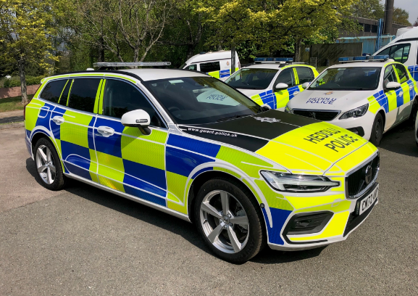

All vehicles are commissioned through Gwent Police Fleet Services maintenance facility for the fitment of telematic units, number plates, Police equipment, livery, and equipment checks.

Where possible, Police equipment such as blue lights, switch panels and relays are re-cycled from decommissioned vehicles reducing both cost and waste.

The use of Gwent Police Radio Engineers to install ancillary force equipment is a cost-effective solution supporting in-house commissioning, eliminating security implications and logistics associated with transferring Police equipment to external suppliers.

**NOTICES OF INTENDED PROSECUTION**

The Fleet Services Department processes all notices of intended prosecution (NIP’s) received by the force. Table F details the volume of NIPs processed since year ending 2020.

**Table F**



**PROCUREMENT**

Vehicle procurement is delivered in accordance with the Vehicle Replacement Policy which was reviewed and updated during the year and conforms to Contract Standing Orders. Fleet Services takes advantage of the National Police Procurement arrangements.

Fleet Services strives to achieve economies of scale; delivering savings by using national contracts where possible taking advantage of preferential purchasing terms and will participate in mini tenders within the framework using regional collaborative agreements and by standardising vehicle requirements where possible.

The COVID-19 pandemic resulted in a severe delay in the renewal of Vehicle Purchasing Frameworks. Delivery lead times are yet to return to pre-COVID-19 timescales with some manufacturers having periods where they have not accepted new orders.

The supply chain has not fully recovered and continues to be affected by the war in Ukraine and global shortage of certain components such as semiconductors together with inflationary challenges. We expect these challenges to continue but ease throughout year ending March 2025.

A 3-year accident damage repair contract, with a 1-year extension, was competed and awarded to Ceejay Autoworks during the year with the contract commencing 1 March 2024.

**VEHICLE PROCUREMENT & DISPOSAL**

Vehicle procurement, utilisation and disposal policies follow best practice encompassed within the Asset Management Strategy to ensure Gwent Police provides value for money.

The annual Vehicle Replacement Programme which was reviewed and updated during the year is based on forecasted vehicle demand considering the operational envelope. Vehicles that reach the vehicle replacement criteria, based on age, are listed for replacement and form the capital bid providing forward visibility and certainty for users and the Finance department. The criteria ensure vehicles are retained for the optimum lifecycle, taking account of warranty the cost of repair and maintenance and level of conversion to obtain optimum value.

Changes to vehicle specification are considered in the replacement programme to ensure that the latest technical and safety features are included where available. Changes in operational requirements are programmed into the following year’s plans for acquisition via the Police and Crime Commissioner’s approval of the capital bid.

End of life vehicles are decommissioned in house by the Fleet Services Department and disposed of through an auction house via a national framework safeguarding Gwent Police from potential risk associated with the disposal of vehicles.

Table G details the value of vehicles purchased to year ending March 2024 being £1.6m with receipts through vehicle sales of £223k.

**Table G**



The volume and value of disposals increased significantly during the year as the department resourced vacant positions and processes were put in place to ensure that vehicles removed from service were efficiently decommissioned and disposed of generating disposal revenue. Where possible reusable Police equipment was retained and recycled by being installed during the conversion of new vehicles before entering service.

**ENVIRIONMENTAL CONSIDERATIONS**

Fleet Services seeks to reduce any potential adverse environmental impact of our activities, including air, land, water pollution and noise. We aim to encourage the efficient use of resources through the minimising of waste and through the conservation, re-use, and recycling of resources wherever possible.

Fleet Services consults with vehicle manufacturers to keep abreast of advances in technology and alternative fuels. The evaluation of new developments in vehicle technology will be assessed in terms of operational fitness for purpose, ease of maintenance, ease of use and environmental impact.

The transition to Electric from ICE (internal combustion engine) power of suitable vehicles remains on track. 33 Electric Vehicles were operational at the end of financial year 2023/24: an increase of 15 from 2022/23. We expect the volume of EVs on fleet to increase by a further 39 resulting in a forecasted total of 72 by year ending March 2025 as the new electric charging infrastructure is installed throughout the Gwent Police estate.

This initiative saw the first fully electric marked beat car deployed within the Gwent establishment.

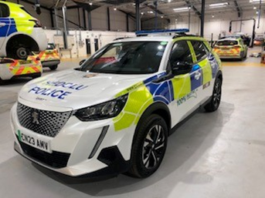

There are currently 69 chargers within the Gwent Police estate; a further 17 are expected to be installed across the estate in the next twelve months, subject to planning approval, making a total of 86 chargers. The force is also able to use the Allstar fuel charging network throughout the UK for charging.

**VEHICLE RECOVERY**

The vehicle recovery scheme, which involves the collection of Police and public vehicles is delivered and managed through a collaborative arrangement with Dyfed Powys Police, with local responsibility assumed by the Gwent Police Fleet Services Manager. Governance and Operational meetings are held regularly.

Table H details the number of recoveries of both public and Police vehicles from year ending March 2020 through to year ending March 2024. The service is provided by private contractors through a collaborative contract which includes South Wales Police and Dyfed Powys Police.

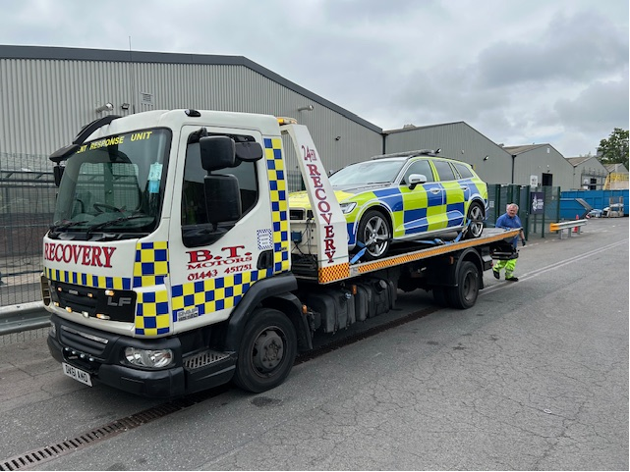

**Table H**



The table illustrates that the number of recoveries to March 2024 of both public and Police vehicles has increased. The increase in Police vehicle recoveries is due to the increase in number of incidents involving Police vehicles together with maximising the benefits of the vehicle recovery provision that is available for vehicle movements including the movement of Police vehicles to and from external suppliers for the completion of warranty work.

Proceeds from the sale of seized vehicles that were not subsequently retrieved by the owner was directed to the Office of the Police and Crime Commissioner (OPCC). This amounted to £166k for 2023/24 an increase of £54k on the previous year.

**CHALLENGES**

Fleet Services navigated several challenges to year ending March 2024, summarised below:

* The high-performance vehicle fleet previously impacted by limitations due to issues with the BMW N57 engine which affected aspects of operational delivery.

Fleet Services implemented national guidelines to identify and classify all affected vehicles resulting in all in-scope vehicles being removed from contract creating a backlog of vehicles that required decommissioning and disposal. The team successfully decommissioned and disposed of all the in-scope vehicles from the Gwent fleet during the year resulting in the force not owning any BMWs fitted with the N57 engine.

* As a result of internal progression within the department as well as staff successfully obtaining alternative positions within the force Fleet Services had three vacant positions to find suitable candidates to fill during the year. Due to the nature of the roles and the associated required security standards which must be achieved the recruitment and onboarding process for all the right reasons can take some months. This coupled with the challenges within the employment marketplace resulted in it typically taking six months to award positions to successful candidates. This left the department without the necessary strength and depth required to maintain resilience for periods of the year.
* The 2023/24 financial year presented Fleet Services with probably the biggest challenge faced for a number of years with the force vacating the site at Croesyceiliog which had been the home of the force and Fleet Services for the last 40 years.

A new facility was identified adjacent to the new Police Headquarters at Llantarnam. The Estates Department secured a ten-year occupancy which future proofs the department, reinforcing the forces commitment for the provision of an in-house maintenance facility supporting operational vehicle capability.

Conversion of the facility was completed as scheduled on both time and budget delivering eight productive bays including two DVSA approved inspection lanes.

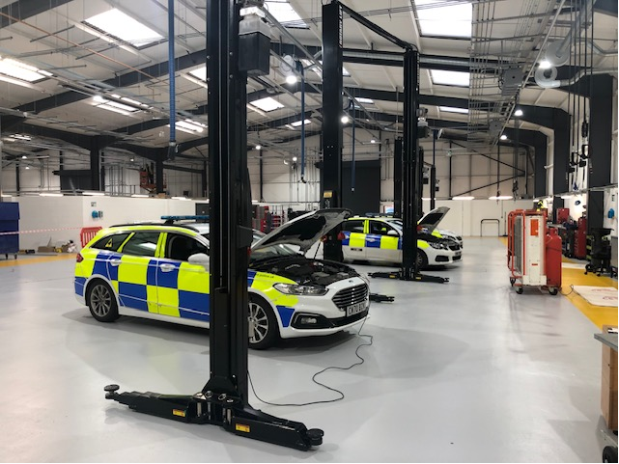

A mature project plan ensured that all stakeholders were engaged in the process that resulted in a smooth relocation to the new facility over the weekend of 11/12November 2023 whilst maintaining the operational capability ensuring any fleet issues were efficiently and effectively dealt with. Fleet availability maintained a steady 93% during the week before and after the relocation.

**COLLABORATION**

Fleet Services makes use of collaborative opportunities through the National Association of Police Fleet Managers (NAPFM) to improve standards and standardisation between all forces and reduce costs through economies of scale wherever possible.

Collaboration with training, contracts and workshop issues are current examples of successful on-going projects. Compliance and assistance with NAPFM/Home Office contracts enhance collaboration, reduces costs and improves safety and conformity through nationally agreed specifications.

The single shared Fleet management database has enabled improved collaborative working between the Welsh forces in several ways.

Consistency in reporting between Gwent, South Wales and Dyfed Powys means Fleet Managers can analyse a wide range of data and compare performance to enable decision making.

Access to data on the type of vehicle repairs being undertaken at the other forces has enabled discussion among technicians regarding the sharing oof best practice and a more efficient service delivery.

Officers are provided with more maintenance locations, as servicing, maintenance and repairs can be undertaken at any Gwent, South Wales, or Dyfed Powys force maintenance facility regardless of the home force. This is enabled by immediate access to vehicle history and improves service delivery timescales.

Gwent Police’s Fleet Services Department forms part of the All-Wales Fleet Joint Advisory Group working on collaborative projects such as standardisation of vehicle types, Police equipment and IT service providers, framework contracts and shared resources.

Fleet Services work closely with the Joint Firearms Unit, South Wales Police Fleet Services and Dyfed Powys Police Fleet Services to achieve continuity in vehicle design and service delivery.

The vehicle recovery scheme, which involves the collection of both Police and public vehicles, is delivered and managed through a collaborative arrangement with Dyfed Powys Police, with local responsibility assumed by Gwent Police’s Fleet Services Manager, and with Governance and Operational meetings being regularly held.

**FORWARD LOOK**

Now provided with a new maintenance facility; coupled with the fact that for the first time in several years the department has a full complement of staff creates a solid foundation to deliver exceptional customer service and efficiencies through process improvement; ensuring the department has sufficient strength, depth and resilience together with a robust succession plan.

As a result of the vehicle recovery contract collaborative contract manager transferring, on secondment, to Gwent from Dyfed Powys, the contract will be governed by Gwent from 1 April 2024. The current recovery contract between Gwent, South Wales and Dyfed Powys will expire 31 March 2026.

The Tranman fleet management system utilised within Gwent is also a contracted collaborative arrangement that includes both South Wales and Dyfed Powys. The current system is due to be replaced as the current extended support contract is due to expire at the end of October 2024. A tri-force collaborative project to replace the current system has commenced with the emphasis on providing a fit for purpose system that delivers value for money considering any potential transition risk and collaboration opportunities.

Fleet Services regularly attends the Emergency Services Network (ESN) Project Board to ensure there will be a smooth transition to any new communication technology.

**FINANCIAL CONSIDERATIONS**

The overall cost of delivering the fleet services is summarised in Table J.

**Table J**



The overall revenue cost of the Fleet Services Department for year ending March 2024 totals £2.2m, a reduction of £147,000 on the previous year. Fuel spend has reduced by £96,000 due to fewer miles being driven together with a reduction in the price at the pump. However, 32,000 more litres were purchased driven by the operational use of the vehicles throughout the year.

Consumable spend has decreased due to reclassification of items previously recorded as consumables now classified as spares.

External vehicle hire spend has reduced due to a reduction of the duration of long-term hires to support operational requirements and 4 X 4 vehicles over the winter period.

**Value for Money**

Customer feedback is provided through customer comments (both positive and negative), and performance indicators regarding the establishment, fuel use and accident statistics are also communicated to management. The Fleet User Group forum has been re-constituted into the Uniform, Equipment and Fleet Users Group to ensure operational requirements are embedded in the force governance arrangements.

The Fleet Management database approved and implemented year ending March 2017 allows for the development of performance indicators and Service Level Agreements between the Fleet Services Department and internal customers. This also provides a basis for feedback and review within the continuous improvement cycle.

The fleet management database is a collaborative provision shared with South Wales Police and Dyfed Powys Police which enables interoperability together with the opportunity for other force workshops to work on each other’s vehicles; a flexibility that provides for further sound business continuity management. A variety of KPI’s are used for the monitoring of vehicle downtime, frontline vehicle availability and vehicle utilisation. KPI’s are reviewed to stay abreast of changing demands such as the need for more sophisticated environmental indicators which are being developed.

Direct access to the computerised fleet management system through a web portal allows specific users to have direct access to view vehicle accident details. The web portal is also used to report accidents and is an improved and enhanced tool for recording and monitoring. This has continued to be upgraded to include the reporting of vehicle defects and the recording of vehicle checks.

**PERSONNEL CONSIDERATIONS**

The Fleet Services Department staffing has developed to support operational demands and is detailed in Table K

**Table K**



The Fleet Services Department staff headcount proved challenging during the year ending March 2024.

As at the end of March 2023 Fleet Services had three vacant positions which we hoped to be filled by the end of the financial year ending March 2024 subject to candidate suitability and employment market challenges.

As expected, a number of the roles had to be advertised for a number of cycles due to the quality of the candidates that submitted applications. Suitable candidates were offered positions with the last vacant position scheduled to be filled in the first quarter of 2024/25 financial year.

A training programme is in place to ensure that staff are proficient with ever evolving technology and able to operate the latest equipment built into vehicles and the fitted ancillary equipment. Staff are trained to cover First Aid, Health & Safety and Fleet Management, along with the technical training of the vehicle mechanics, including MOTs and stolen vehicle identification.

**LEGAL IMPLICATIONS**

All contract arrangements are progressed in line with legal requirements.

**EQUALITIES AND HUMAN RIGHTS CONSIDERATIONS**

This project/proposal has been considered against the general duty to promote equality, and has been assessed not to discriminate against any group.

In preparing this report, consideration has been given to requirements of the Articles contained in the European Convention on Human Rights and the Human Rights Act 1998.

**RISK**

None identified.

**PUBLIC INTEREST**

In producing this report, has consideration been given to ‘public confidence’? **Yes**

Are the contents of this report, observations, and appendices necessary and suitable for the public domain? **Yes**

If you consider this report to be exempt from the public domain, please state the reasons: **N/A**

Media, Stakeholder and Community Impacts: **None**

I confirm this report is suitable for the public domain.

**FORCE SCRUTINY**

This document has been presented to Formal Chief Officer Team Board, chaired by Chief Constable Hobrough.

There are no actions or amendments arising from this report.

**REPORT AUTHOR**

Ken Peart - Fleet Services Manager

**LEAD CHIEF OFFICER**

Assistant Chief Constable – Organisation Nicholas McLain

**ANNEXES**

There are no annexes to this report.

**CHIEF OFFICER APPROVAL**

I confirm thisreport has been discussed and approved at a formal Chief Officers’ meeting.

Meeting date 15/08/24

**Signature:**



**Date: 21st August 2024**