Data Quality of Crimes and Incidents
Strategy and Performance Board 2023
- PURPOSE AND RECOMMENDATION

The purpose of this report is to provide information on force crime recording performance for monitoring purposes and OPCC reporting.

- INTRODUCTION & BACKGROUND

This report aims to brief the Office of Police and Crime Commissioner (OPCC) about the timeliness and accuracy of crime recording in Gwent Police.
It is important to provide the highest possible service levels to victims of crime. This should start at the first point of contact and last throughout the criminal justice process. It not only includes recording the victim’s report, responding and undertaking proportionate investigations, but also ensuring that any victim vulnerability is identified and that appropriate safeguarding measures are taken.
As part of this process, it is important that the force has high-quality crime data. This ensures victims are identified and supported at the earliest opportunity and establishes where, when, and how often crime is happening. Good crime recording ensures that the force:
• offers victims of crime access to appropriate support services.
• gives the public accurate information about crime in their area.
• understands current and future demand; and
• can plan effectively to ensure provision of a victim focussed service.

Compliance with national guidance and crime data integrity is the responsibility of the Force Crime Registrar (FCR) assisted by her Crime and Data Audit Team. The rules about crime recording are governed by Home Office National Crime Recording Standards (NCRS).

- ISSUES FOR CONSIDERATION

3.1 NCRS Compliance.

The force has recorded the following numbers of crimes annually:

- 2016 - 2017 - 41,046
- 2017 - 2018 - 48,717
- 2018 - 2019 - 58,530
- 2019 - 2020 - 57,152
- 2020 - 2021 - 48,633
- 2021 - 2022 - 54,649
- 2022 – 2023 - 60,893
- 2023 – 2024 - 17,393 as of 12/07/23

As you can see there is an increase year on year, this is due to changes in crime recording, for example recording an additional crime alongside the behavioural crime. However as of the 1st May 2023 this rule has reverted back, so only the substantive crime is now recorded. This decision was made by the Home Office and the NPCC. This increase is also due to the awareness of Crime Data Integrity force wide. 2020 - 2021 saw the decrease in crimes being recorded due to Covid restrictions.

The Data Audit team conduct regular crime audits to assess crime recording accuracy and compliance with NCRS. Quarterly audits of a sample of 100 Niche occurrences are undertaken to establish adherence with crime recording rules. Alongside the audits the Data Audit team are responsible for the cancellation of crimes, reclassifications, transfers of crimes to other forces and applying positive outcomes.

Additionally, daily crime and incident audits review crimes and incidents in specific areas of risk. These include Harassment/Stalking, GBH offences, residential burglaries, all ASB and N100’s (rape reports). Also, the Daily Management Meeting (DMM) document is reviewed on a daily basis to ensure all crimes are recorded in accordance with NCRS.

NCRS Audits completed during 2022/2023 recorded the following results:

- January 2022 – 90%
- May 2022 – 92%
- July 2022 – 91%
- October 2022 – 87%
- March 2023 – 88%

This compares with an average NCRS compliance rate of 84% in 2019. The professional opinion of the Force Crime Registrar is that this level of compliance would lead to an HMICFRS inspection rating of ‘Requires Improvement’. An NCRS compliance rate of 92 - 95% and above would be required to achieve a positive HMICFRS inspection outcome.

2023/2024 Audit schedule:
Date audit conducted | Month of data reviewed | Audit report due
May 2023 | March 2023 | June 2023
September 2023 | July 2023 | October 2023
January 2024 | November 2023 | February 2024
May 2024 | March 2024 | June 2024
September 2024 | July 2024 | October 2024

3.2 Timeliness

Any crime reported must be recorded at the earliest opportunity, or in any case within 24 hours of reporting. The force was previously praised by the HMICFRS for the timeliness of recording crime in our previous inspection. The force continues to record crime efficiently and in accordance with NCRS guidance as detailed in the audit findings below.

- January 2022 – 85%
- May 2022 – 96%
- July 2022 – 95%
- October 2022 – 94%
- March 2023 – 96%
The recording of our crimes within 24 hours is at a constant high. This team review all logs for the past 24 hours and record crimes as necessary. As of the 1st July 2023 the Force Contact Centre will cease recording any crimes, this role will be the main priority/function of the new CDI team.

3.3 Outcomes

Outcomes were introduced by the Home Office to promote a truer picture of how crime is finalised. The outcome categories provide a framework which can assist in giving the victim a better understanding of the final outcome of their case, and also a better understanding amongst the general public about how crime is investigated.
In each of the audits since June 2020, the force also audited the accuracy of the outcomes applied to each crime on closure. The results were as follows.

- January 2022 - 94%
- May 2022 – 93%
- July 2022 – 90%
- October 2022 – 87%
- March 2023 – 95%

Further training has been implemented with regards to the application of crime outcomes, however the Data Audit team now apply the majority of these outcomes, which has seen a significant improvement in our data.

3.4 Performance Improvement Actions.

The Force has taken the following actions to help improve performance:

- Aligned the Force Crime Registrar and associated teams to the Continuous Improvement Dept, leading to a closer working relationship with the Deputy Chief Constable. Completed
- Aligned the Force ‘Crime Recording Timeliness Team’ to the Data Audit department to ensure more consistent methods of audit. Completed
- Altered operating procedures to ensure all incidents from the last 24 hours are reviewed by a central team, rather than review incidents as they are created. This enables a more consistent and accurate judgement with regards to crime recording and ensures a higher proportion of incidents are reviewed. Completed
- Implemented a quality assurance process that ensures accuracy of information recorded and crime recording decisions at first point of contact. Completed
- Refreshed First Point of Contact staff knowledge of the domestic abuse question set guidance and importance of its use. Completed
- Implemented an annual force wide communications plan to reinforce the importance of crime recording in accordance with national guidance. Completed
- Provided crime-recording training to all supervisors, officers and staff in a crime recording role via the Force Training Day. This included national crime recording standards, additional verifiable information requirements and crime outcomes. Completed
- Introduced a process to quality assure community resolution outcomes. Completed
- Provided training and guidance to the Crime Management Unit in relation to the application of crime outcomes. Completed
- Continued the quality assurance and feedback process across the organisation regarding crime recording quality. Completed
- Introduced a force Crime Recording DMM. Completed
- Developed a Crime Recording Business intelligence application to allow better performance monitoring. Completed
- Developed a system to identify high risk incidents that are at risk of not being crimed. This is monitored through Force DMM. Completed
- Create a College Learning (NCALT) package for Crime Recording – Completed

Crime Data Integrity Unit

As part of a review of departments and functions within the crime recording arena it was approved that there will be one team who will have sole responsibility of recording crimes, therefore as of the 1st July the Force Contact Centre will not be recording any crimes, this is now the main priority of the new CDI Team. Its business as usual for the Timeliness Team who will continue to review all Storm logs retrospectively for the previous 24 hours. The team will be known as the Crime Data Integrity Unit and is comprised of the Crime Management Unit, Data Audit and the Timeliness Team. Going forward all staff, apart from Audit as this is a specialist role, will be omni competent.

3.5 Officers responsibility

Although we have back-office functions to record crime, the responsibility still sits with the officer in the case to record crimes in the first instance or any additional crimes that have been disclosed to them. In 2021 the implementation of the CRR01 document was introduced to assist officers with recording crimes. This is a document that the officer completes, press a button and the request goes straight through to the Crime Management Unit to record the necessary crimes. This has had a significant impact on our crime recording, as you can see in the below chart:

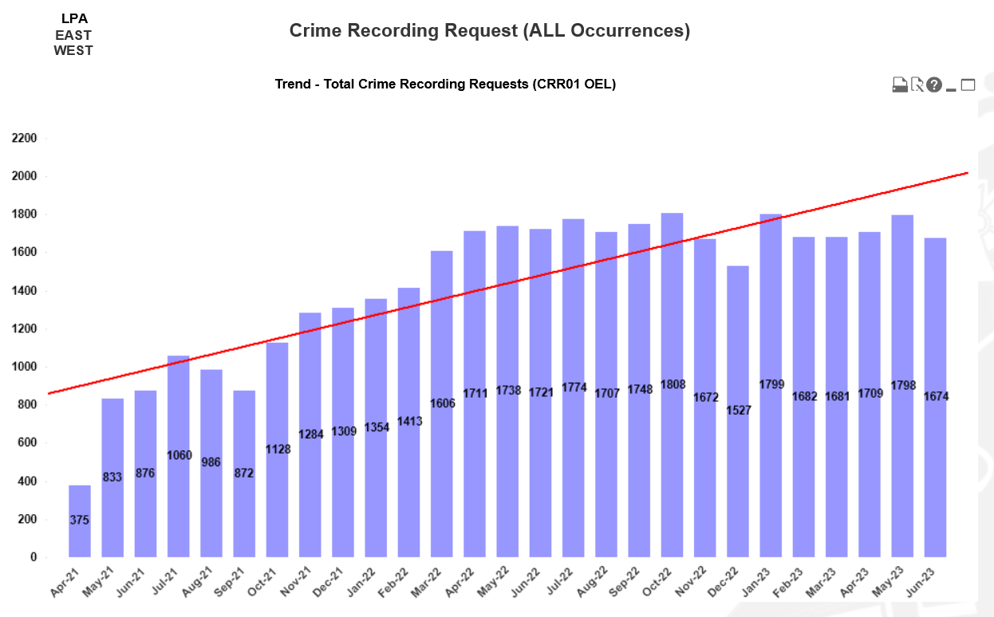

- COLLABORATION

The Force Crime Registrar recently conducted a peer review of public order offences, to ensure that we are recording them correctly in line with the Home Office Counting Rules and National Crime Recording Standards.

With the assistance of the Deputy National Crime Registrar, they selected dates from 01/01/23 – 23/06/23 there were 1688 crime recorded so they decided to review 16 of them which is 10%. Of the 16 public orders that were recorded we had over recorded by one crime. However, after reviewing the remaining 15 offences, 1 should have been recorded as S4 public order and not a S4a, this has been reclassified and we have potentially missed an additional 5 crimes – 2 x public orders, 1 x damage and 2 x assaults. These have now been recorded.

Consensus is that we are not over-recording in this area, however a more detailed review of crimes needs to be undertaken to ensure that we are not missing crimes going forward.

Also, as stated below in the next steps, we are also collaborating with SWP with regards to the animation video’s that L&D are assisting us with.

- NEXT STEPS

- Continuing to implement the Crime Data Integrity Action Plan through the Crime Data Integrity Improvement Group,
- Implement the recommendations of the Victims Services Self- Assessment,
- Continue with the force audit regime on a quarterly basis and seek to improve the lessons learned from the process,
- Reinforce the crime recording advice and guidance provided at force training days through pro-active communications,
- Increase the number of CDI champions to offer advice and guidance to officers and staff within the LPA,
- Maintain and increase the higher standard of Crime Recording and continue to improve our NCRS compliance rate.
- Animation videos are being created with L&D to improve the knowledge of crime recording, these are in collaboration with South Wales Police, and will include Conduct Crimes, Assaults and many more topics.
- All Burglary and GBH offences are now scrutinised as a result of a daily audit to ensure that these are correctly recorded.

- FINANCIAL CONSIDERATIONS
None

- PERSONNEL CONSIDERATIONS
None

- LEGAL CONSIDERATIONS
None

- EQUALITIES & HUMAN RIGHTS CONSIDERATIONS
  - This report has been considered against the general duty to promote equality, as stipulated under the Joint Strategic Equality Plan and has been assessed not to discriminate against any particular group.

  - In preparing this report, consideration has been given to requirements of the Articles contained in the European Convention on Human Rights and the Human Rights Act 1998.

- RISK

- Due to results of audits and the below average NCRS compliance rates the matter is included on the Force/ OPCC Joint Risk Register as a high risk.

- PUBLIC INTEREST
  - In producing this report, has consideration been given to ‘public confidence’? Yes

  - Are the contents of this report, observations and appendices necessary and suitable for the public domain? Yes

  - If you consider this report to be exempt from the public domain, please state the reasons: N/A

  - Media, Stakeholder and Community Impacts: N/A

- REPORT AUTHOR
  - Rhianne Wiltshire (Force Crime Registrar)

- LEAD CHIEF OFFICER
  - DCC Rachel Williams

- ANNEXES
  - Nil

- GOVERNANCE BOARD AND CHIEF OFFICER APPROVAL
  - This report has been presented to the following board:
Operational Performance Board

  - Meeting chaired by:
Ch/Supt Nicholas McLain

  - Meeting date:
25.07.23

  - Actions and amendments arising from the meeting:
N/A
Report approved for presentation at SEB.

  - This report has been presented to the following oversight board:
Scrutiny Executive Board (SEB)

  - Meeting chaired by:
DCC Rachel Williams

  - Meeting date:
01.08.23

  - Actions and amendments arising from the meeting:
N/A

  - I confirm this report has been discussed and approved at a formal Chief Officers’ meeting.

  - Meeting chaired by:
CC Pam Kelly

Meeting date:
15.08.23

  - I confirm this report is suitable for the public domain.

Signature: 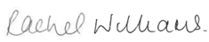 Date: 15.08.2023

