Gwent Police Headquarters
Llantarnam Park Way
Llantarnam
Cwmbran
NP44 3FW

Members of Gwent Police and Crime Panel

Dear Panel Members,
I am writing to confirm my support of the Police and Crime Commissioner’s proposal in relation to the Budget Requirement and Council Tax Precept for 2025/2026. I am confident that my bid to the Police and Crime Commissioner has been given full consideration and is appropriately reflected within her report. I very much hope that the presentation I delivered in December provided the necessary operational context to demonstrate how we will meet our ever-increasing demands, protect our communities, and deliver the Police, Crime and Justice Plan. My bid to the Commissioner was also clear that it is vital that we receive sufficient funding to do so.
I understand the very difficult role you play in balancing the affordability for residents with the requirements to fund an efficient and effective policing service for the people of Gwent. Further to the pledges I made at my confirmation hearing last month, I offer my commitment to continue to closely scrutinise spend, make efficiency savings where possible, invest appropriately and seek value for money in all financial decisions.
Yours sincerely
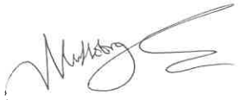
Mark Hobrough
Chief Constable, Gwent Police

