Police and Crime Commissioner for Gwent Decision
PCCG-2025-011 | Police and Crime Commissioner for Gwent Decision Session
Subject | Community Cohesion Fund 2025/26
Summary | To record the decision of the Police and Crime Commissioner to establish a Community Cohesion Fund in 2025/26.
DECISION
1. | In order to assist my office in the delivery of my Police Crime and Justice Plan, I have established an annual fund of £100,000 for distribution to organisations who deliver appropriate and relevant activities across Gwent. The fund will be known as the Community Cohesion Fund (CCF) and will be aligned to my Strategic Equality Plan. The first objective of which is :  - Increase confidence and trust in public services for marginalised and minoritised communities, with a specific focus on race, disability, gender, and sexual orientation.
2. | I have decided that this fund will be used to support my role as Police and Crime Commissioner. The CCF will be distributed at my discretion with an annual decision log published at the end of the financial year. However, dependent upon the nature of a particular bid, a more timely individual decision log may be produced and published.
3. | It is my intention to run the CCF as an ongoing rolling application process continuing into future financial years and I will adjust the budget accordingly to reflect the financial position at the time.
4 | In order to monitor progress and provide assurance that funding allocated is effectively meeting the priorities of the CCF, reporting templates will be required to be provided at the completion of the project and reviewed by OPCC staff. Staff may also attend site visits with any successful organisation during the funding period.

Jane Mudd, Police and Crime Commissioner for Gwent
I confirm I have considered whether or not I have any personal or prejudicial interest in this matter and take the proposed decision in compliance with my code of conduct.
Any such interests are recorded below.
The above request has my approval.
Signed  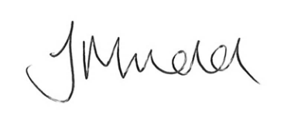 | Date  27/08/2025

Contact Officer
Name | Rob James
Position | Commissioning & Funding Manager
Telephone | 01633 642200
Email | Rob.james@gwent.police.uk
Background papers | Appendix A: Guidance Document

