PCCG-2025-022 | Police and Crime Commissioner for Gwent Decision
Subject | Remote Evidence Site
Summary | To record the decision of the Police and Crime Commissioner regarding the use of a Gwent Police property as a Remote Evidence Site
Police and Crime Commissioner for Gwent Decision

DECISION
1. | The National Remote Link Sites Protocol (October 2020) entered into by His Majesty’s Courts and Tribunals Service, the Crown Prosecution Service and the National Police Chiefs’ Council relates to the use of sites by criminal justice and partner agencies supporting witnesses providing evidence via live video links at locations away from court buildings. Paragraph 5 of this Protocol provides that ‘these sites can be found at many different locations including in buildings owned by organisations within the criminal justice system’.
2. | Accordingly, as part of the VAWDASV (Violence Against Women, Domestic Abuse and Sexual Violence) Board, it has been agreed that as regards the location of Remote Evidence Site (RES) within the Gwent area, this will be housed within the Gwent Police estate at a location agreed by the Police and Crime Commissioner. In consultation and with the support of the Chief Constable of Gwent Police, the Police and Crime Commissioner as the legal owner of the police estate has confirmed her support the of the hosting of these services within the police estate at such location for the period ending 31st March 2028, with the value of the use of the premises being Commissioner’s contribution (in kind), on behalf of Gwent Police, to the wider collaborative provision of the remote link site..

Jane Mudd, Police and Crime Commissioner for Gwent
I confirm I have considered whether or not I have any personal or prejudicial interest in this matter and take the proposed decision in compliance with my code of conduct.
Any such interests are recorded below.
The above request has my approval.
Signed
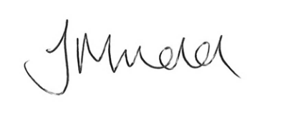
Date
16.10.2025

Contact Officer
Name | Siân Curley
Position | Chief Executive
Telephone | 01633 642200
Email | Sian.Curley@gwent.police.uk
Background papers

