**

**Southern Wales Police Forces**

**Collaborative Commercial and Procurement Strategy**

**2025 - 2030**

**Version Control**

|  |  |  |  |
| --- | --- | --- | --- |
| **Version** | **Date** | **Author** | **Comment** |
| V1.1 | 140425 | Sian Freeman | Draft version subject to sign off by Umar Hussain, CFO |
| V1.2 | 020525 | Sian Freeman | Revision to include further DPP information and SWP & Gwent 2024-25 spend figures.  This draft is subject to approval by South Wales CFO and Gwent ACC (Organisation) |
| V1.3 | 060525 | Sian Freeman | Addition of reference to ICT Procurement |
| V1.4 | 160725 | Sian Freeman | 3 Force collaborative spend percentage updated |
| V1.5 | 210825 | Sian Freeman | Amendments made following review and approval by U Hussain, SWP CFO |

**Table of Contents**

1. **Introduction**

* Success of the three Force Procurement Collaboration to date
* Looking Forward 2025-2030

1. Why Procurement Matters
2. Our Mission
3. Informing Our Strategy

* The National Procurement Policy Statement
* Procurement Reform
* Green and Sustainable
* Policing Policy Drivers

1. Delivering Value throughout the Procurement Lifecycle
2. Strategic Goals and how we will achieve them

* Maximise Commercial Benefits and Collaboration
* Build Commercial Skills and Capability
* Support Business in our Communities
* Deliver Sustainability and Responsible Procurement
* Social Value
* Ethical Supply Chains
* Ensuring legal compliance and transparent governance

1. Key Enablers

* People, Process, Culture, Technology, Collaboration and Information
* Collaboration

1. Measuring and Monitoring Performance
2. Introduction

This Commercial and Procurement Strategy 2025-2030 builds upon the Procurement Strategy to 2025 for the three police forces of South Wales, Gwent and Dyfed-Powys.

The three forces have collaborated in the procurement of key goods and services for over a decade. In 2020, South Wales Police and Gwent Police established a Joint Commercial and Procurement Services unit and has continued to collaborate with Dyfed-Powys Police (DPP) on several key contracts as well as sharing work on ethical supply chains and sustainability activity, to make best use of the limited procurement resource within the Southern Wales Forces. The joint unit adopted a hybrid approach to realise the many benefits of a best practice category management approach but maintaining informal category specialisms and flexibility within a relatively small team. However, this has developed positively with the growth of focus on the contract management phase of the commercial lifecycle and growing our own talent.

**Success of the three Force Procurement Collaboration to date**

* 74% of £159.7 million spent by the three forces on goods, works and services in 2024-2025 was spent collaboratively.
* The three forces have together delivered over £25.7 million of procurement related savings during the last five years, of which £22.7 million was cashable.
* Key processes are aligned - the development of standardised procurement documents, processes, terms and best practice have increased efficiency, improved the experience for suppliers and ensured our compliance with regular changes in the procurement regulations.
* Joint working such as our undertaking to provide assurance of ethical supply chains, progress towards net zero and the delivery of social value through our contracts. In December 2024, we achieved our target to assess the top 100 suppliers across South Wales and Gwent by 2025 to assure ethical employment in our supply chains. The annual turnover of these 100 suppliers exceeds £55 billion which illustrates the impact of Welsh Policing on ethical procurement.
* Successful collaboration on a range of key contracts including Forensic Medical Services and SARC Services, Appropriate Adult Services, Police Officer Apprenticeships, Forensic Pathology Services, Police Officer Pensions, Vehicle Recovery Services, Laundry Services and Independent Sexual Violence Advisors.
* Whilst North Wales Police (NWP) continues to sit outside the core remit of the southern forces’ procurement collaboration, work with North Wales has been beneficial across a number of areas. NWP continues to remain sighted on the national work being done by the Southern Forces Procurement collaboration through the Finance Joint Assurance Group and other forums which helps to ensure it is up to date on the work and good practice taking place within the southern forces.
* The contract management phase of the commercial lifecycle is now as prominent as the procure phase. We have increased the number of contract management officers due to the benefits realised through these dedicated roles and the need to deliver best value from our high value, complex ‘gold’ rated contracts.

**Looking Forward 2025-2030**

Over the next five years, our procurement strategy will continue to focus on the delivery of best value for the public purse but with an increased emphasis on social value, sustainability, fostering innovation and building stronger relationships to support the priorities of the three Forces.

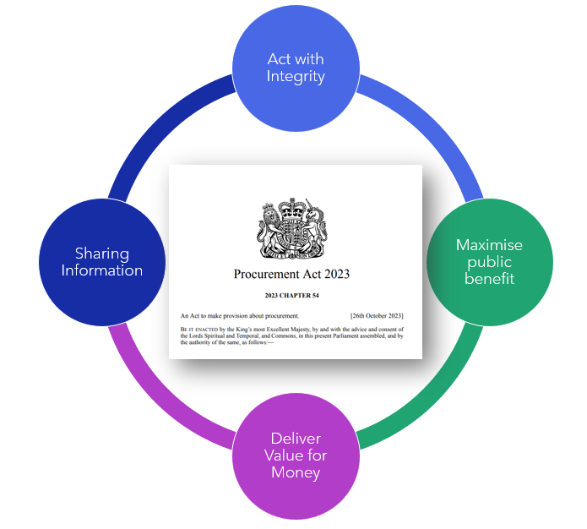

The Procurement Act 2023 went live on 24th February 2025 and will impact our procurement strategy, with a greater emphasis on transparency, social value, enhanced supplier management, a focus on engaging SME and local suppliers and the introduction of new processes.

The Act seeks to strengthen public trust, enhance service delivery and contribute to broader social and economic objectives. The statutory requirement to share information by publishing a range of notices increases the level of transparency and scrutiny. We will publish a procurement pipeline in line with the requirements of the Procurement Act. The overriding duty to deliver value for money remains the primary focus and acting with integrity is embedded as a core value in both policing and procurement.

By prioritising ethical sourcing and working with suppliers who share our commitment to environmental and social responsibility, we aim to reduce our carbon footprint and to a develop a supply chain that delivers benefits for their business and our communities. We will encourage suppliers to actively work to tackle modern slavery and human rights violations, bribery, fraud and corruption and their environmental impact, as well as stamping out late payment of invoices in their supply chains. We will build on the work to deliver social value through our contracts to date and expect our suppliers to identify where they already have a positive social value impact and where they could do more. We will track this using a Social Value Register.

We will continue to invest in our staff with a focus on growing our own talent, as our team is integral to our ongoing progress and our ability to ensure the right commercial capability and standards are in place to procure and manage contracts effectively. We will build commercial skills and capability and invest in digital technology to deliver further efficiency, transparency and compliance, supplier management and a simplified supplier experience. We have been successful in securing a procurement graduate position with the successful candidate commencing in September 2025.

Continuous improvement is deeply ingrained within the procurement function and change is considered a constant. There is a strong commitment to actively apply lessons learned to drive enhancements based on our experience and changes in legislation and best practice.

1. Why Procurement Matters

CIPS (Chartered Institute of Procurement and Supply) defines procurement activity as:

“The activity overseeing the steps of the procurement cycle, such as market analysis, sourcing, negotiation, contracting and supplier relationship management for goods, works and services, covering both acquisitions from third parties and in-house providers. The process spans the whole procurement cycle from the identification of needs, through to the end of a services contract or the end of the useful life of an asset. It involves options appraisal and the critical “make or buy” decision.”

Expenditure on goods, services and works across the three Southern Wales Forces exceeds £159 million. Whilst the forces purchase from over 3000 suppliers, over 50% of spend is with approximately 20 suppliers, highlighting the importance of effective contract management. Approximately 74% of the three force spend is spent collaboratively.

In addition to placing value for money, public benefit, transparency and integrity at the heart of our procurement, procurement is increasingly seen as an agent for the delivery of a number of local and national priorities. The National Procurement Policy Statement reinforces a focus on decarbonisation, support for local businesses and communities, small business and taking a broader view of what can be achieved through our contracts, such as relevant social and environmental outcomes.

In addition, effective procurement processes matter because:

* The forces deliver a wide range of services that have a fundamental impact on the lives of communities.
* We must have confidence that we are buying goods and services that enhance, not detract from, that quality of life.
* We must understand who we are trading with and be confident that by trading with that company any risks are reduced.
* We have an obligation to ensure that our procurement processes are open, transparent and give equal treatment to everyone.
* We have a duty to promote free and fair competition in the market.
* Establishing effective contract management arrangements from the commencement of a contract and throughout its life, is the only way to deliver best value from our procurement. The Procurement Act 2023 brings additional demands to this stage of the procurement lifecycle but the increased scrutiny should be positive for the market, the public and for effective suppliers.

This Strategy sets out what the Forces will do to adopt a continuous improvement approach to managing our procurement activity, to support delivery of our local and national priorities, alongside our duty to deliver value for money for the public purse.

1. Our Mission

**To provide a transparent procurement service that benefits suppliers, clients, stakeholders and the public purse through innovative continuous improvement, commercial expertise and best practice**.

Value for money is paramount in fulfilling our commitment to taxpayers and delivering public services efficiently. We will place value for money at the forefront of our procurement activities which means optimising the use of public funds by balancing effectiveness, efficiency and economy over the life cycle of a product, service or works to achieve the intended outcomes of the procurement.

This report’s introduction describes the collaboration across the Southern Wales Forces, in particular the establishment of a joint commercial and procurement services unit across South Wales and Gwent Forces.

This strategy links the objectives of the Forces with commercial goals to meet financial challenges, recognising the responsibilities Commercial and Procurement have in collaborating with internal and external partners and working in a fair and transparent manner. This is fundamental to achieving best value for both the organisation and the supply chain and supports the Police and Crime Commissioners and Chief Constables in their overall approach to the delivery of operational policing. Objectives within our Police, Crime and Justice Plans include demonstrating and delivering value for money and social return on investment, optimising the organisation’s use of resources, buying local to benefit our communities, working in collaboration with partners and police collaborations, lowering our carbon footprint and improving workforce sustainability.

1. Informing our Strategy

**The National Procurement Policy Statement**

The Government sets out the strategic priorities for public procurement in the UK in the National Procurement Policy Statement (NPPS), as summarised in this diagram. The NPPS came into effect on 24th February 2025 in accordance with the Act. The Statement guides contracting authorities on how to support these priorities in their procurement processes.

The national priorities are familiar and therefore more of an evolution. They relate to value for money, social value, small and medium-sized enterprises, commercial and procurement delivery and skills and capability for procurement.

As a contracting authority, we must have regard to this Statement and seek to drive economic growth and strengthen our supply chains by giving SMEs and VCSEs a fair opportunity to bid for our contracts, creating high quality jobs and championing innovation. We will consider whether a procurement can contribute to achieving one or more of the policy NPPS objectives in a manner that is appropriate, proportionate and relevant and take steps to address this where possible. We will work to optimise the use of public funds by balancing effectiveness, efficiency and economy over the lifecycle of a product, service or works to achieve the intended outcomes of the procurement. This includes wider socio-economic and environmental benefits and impacts.

We frequently work in partnership across organisational boundaries and seek to collaborate in procurement. The very nature of the joint procurement unit supports this.

**Procurement Reform**

The Procurement Act 2023 (PA23) represents the most significant transformation to UK public procurement in a decade. It is designed to deliver a regime that is “quicker, simpler, more transparent and better able to meet the UK’s needs while remaining compliant with its international obligations.” It went live on 24th February 2025.

The aims of the Act are to:

* embed transparency throughout the commercial lifecycle so that the spending of taxpayers’ money can be properly scrutinised.
* create more flexible procurement processes, aligned to the market, goods or service
* help level the playing field for Small and Medium Sized Enterprises (SMEs) and Voluntary, Community and Social Enterprises
* strengthen provisions for prompt payments
* create more flexible commercial frameworks, giving suppliers improved access
* develop compliance and complaints processes and consideration of national security and debarment issues
* simplify the bidding process with a new central digital platform, so suppliers can register their details once, find a tender and see all opportunities in one place

**Green and Sustainable**

The four Welsh forces have developed a Sustainability & Decarbonisation Strategy, working towards the Welsh Government’s commitment to achieve net zero emissions by 2030 and UK legislative targets by 2050.

We have adopted the Bluelight Commercial Responsible Procurement Policy which focusses on the three main themes of **People, Planet** and **Purse** and we are working towards carbon net zero.

We will play our part to increase environmental sustainability by assessing suppliers’ commitments and actions to reduce carbon emissions and increase sustainable procurement in their supply chains. One of the commitments in the Police and Crime Plan is to spend money wisely, playing our part to protect the environment and support our people to provide the best possible policing in your community. We have a zero tolerance of modern slavery and all other forms of discrimination in our supply chains.

The Strategy commits to ensuring our estates, fleet and procurement functions pro-actively work to a common goal of achieving ambitious environmental and decarbonisation targets. Further details are provided in the section below on our strategic goal to deliver sustainability and responsible procurement.

**ICT Procurement**

Gwent Police have taken the decision to exit the current arrangement with the Shared Resource Service (SRS) as of 3rd July 2026 when the memorandum of understanding expires. The decision was based on the vision of the remaining partners to take advantage of cost recovery and revenue raising opportunities and establish an arrangement to allow them to market the SRS to customers from other sectors but policing is not able to participate in the goal of income generation. This will impact the joint procurement unit as the management of the contracts by SRS for Gwent Police will transfer to Gwent Police and therefore to joint procurement. No procurement resource will transfer across so our strategy includes working to understand the requirement and how we will support this.

South Wales Police and Gwent Police have agreed to create a new Joint Technology Service with an annual contracted services spend of £30 million and procurement will play a key role in rationalising technology contracts for both forces.

**Policing Policy Drivers**

**Policing Vision 2030**

Policing Vision 2030 builds on the successes of the Policing Vision 2025 to make transformative change across the whole of policing. The vision is where policing wants to be by 2030, to deliver a police service that is effective, inclusive and trusted by the communities it serves.

Vision Statement: By 2030, to be the most trusted and engaged policing service in the world working together to make communities safer and stronger.

Pillar 5 of the Vision is to embed a culture of continuous improvement and innovation in policing. This includes a commitment to delivering a sustainable police service and delivering a more efficient and productive police service, delivering value for money and balancing opportunity and risk.

**Bluelight Commercial** (BLC) works with blue light organisations, including the Welsh forces, to help them transform their commercial services. Their commercial strategy embraces the spirit of regional partnership with a combined national strength. BLC works alongside regional forces, providing them with commercial intelligence, market insight and effective processes and tools. They work with local and national suppliers to ensure they are meeting the specific needs of blue light organisations in a responsible and sustainable way. This collaborative approach delivers commercial excellence and generates savings that are put back into front-line resources.

BLC’s focus is to deliver across three main areas:

**The Southern Wales Police Forces Collaborative Commercial and Procurement Strategy, 2025-2030** sets out what the Forces will do to adopt a continuous improvement approach to managing our procurement activity, to support delivery of our local and national priorities, alongside our duty to deliver value for money for the public purse. The Strategy confirms our increased focus on contract management as we have demonstrated this delivers tangible benefits and best value. We are committed to a sustainable procurement approach and understand there is significant work to be done to achieve environmental targets.

The following sections detail our procurement objectives and how we will add value through our involvement throughout the procurement lifecycle and explains how we will measure our achievement.

1. Delivering Value throughout the Procurement Lifecycle

We have demonstrated that best value can be better achieved where procurement plays a role at each stage of the procurement lifecycle, often supporting client departments and contract owners to deliver robust contract management.

Examples of the way in which best value can be delivered include:

* 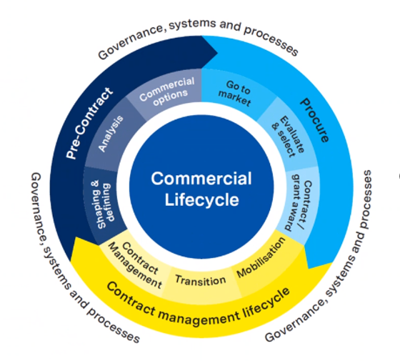By focusing on outcomes or outputs rather than inputs to encourage innovation and value-added activities by suppliers and bidders.
* Conducting effective preliminary market engagement to inform the specification
* Structuring tenders to make them accessible to smaller businesses
* Through social value considerations as scored evaluation criteria in our tenders and ensuring value added commitments are delivered throughout the contract’s life
* Considering whole life cost in the evaluation of tenders
* Including sustainable and ethical supply chain requirements in our contracts
* Contract management and user feedback from the current tender informs the specification for the replacement tender.

1. Strategic Goals and How We Will Achieve Them

We will deliver our Mission through our strategic goals, which are to:

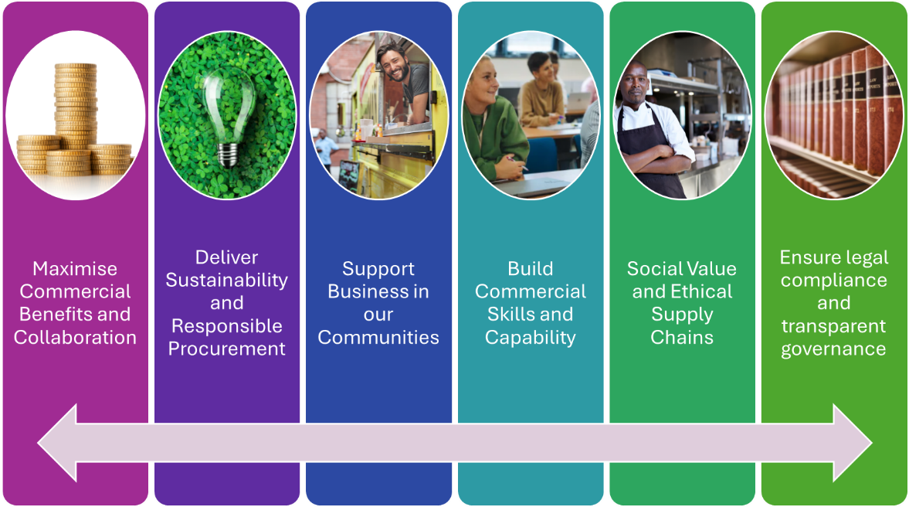

**Maximise Commercial Benefits and Collaboration**

* Support policing by maximising commercial benefits through innovative solutions, commercial expertise, cashable savings, negotiation, cost avoidance and collaboration to support investment in frontline activities.
* Procure and support the delivery of cost effective and quality goods and services to support the policing priorities. We will engage with the market and drive improvement by challenging the status quo and encourage new ways of working by focussing on outcomes rather than inputs and outputs.
* Collaborate and connect with the national procurement agenda for policing, engage with Bluelight Commercial, other police forces and the wider public sector, especially in Wales, to facilitate collaborative procurement. We will share good practice with other forces and the wider public sector.
* Effectively manage contracts to ensure that requirements and added value commitments are delivered. We will manage the impact of price and market pressures.
* Continue to develop working relationships with key stakeholders and to nurture supplier relationship management, delivering effective contract management performance.
* We will publish an annual Collaborative Procurement Report.

**Build Commercial Skills and Capability**

* Build commercial skills and capability in procurement with a focus on growing our own talent. We will make best use of training and tools offered by Bluelight Commercial, Cabinet Office, Welsh Government, local legal firms and CIPS.
* Continue to develop eProcurement and embrace digital technology in procurement.
* Strengthen procurement leadership through further development of commercial awareness skills and sharing of best practice.
* Our procurement staff receive comprehensive training to keep abreast of new procurement legislation and best practice.
* We will upskill officers and staff who are involved in procurement processes to enable them to fulfil their role in a compliant and effective manner.
* We will regularly review and update procurement documentation, processes, systems and controls to ensure they reflect legislative changes.
* JCPS has recruited two procurement apprentices and a procurement graduate placement will commence from September 2025 for two years, with a view to retaining the individual within the team. The three forces have supported team members in achieving CIPS (Chartered Institute of Procurement & Supply) through the Welsh Government Corporate Award Programme. In addition to developing current team members, the addition of a graduate trainee will contribute to developing talent internally.

**Support Business in our Communities**

* Our procurement activity will demonstrate regard for small and medium enterprises (SMEs) and local businesses, creating opportunities for quality employment and skills development, improving innovation and supply chain resilience, tackling climate change and reducing waste. Many national priorities are delivered through local procurement activity and we recognise that SMEs are the backbone of our economy.
* We have updated our internal policies and procedures to align with the Procurement Act requirements and to provide more flexibility to offer opportunities to small and local businesses in relation to below threshold procurements.
* We will structure our procurements, consider lotting our requirements, ensure we do not include onerous or disproportionate clauses in our tenders and reduce barriers to allow SMEs, VCSEs and start-ups to compete in public procurement.
* Drive continuous improvement and efficiencies by working with our supply chain. We will challenge existing arrangements and delivery models.
* We will work to increase our awareness of potential local businesses supplying goods and services to consider them for request for quotation opportunities.
* We will encourage suppliers to register on the Central Digital platform to find out about opportunities they may wish to bid for, as well as details on contracts let and to share their commonly used information as part of the procurement.

**Deliver Sustainability and Responsible Procurement**

There is an increasing recognition of the key role procurement can play in tackling some of the greatest challenges facing our communities and the wider world.

As referenced earlier, the three forces have adopted the Bluelight Commercial Responsible Procurement Policy which focusses on the three main themes of **People, Planet** and **Purse** and we have set our long-term ambitions for decarbonisation and sustainability across the service.

* We will demonstrate our commitment to ethical procurement and supply practices, working with others to drive environmental, ethical and sustainable procurement.
* We will use our contracts to reduce carbon emissions, consider whole life cost, encourage fair working and ethical practices and effectively manage contracts to ensure that added value commitments are delivered.
* A logo for a company

  Description automatically generatedThe four Welsh forces have committed to a Sustainability and Decarbonisation Strategy to drive carbon reduction activity. We are working to reduce our own carbon footprint. Scope 3 emissions are direct emissions as a consequence of our policing activities and can be influenced through our approach to the procurement of goods and services and decarbonisation of the supply chain.
* We support the Welsh Government declaration of a climate emergency for Wales and acknowledge that we have an important role to play to contribute towards the ambition for the public sector in Wales to become carbon neutral by 2030.
* A logo with text on it

  Description automatically generatedThe Greener Gwent Group and the South Wales Blue Dot Board track and report progress at a local level and inform annual improvement plans to ensure we are on course and highlight priorities for the year ahead. Dyfed Powys Sustainability Steering Group has been established to report departmental highlights and discuss strategic direction in relation to Sustainability and Decarbonisation.  All three groups feed into the All-Wales Sustainability and Decarbonisation Committee, with representation from the four Welsh Forces.

**Social Value**

* The Procurement Act 2023 brings a change of emphasis to tender award based on Most Advantageous Tender (MAT). Whilst including social, economic and environmental social value in our contracts is not a new practice for us, the change provides a clearer focus on social value. Contract award will be determined on the optimum price and quality ratio, including social value where applicable. Award criteria will take into account the broader view of what can be achieved through the contract, such as relevant social and environmental outcomes.
* We will ensure social value commitments by suppliers are targeted at the delivery of policing priorities.
* We have created a central Social Value Register to capture the social value delivered by our supply chain. We are working with areas of the Force to understand where suppliers can provide specific social value to support our projects, our communities and partners.

**Ethical Supply Chains**

The southern Wales Forces are leading the way in policing to provide assurance of ethical practice and tackling modern slavery in our supply chains. The four Welsh forces signed the Welsh Government Ethical Employment in Supply Chains [Code of Practice](https://gov.wales/docs/dpsp/publications/valuewales/170502-ethical-en.pdf) in 2017. The Code aims to support the development of more ethical supply chains delivering contracts for the Welsh Public sector. In signing up to the Code, organisations agree to comply with 12 commitments. We will continue to issue an annual Modern Slavery Statement to demonstrate our progress.

We have reached our target to assess the top 100 suppliers across South Wales and Gwent by 2025, based on risk due to industry type, nature of the workforce such as reliance on low skilled or low paid workforce, seasonal workers, dangerous work, manufacturing location, the presence of complex supply chains or the level of our spend.

We will use a tool provided by Bluelight Commercial, to expand the assessment of tackling modern slavery and ethical business practice to include wider social value considerations, climate emergency, equality, diversity and inclusion and social and community contribution. We will work with suppliers to encourage them to improve their rating, using the initial assessment as a baseline.

Ensure legal compliance and transparent governance

The Forces’ procurement principles are designed to ensure that expenditure on goods, services and works:

* delivers best value for money
* maximises public benefit
* secures the most advantageous tender
* maintains the highest standards of integrity
* provides transparency – sharing information for the purpose of allowing suppliers and others to understand procurement and policy decisions
* complies with the Procurement Act and related procurement legislation as well as best practice
* complies with the Commissioner’s Manual of Governance
* has regard to the National Procurement Policy Statement objectives

Strategic direction is provided to the Joint Commercial and Procurement Services (JCPS) unit by the JCPS Board. The Board is comprised of representatives of each of the two legal entities. The Board is chaired by the Chief Finance Officer (CC) for South Wales and will agree and monitor delivery of the annual local delivery plan, ensuring value for money, and monitoring performance through agreed key performance indicators and performance objectives for the JCPS. The Board meets to coincide with the timing of the Finance Joint Assurance Group which is attended by the Chief Finance Officers for the 4 Welsh forces. This ensures Dyfed-Powys input into the strategic direction and agreed objectives for Procurement.

1. Key Enablers

Six key enablers are critical to the delivery of this Strategy.

We will:

**Collaboration**

The Forces have actively engaged in collaboration for over a decade. Establishing a two Force joint procurement unit formalised our approach and we are in a strong position to apply lessons learned from our experience of collaborating with a range of organisations.

Procurement collaboration can take many forms. In many cases, letting a single contract brings efficiency through a single process. The potential benefits are:

* better use of a limited procurement resource.
* lower costs for the market - suppliers only need to draft a tender bid once.
* economies of scale - increased purchasing power should deliver greater efficiency through common requirements and higher volumes.
* a more attractive opportunity may increase interest and therefore provide better competition.
* increased opportunity for standardisation e.g. of equipment, which may reduce training requirements and improve interoperability across Forces
* potential for improved supplier relationships and stronger contract management where there is a common supplier.
* improved cost savings through collective bargaining power.

However, a collaborative procurement exercise involves more parties, the total value is increased and therefore risk increases. There are instances where for good reason, the specification for each organisation differs and the tender is structured into separate lots. This may result in awarding lots to separate contractors and thus the process delivers very few efficiencies. The principal benefit is a saving in the procurement resource but our experience is that this rarely outweighs the added complexity of a collaborative procurement. A local procurement may deliver a better outcome and more efficient process, in addition to providing improved opportunities for local business and SMEs.

Collaboration can mean that suppliers are locked out for years if they do not win a place on a framework or win some business outright. Therefore, consideration should be given to the pros and cons of a collaboration on a case-by-case basis.

We recognise that consideration should be given at the outset of a procurement as to which party is best placed to lead the collaborative exercise, understand whether a party has unique requirements, will each party seek their own legal advice, are there real opportunities for standardisation and genuine efficiencies of a collaboration?

We can demonstrate excellent examples of successful complex collaborative procurements, delivered on time with a good outcome, despite a high number of stakeholders involved, a high value and increased risk for the procurement. Experience shows that in this case, the strategy should consider a robust project board structure, attended by decision makers from each organisation and led by a senior stakeholder. The Board is able to hold all parties to account and resolve difficulties effectively, leading to a positive outcome for all.

1. Measuring and Monitoring Performance

* Our target of 66% for collaborative procurement arrangements as a percentage of spend on goods, services and work remains as a benchmark. We have consistently achieved this target year on year.
* The Home Office has set up the Police Efficiency and Collaboration Programme (PECP) in collaboration with the sector to enable savings through a range of efficiencies. The programme is accountable for realising hundreds of millions of pounds in cashable savings and thousands of officer hours facilitated by business led change and long-term sustainability and performance optimisation. Bluelight Commercial is the key PECP delivery partner for the commercial efficiencies workstreams. Initial activities include Energy, ICT Hardware, ICT Software, Fleet and Fuel. Each workstream will identify, drive, review and monitor commercial savings and enable services benefits across all forces. As a region, the Welsh forces will report against targets such as local savings and other measures identified to maximise benefits and efficiencies.
* Efficiency and Cost Savings – each Chief Financial Officer sets an annual cost savings target for Procurement. The Home Office monitors cashable and cost avoidance savings by each Force towards an annual target. We will continue to report against the targets on a monthly basis. The measurement of notional savings demonstrates the benefits of a competitive process. The initiatives outlined in this strategy such as effective procurement processes, collaboration, e-procurement and early engagement with stakeholders will contribute to both efficiency and cost savings.
* We will capture and record the social value work we have built into our contracts and bidders have committed to through a social value register and seek to develop this through a continuous improvement approach.
* We will engage with Bluelight Commercial to continue to improve commercial capability within policing, maximising benefits to the front-line and avoiding unnecessary duplication.
* Make use of and support collaborative sourcing, including Welsh Government Commercial Delivery team opportunities where it represents value to the Forces.
* Analysis of comprehensive and accurate expenditure information in order to facilitate timely and objective decisions on future procurement. This may include benchmarking, monitoring expenditure as an indicator of effective demand management and monitoring the number and value of direct awards.
* Training and Information - We will ensure procurement staff develop their knowledge and skills through continuous professional development and keep abreast of developments in procurement best practice as detailed above in Build Commercial Skills and Capability
* Compliance with relevant policies and procedures and robust risk management with particular regard to all statutory requirements.
* Regular review of local risk registers and management of risks
* Support the rationalisation of Technology Contracts for both Gwent and South Wales Police.