ICT Digital
Annual Report
2023/24

1. | PURPOSE AND RECOMMENDATION
1.1 | The purpose of this report is to present the annual report for ICT and Digital Services.
1.2 | There are no recommendations made requiring a decision.
2. | INTRODUCTION & BACKGROUND
2.1 | This report discusses the arrangements with and projects undertaken by:  - Shared Services Resource Service (SRS)  - Digital Division (DSD)  - Devices Team.
2.2 | Since July 2011, the Information Communication Technology (ICT) service for Gwent Police has been delivered through a collaborative service model with Torfaen County Borough Council and Monmouthshire County Council. During 2016 and 2017 additional members, Blaenau Gwent County Borough Council and Newport City Council, were added to the partnership. The service is known as the SRS.
2.3 | In January 2018, the DSD was established as the digital delivery model in collaboration with South Wales Police and manages the delivery of shared operational and business systems across the two forces.  In 2023, SRS merged the previously separate DSD, corporate and education technical resources into single teams covering different technological strands. For Gwent Police, this meant that resources that would previously have been aligned to DSD projects are now available to support other Gwent Police projects.
2.4 | The force Devices Team was established in 2020/21 to provide a core team to manage digital devices that officers and staff use. They manage inventory, stock control, updates and training.
2.5 | The ICT service is a key enabler to the development and implementation of new processes to support service improvement.
3. | ISSUES FOR CONSIDERATION
3.1 | SRS Strategy  The SRS Strategy (Annex 1 refers) details the approach agreed for the period 2020 to 2026 and was produced following consultation and engagement with the partners. Progress with the implementation of the strategy is monitored through the SRS Strategic Board which meets quarterly.  The strategic direction for the SRS is to focus on consolidating the needs of multiple public sector organisations and brokering shared solutions as a response to those needs. Its strategic aims are;  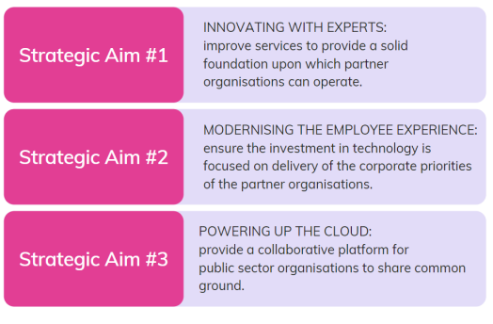  The strategy enables greater collaboration across local authority partners and supports the digital strategy which is delivered in partnership with South Wales Police (SWP) through the DSD. This has enabled the implementation of technologies that improve the effectiveness of front-line policing delivery and support functions.
3.2 | DSD Digital Strategy  The focus of the Digital Services Strategy 2018-2025 (Annex 2 refers) is to provide effective services for around 8,000 officers and staff of Gwent and South Wales Police and around two million members of the public across both the Gwent Police and South Wales Police regions. As per the strategy, the joint digital vision can be illustrated as follows;  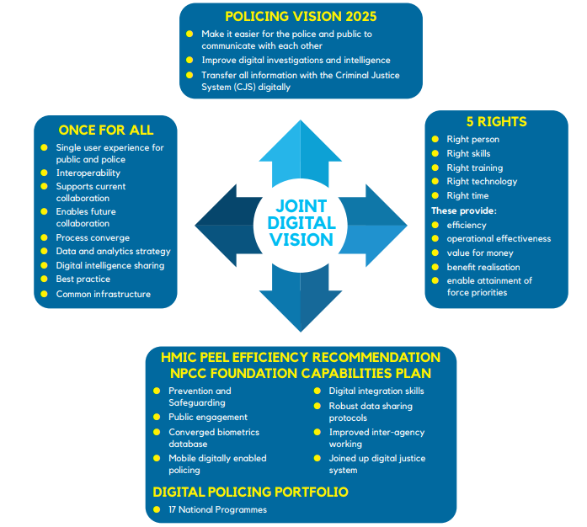  The strategy has been designed to enable the following:  - An annual business plan for Digital Policing to meet the National Policing Digital Strategy.  - Ensure key pieces of work become projects with owners appointed for work so that there is clear accountability for delivery.  - Communication of digital services to a wider audience and to key stakeholders.  This strategy is owned by the joint Gwent Police and South Wales Police Chief Officer’s Digital Services Gold Board and delivered through the Digital Services Division team.  The SRS and DSD strategies provided the framework on which the ICT work plan was established for 2023/24 which has driven the delivery of services.  The current Digital Services Strategy sets out the vision and priorities for DSD between 2018 and 2025, with the next iteration of this strategy currently in draft outlining the vision, priorities and plan for the next five to ten years.  The strategy is delivered through the Digital Services Division, working closely with both South Wales Police ICT and SRS. The Digital Services Division has an establishment of 140 officers and staff from Gwent and South Wales Police, comprising of four delivery branches that include Business Support, Operational Systems, Business Systems and Research/Development and Transformation.
3.3 | Deliverables  During the past year, the technology services delivered improvements in performance and customer satisfaction. In addition, a structured governance model operates through the force ICT Delivery Board that enables all ICT requirements to be assessed, evaluated and prioritised. Structured reporting of progress is reported to the force’s Scrutiny Executive Board.
3.4 | The SRS and DSD activities for Gwent Police are prioritised and monitored through the ICT Delivery Board which has overseen the delivery of the force ongoing projects along with the core services already established. The following projects have been delivered in the year.  Technology projects progressed in 2023/24 were:  - Relocation of all Gwent Police ICT services from the SRS’s Data Hall 3 in Blaenavon to Gwent Police Headquarters or Fairwater Police Station (Cardiff) – completed.  - De-commissioning of ICT services located in the old police Headquarters building – completed.  - DIMETRA Dispatch Communications System (DCS) implementation – completed.  - Disaster recovery (phase 2) - ongoing.  - IT infrastructure planning and installation for relocation of Fleet Workshop – completed.  - IT infrastructure planning for Abergavenny Police Station – completed.  - Reconfiguration of yellow phones to new HQ control room – completed.  - Integration of audio-visual equipment at new Headquarters - completed.  - Integration of local authority CCTV images to the new HQ Control Room - completed.  - SharePoint upgrade for Microsoft 365 compatibility - completed.  - Implementation of Voice Analytics functionality – completed.  - Implementation of the Law Enforcement Community Network – competed.  - National Law Enforcement Data Services (NLEDS):  - Connectivity/Integration with National Identity and Access Management (NIAM) system - established  - Property Module – completed  - Drivers Module – completed  - Vehicles Module – completed.  - CoreVet version 5 upgrade - completed.  - Integration of new patient management system for Occupational Health Services – completed.  - Migrated the National Monitoring Centre (NMC) system from QRadar to Sentinel – completed.  Digital Services Division work progressed in 2023/24 included:  - Implementing the Control Room Systems programme.  - National Enabling Programme (NEP), including the implementation of Microsoft 365.  - iR3 Human and Vehicle Telematics.  - Digital Evidence Management System (DEMS).  - Printing from Niche to support the Niche property project.  - Rollout of new body worn video for police officers, including live streaming functionality.  - NICE Data Migrations.  - JOINS 2.  - Issue of new mobile phones to officers and staff.  - National Law Enforcement Data Services (NLEDS)  - Connectivity/Integration with National Identity and Access Management (NIAM) system - established  - Property Module – completed  - Drivers Module - completed  - Vehicles Module – completed.  - ESN coverage testing.  - Digital Case File – UK lead for development and testing in advance of the 2026 roll out.  - Commenced Process Efficiency Project (PEP) – to develop robotic process automation into policing.  - Facial Recognition Technology, including:  - Live Facial Recognition (LFR) (South Wales police only)  - Retrospective Facial Recognition implemented in both forces.  - Operator Initiated Facial Recognition – first UK force to develop the technology and aiming to go live in 2024.  - Missing persons action logs in Niche.  - Vulnerability App developed and implemented.  - Golden Hour App developed.  - Property App implemented within Gwent Police.  - Electronic Incident on Duty form developed and implemented.  Devices Team work progressed in 2023/24 included:  - Laptop replacement programme in progress 500 to be replaced in 2024/25, 250 of these are in the process of build and allocation.  - Replacement of docking stations/screens across the estate – priority to operational officers.  - Induction sessions for new starters Police Officers and staff supported.  - Station audits undertaken and programme in place for 2024/25 to ensure kit and equipment is audited and updated.
3.5 | SRS Service Levels  Requests for day-to-day support or services are raised by staff in the force in two ways:  - Telephone calls to the Service Desk  - Via self-service portal or by phone to the Service Desk  The total number of calls raised is recorded alongside customer satisfaction levels and percentage of calls closed at First Point of Contact (FPOC). Figures for the last two years are shown below:  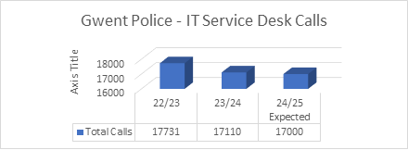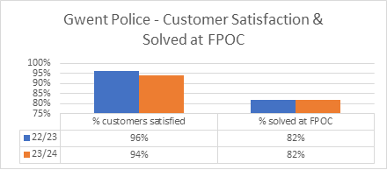  The number of calls resolved at first point of contact has consistently exceeded the 70% target throughout 2023/24 with an average percentage of calls resolved at first point of contact of 82%.
3.6 | Audit  The SRS is subject to internal audit scrutiny. The findings are reported to the force’s Joint Audit Committee where findings are considered and if required action plans developed to provide improvements to service delivery and controls assurance.  In addition, the SRS implements the Information Security requirements as identified by the Force Information Security Officer.  The reports to the Joint Audit Committee provides scrutiny and has enabled a significant improvement in the prioritisation of this aspect of service delivery.  Internal Audit – Summary of Findings - 2023/24  Active Directory Substantial Assurance  Firewall Full Assurance  Identity and Access Management Full Assurance  HALO Full Assurance  SolarWinds Substantial Assurance  EdTech Full Assurance, although risk for local authorities raised at Finance & Governance Board, June 2023  Application Support Full Assurance  CCTV Control Centre Full Assurance  O365 Full Assurance  Change Management Full Assurance  Telephony Full Assurance  IT Governance Substantial Assurance
4. | COLLABORATION
4.1 | The SRS staff are employed by Torfaen CBC and provide services to the five collaborative partners.
4.2 | The DSD is staffed by both officers and staff of Gwent Police and South Wales Police.
4.3  4.4 | The Devices Team is staffed by Gwent Police staff.  These teams work together to ensure a co-ordinated approach to programme implementation.
5. | NEXT STEPS
5.1 | The ICT priorities for Gwent Police in 2024/25 are:  - Software upgrade to the existing Integrated Command & Control System (ICCS).  - Upgrade to SmartSTORM.  - Upgrade to Voice Telephony to support extended use of current Control Room systems.  - Implementation of the new IT network between Gwent Police and South Wales Police to replace the current Citrix Access Gateway (JOINS2).  - Continued development of Microsoft 365 services including Teams Telephony and automated applications.  - Disaster Recovery Services – review and testing.  - Upgrade to the self-serve ICT reporting system.  - Commence the roll-out of the new Access Control System with SWP.  - Development of Azure SQL environment.  - Implementation and support for IT services in the new police station in Abergavenny.  - Mobile phone refresh programme.  - IT support for the Estates Team to meet the Estates Strategy.  - Implementation of IT services for the Joint Scientific Investigation Unit (JSIU) supporting accreditation.  - Supporting efficiency improvements through the use of the M365 Power Platform.  Digital Services Division  - Completing remedial tasks due to the force relocating all ICT services from the SRS Data Hall 3 in Blaenavon.  - Design and implementation of a collaborative Command and Control System (Saab SAFE Cymru).  - All staff laptops migrated to use Microsoft Always on VPN. Currently using Netmotion.  - Telematics Schedule B implementation, including Briefing Module and Mobile Application.  - Implementation of Robotic Process Automation (RPA) under the Process Efficiency Project (PEP).  - Implementation of Text Redaction software.  - Continued development of functionality within Body Worn Video, including remote activation.  - Continue transition to NLEDS.  - Implementation of Operator Initiated Facial Recognition (OIFR).  - AI and Automation ethics and standards forum to develop our joint approach to robotics and artificial intelligence.  - Cloud assessments and considerations for existing systems (i.e. Business World and GRS).  - Audio and Video Redaction Management – working with the Home Office to pilot.  - Joint Data Analytics Project.  - Introducing a centralised M365 team to enhance our ability to maximise use of M365 and products.  - Home Office Biometrics (Electronic Fingerprint solution).  - Migrate staff and officers’ mobiles phones to use Microsoft Tunnel as the VPN. Currently using Netmotion.  - Niche Property Printing.  - RBAC - Rolled Based Access Controls.  - Windows 11.  - FCS migration of 999 service to Session Initiate Protocol (SIP).  - Data Migration to SharePoint Online.  - Body Worn Video Phase 2.
5.2 | Preparedness  There are also a range of additional projects required by the force through the Change Programme and estate transition.
6. | FINANCIAL CONSIDERATIONS
6.1 | The below table shows the budget and actual values for the financial year 2023/24:  Section Budget Expenditure Variance  £ £ £  SRS Collaboration (2M300) 4,725,273 4,871,957 -146,684  Airwave (2M302) 721,543 714,435 7,108  Devolved Force Budgets (2M301 less National ICT Services) 1,686,556 1,500,029 186,527  National ICT Services (2M301) 1,333,989 1,269,478 64,511  DSD (6M300) 2,020,011 1,832,832 187,179  Total 10,487,372 10,188,731 298,641
6.2 | The financial performance shows an underspend of £298,641. The variances across the technology budgets have been addressed through the budget setting process.
6.3 | The budget requirements were reviewed and reset at budget setting for 2024/25.
7. | BUSINESS BENEFITS
Given the nature and investment of the projects undertaken by DSD, business benefits are identified of both cashable and non-cashable natures. A benefits input is covered across the entire project lifecycle from baselining where estimations are made, all the way to project closure where the benefits are analysed whether they continue to deliver. Within the 23/24 financial year at Gwent Police, it’s estimated that in the region of £80k of cashable savings were realised as well as £3.3m in non-cashable efficiency savings.

Much of the non-cashable savings came from the Digital Evidence Management board that delivered NICE Investigate as well as the new Reveal K7 body cameras. Both systems, particularly NICE, have offered the force substantial savings to officers in travel time to affected businesses/properties and stations respectively. The Facial Recognition Technology board also delivered a high number of savings through the retrospective element. Having this technology has prevented officers in spending significant time trying to identify those who the system has automatically found.

Regarding cashable savings, the majority of these have been seen within the National Enabling Programme (NEP) through the disposal of the SimplyDo platform as well as a reduction in Egress licences. Using Microsoft replacement solutions, Gwent Police have been able to save money.

8. | GOVERNANCE
8.1 | The governance arrangements for the service include the following:  - The SRS Strategic Board meets quarterly. This includes the Police and Crime Commissioner, along with the Chief Constable. The board determines strategic direction on the delivery of services for the collaboration.  - The SRS Governance & Finance Board meets quarterly to consider governance issues such as audit findings, financial performance and personnel issues.  - The SRS Business & Collaboration Board meets monthly to consider service and system alignment opportunities.  - The ICT Delivery Group is a force-based forum that meets monthly to set priorities, monitor progress and to take account of operational, financial and service benefits.  - The DSD governance structure reports quarterly to Chief Officers via the DSD Gold Board.  - The Information Security Leadership Board, attended by the five SRS partners, SRS staff and the Force/Security Information Security Officer, meets quarterly and monitors progress with Information Security.
9. | PERSONNEL CONSIDERATIONS
9.1 | The area of technology has a dynamic employment market and the SRS has experienced challenges in retention of staff which has been considered by the SRS Strategic Board.
10. | LEGAL IMPLICATIONS
10.1 | There are no legal considerations arising from this report.
11. | EQUALITIES & HUMAN RIGHTS CONSIDERATIONS
11.1 | This report has been considered against the general duty to promote equality, as stipulated under the Joint Strategic Equality Plan and has been assessed not to discriminate against any group.
11.2 | In preparing this report, consideration has been given to requirements of the Articles contained in the European Convention on Human Rights and the Human Rights Act 1998.
12. | RISK
12.1 | Risks are managed through the individual estate programme and reported through the force governance structures.  FORCE SCRUTINY  This report has been scrutinised and approved at Force Chief Officer team Board by Chief Constable Mark Hobrough.  There are no actions or amendments to raise.
13. | PUBLIC INTEREST
13.1 | In producing this report, has consideration been given to ‘public confidence’? Yes
13.2 | Are the contents of this report, observations and appendices necessary and suitable for the public domain? Yes
13.3 | If you consider this report to be exempt from the public domain, please state the reasons: not applicable
13.4 | Media, Stakeholder and Community Impacts: None
14. | REPORT AUTHOR
14.1 | Zack Shelley; Staff Officer to Assistant Chief Constable – Organisation
15. | LEAD CHIEF OFFICER
15.1 | Nicholas McLain; Assistant Chief Constable – Organisation
16. | ANNEXES
16.1 | Annex 1: SRS Strategy 2020-2026  Annex 2: DSD Strategy
17. | GOVERNANCE BOARD AND CHIEF OFFICER APPROVAL
17.1 | I confirm this report has been discussed and approved at a formal Chief Officers’ meeting.  Meeting chaired by: CC Mark Hobrough  Meeting date: 15/08/2024  I confirm this report is suitable for the public domain.
Signature:
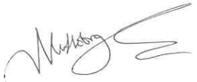
Date: 21/08/2024

