Office of Police and Crime Commissioner

Office of Chief Constable

Victim Code of Practice (Key Entitlements) Compliance

Annual Report 2022 / 2023

1.0 RECOMMENDATION
1.1 To continue to monitor and report compliance with the Victim’s Code of Practice (VCOP), utilising performance and compliance data obtained through the VCOP model for 23/24.
  - To monitor the implementation and impact of the victim/witness action tracker

INTRODUCTION AND BACKGROUND
  - The Victims Code of Practice 2020 (VCOP) sets out the minimum level of service a victim should receive throughout their criminal justice journey from Policing, CPS, HMCTS and Probation.
  - In September 2018, the UK Government published a Victim Strategy, detailing its vision for how victims should be supported during their journey through the criminal justice system. The strategy included a commitment to ‘hold agencies to account for compliance with the Victim’s Code through improved reporting, monitoring and transparency’. To fulfil this commitment, it was agreed that Police and Crime Commissioners would oversee the monitoring of criminal justice agencies compliance with the Victim’s Code of Practice (the Code) and report this to the Ministry of Justice (MoJ).
The MoJ guidance stated a process whereby 30 cases are dip sampled per quarter against the ‘5 key entitlements’ within the Code. This process was completed for the financial year 2019 –/20. However, the MoJ put this process on hold for the year 2020 –/21 in response to feedback that questioned the value and validity of the results as they were taken from a very small sample.
The force extended this process through 2020/21 to ensure compliance was captured while we continued to work with the MOJ around the new metrics.
In 2022-23 the innovation of the Victim Care Unit enabled the force to capture mass data for some of the rights under the Code. This, along with taking part in the OPCC DIP sampling process which collaborated with our CPS, HMCTS and Probation partners captured the victim journey end to end. However, the age of some cases being scrutinised through this method didn’t provide findings that could utilise to make change; some of the cases being DIP sampled were from 2018/19 due to the time taken to work their way through the criminal justice system in its entirety.
The Victim and Prisoners Bill has been introduced into Parliament with Royal Assent expected in 2024. The Bill aims to enshrine the principles of the Victims Code in law and increase transparency and oversight throughout the criminal justice process.
In preparation the VCU have created a compliance model for 23-24 that will enable us to capture and scrutinise data that can lead meaningful change.
This work remains a national priority within the victim and witness workstreams and we continue to collaborate with the Ministry of Justice around how all agencies will report compliance, with the implementation of collecting the metrics planned for 2025.

2.4 This report details the findings from both mass data collected from the Victim Care Unit, and a DIP sample to capture post charge compliance. It therefore does not capture compliance for crime outside of the Victim Care Unit remit.

ISSUES FOR CONSIDERATION
3.1 All of the data within this report has been manually extracted and collated by the Head of Victims Services as there is currently no mechanism in place through the Analyst Team. While this is under review in readiness for implementation of the Victim and Prisoners bill; without Victim Services managing this area of work and utilising its own resource the organisation wouldn’t have had any data to report on.

COMPLIANCE
  - Right One – To be able to understand and be understood
The right to be given the option to converse in Welsh.
One of the entitlements under right one, is to be given the option to speak in the language of preference, in Wales this relates to being offered to converse in Welsh. The the below data is collated from the Victim Care Unit, however it’s worth noting the offer of contact in Welsh should be made by all in contact with victims of crime.

*April 2022 – March 2023

  - Right Two – to have the details of the crime recorded without delay
The right to have the crime recorded within 24 hours.
While this right sits under the code it is also heavily scrutinised through the HMIC Victim Services Assessment work.

  - Right Three – To be provided with information when reporting the crime.
The right to receive written confirmation of allegation, occurrence number and contact details.
For standard cases all victims should be sent a text and/or letter/email with all of the above information. Enhanced cases where there is risk (DA/SV) can only have this sent with explicit consent from the victim. Any victim of crime can opt out of this information.

*April 2022 – March 2023
The right to be provided with information on their rights as a victim.
Along with the Victim of Crime letter the VCU also sends a victim information pack which includes detail on VCOP and support services in this area. The pack also details what they can expect as a victim of crime with further detail around restorative justice and the journey through criminal justice.

  - Right 4 – To be referred to services that support victims and have services tailored to your needs

The right to be assessed for a standard or enhanced service
When a crime is recorded with an aggrieved attached, a victim needs assessment needs to establish eligibility for a stand or enhance service. The below is captured through the VSA data following the HMIC PEEL inspection; it’s worth noting this data compares completion of the ICP01 against all crime recorded and not just those occurrences with an aggrieved so compliance is higher than illustrated below. A request has been made with the analytical team to consider a function to only capture compliance against crimes with a victim.
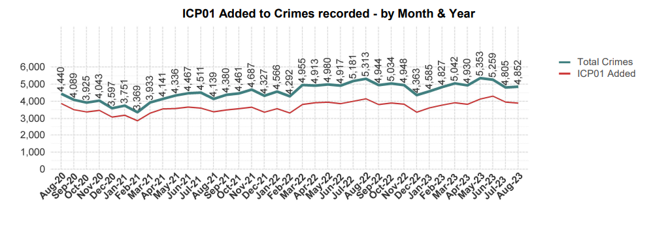
The right to be referred to a support service within 2 working days
All volume crime is allocated to the Victim Care Unit within 1 working day. Every 24 working hours a report is run from NICHE pulling all crimes with an aggrieved attached and, is further assessed to be ‘standard or enhanced’ and allocated appropriately to a Victim Care Officer.

*April 2022 – March 2023
The right to have a needs assessment and be referred for tailored support
When successful contact is made with a victim by the unit, a full and thorough needs assessment is completed to capture all elements of their lives that may impact their engagement in a criminal justice process and achieve their best evidence. This enables a robust understanding of risk/need and the ability to implement a tailored support plan. While 100% would be the ideal compliance, unfortunately there will always be victims who refuse to speak to us.

*April 2022 – March 2023

The right to have a needs assessment to attend court
Once a case has a first hearing, all victims and witnesses in the case are referred into the Witness Care Unit, who complete a needs assessment around the court process to ensure victims have all the help and information they need to achieve their best evidence.
The below shows a decline in compliance throughout Q3 however this was identified and actions put in place to improve during Q4.

*April 2022 – March 2023
  - Right 5 – To be given information on the Criminal Injuries Compensation Scheme
Victims are provided with information on CICA within the information packs sent at the beginning of their criminal justice journey. At this time we do not have direct conversations at the beginning around CICA as the defence can use this against victims in court. However, we do discuss it in more detail at the end of the process.

*April 2022 – March 2023
  - Right 6 – To be provided with information about the investigation

The right to be provided with key stage updates
While it is the Officer in Charge’s responsibility to provide key stage updates, the Victim Care Officer will sometimes provide these to ensure compliance and that the victim has the information they need. While the below is pleasing to see, it’s worth noting this should be done by officers and doesn’t illustrate compliance outside of the VCU.

*April 2022 – March 2023
The right to agree a schedule and be provided with regular updates
All victims who are referred into the VCU are given the opportunity to have regular updates. Should they wish to engage, a contact schedule will be arranged using the VCM by the VCO which should be adhered to throughout the criminal justice journey. Victims can opt out of this at any time.

*April 2022 – March 2023

  - Right 7 - To make a victim personal statement
All victims should be offered the opportunity to make a VPS at the time of taking a witness statement. It’s recognised that this wouldn’t always be the most appropriate time, but the offer should be continuously made with emphasis on this being explored again before a case file is submitted.
In Q1 and 4 we focused on enhanced cases and in Q2 and Q3 we concentrated the DIP sample on volume crime. What the below tells us is that for enhanced cases compliance is excellent but with standard cases the offer isn’t made, or if it is it isn’t documented appropriately.
*April 2022 – March 2023
While the offer to make a VPS is important; when the victim agrees it is vital for the statement to be taken.
Below shows inconsistency across the board and although an improving picture; with such a high percentage declining, it could indicate the offer isn’t meaningful and doesn’t fully explain the benefits of a VPS and the impact it can have on sentencing. While it’s please to see an increase in those wanting a to make a VPS, the increase in this not being completed is disappointing.

*April 2022 – March 2023

  - Right 8 - To be given information about the trial, process and your role as a witness
The right to be provided with key stage updates throughout the court process

Witness Care Officers are responsible for providing key stage updates around the court process post charge. 100% compliance for the year is outstanding.

*April 2022 – March 2023

  - Right 9 - To be provided with a final court update
At the end of the court process the Witness Care Unit are responsible for ensuring the victim is aware of the outcome. Unfortunately there has been a decline in compliance in this area due to the unit being understaffed.

*April 2022 – March 2023

NEXT STEPS
  - To await the finalised methodology and metrics from the MOJ following royal assent of the Victims and Prisoners Bill.
  - To continue to develop the Victim Services model to assist Gwent Police in providing an excellent service to victims of crime, ensuring they receive their entitlements under the Code.
  - To utilise the new VCOP model for 23/34 to better understand area’s for improvement and take action before the implementation of reporting nationally.
  - To use performance data to inform future training, communication and improvements across the organisation.

FINANCIAL CONSIDERATIONS
  - There are no financial considerations at this stage.

PERSONNEL CONSIDERATIONS
  - No personnel considerations at this stage.

LEGAL IMPLICATIONS
  - There are no legal implications at this stage.

EQUALITIES AND HUMAN CONSIDERATIONS
  - In preparing this report, consideration has been given to requirements of the Articles contained in the European Convention on Human Rights and the Human Rights Act 1998.

RISK
9.1 None.

PUBLIC INTEREST
  - There are no public interest matters.

REPORT AUTHOR
  - Elizabeth Lowther – Head of Victim Services.

LEAD CHIEF OFFICER
  - A/DCC Mark Hobrough

ANNEXES
  - None.
- GOVERNANCE BOARD AND CHIEF OFFICER APPROVAL

This report has been presented to the following meeting:
Victims Meeting

Meeting date:
27.10.2023

Actions and amendments arising from meeting:
N/A

This report has been presented to the following oversight board:
Scrutiny Executive Board

Meeting chaired by:
A/DCC Mark Hobrough

Meeting date:
07.11.2023

Actions and amendments arising from meeting:
N/A

I confirm this report has been discussed and approved at a formal Chief Officers’ meeting.

Meeting chaired by:
CC Pam Kelly

Meeting date:
14.11.2023

I confirm this report is suitable for the public domain.

Signature: Date: 14.11.2023

