Gwent Police Estate Strategy

Introduction
The Police and Crime Commissioner for Gwent (PCC) and the Chief Constable are committed to delivering effective inclusive policing services in the modern age, utilising new technology, community co-production and up-to-date working practices to safeguard and reassure the public.

As the nature of policing is changing, the Office of the Police and Crime Commissioner (OPCC) and Gwent Police needs to be well placed to respond on a national as well as a local level, meeting the priorities set out in the Police and Crime Plan, responsibilities within the national Strategic Policing Requirement and commitments under the Equality Acts 2010 (including the Public Service Equality Duty (PSED)) . In addition, in support of the Wellbeing of Future Generations Act, the sustainability of the estate will be a key success.

To support service delivery, the OPCC and Gwent Police require an estate that is fit for purpose. This strategy seeks to provide an assessment of the current estate against the policing and public requirements. It outlines the future vision for the estate and sets the objectives and direction for its future.

Vision for Policing
The National Policing Vision 2025 identifies six primary objective areas that police services must address to ensure that future requirements are met. These will drive the strategic direction of the service over this time period; Local Policing; Specialist Capabilities; Workforce; Digital Policing; Enabling Business Delivery; and Governance and Accountability.

The vision for policing in Gwent is to develop the right balance between provision and re- assurance, which includes having a responsive police service, well located police stations and modern forms of communication and technology to ensure that officers are contactable and can provide an efficient, effective and economic service.

The Commissioner’s Police and Crime Plan sets the priorities for Gwent Police and the Chief Constable manages resources to ensure delivery of services and response to all communities in Gwent. The priorities within the Police and Crime Plan are:

- Keep Neighbourhoods Safe;
- Combat Serious Crime;
- Support Victims and the protect the vulnerable;
- Increase community confidence in policing; and
- Drive sustainable policing

A fit for purpose estate is critical to achieving these priorities and the Commissioner is committed to promoting police accessibility and visibility to ensure that uniformed presence is organised and deployed as effectively as possible.

In addition, the national Strategic Policing Requirement identifies new areas of crime that must be addressed alongside the Commissioner’s priorities. Gwent Police, therefore, must be flexible, agile and adaptable to the changing nature and shape of service delivery.

Gwent Police’s mission is Protecting and Reassuring local communities and the service has specified the essential values that need to be demonstrated to meet that purpose. These values are that the people within Gwent Police are Compassionate, Proud, Courageous, Positive and that they Keep Learning.

Vision for the Estate

The Police and Crime Commissioner’s vision for the Estate is:

A future-focussed sustainable estate which reassures the public, motivates and enables officers and staff to deliver an excellent service with partners, whilst being financially viable.

  - Future Focussed
The estate must be fit for purpose for the next 20-25 years and accommodate the way in which policing will change to meet differing demands and policing tactics including a focus on cybercrime and the investigation of crime using technology.

Sustainable
The estate must deliver the principles of sustainable development enshrined in the Wellbeing of Future Generations (Wales) Act 2015.

Reassuring
We must recognise the important role that a physical police presence in communities plays in reassuring the members of those communities reflected in the Chief Constable’s strategic aim to have engaged communities. We will include co-production with members of the community to ensure that the services and facilities that we develop serve the communities that we serve.

Motivating and Enabling
Officers and staff are our most important asset and we should provide them with a positive environment, physical space and the tools to do their job delivering the Chief Constable’s strategic aim to promote the wellbeing of all officers and staff.

Excellence in Service Delivery
Gwent Police aspires to achieve excellence which is promoted by the Chief Constable’s strategic aim to provide a service that strives to continuously improve. We will include national commitments to ensure that the development of the Estate caters for all needs, so that buildings have inclusive design for all.

Partners
Proactive working with partners underpins our ‘One Public Service Ethos’ and will enable us to manage demand, provide an improved service and also provide better outcomes for the public and communities.

Financially Viable
The aspiration of the vision for the estate must be grounded in the reality of the financial situation we face, the need to deliver Value for Money (VFM) and also the responsible stewardship of public funds.

Objectives of the Estate Strategy

The primary objectives of the strategy are to provide:

  - An estate which provides a citizen-focussed policing service;
  - An estate which supports operational policing requirements;
  - An estate which demonstrates value for money; and
  - An estate which is designed for the future.

In aspiring to achieve these objectives, the following secondary objectives will be considered in the development of business cases for change:

- An estate which provides a citizen-focussed policing service
  - Co-production with members of the community will be crucial in all developments;
  - ‘Community voices’ will be heard when creating, reviewing and implementing estate development;
  - Services meet the requirements of the public and communities;
  - Services are accessible;
  - Services present a positive corporate image; and
  - Services are visible where the need is greatest.

- An estate which supports operational policing requirements
  - Services are positioned to meet demand and operational needs;
  - ‘One Public Service’ is delivered through collaboration and co-location with partners;
  - The welfare needs of officers and staff are met; and
  - Officers and staff are supported to deliver an excellent public service.

- An estate which demonstrates value for money
  - Estate running costs are commensurate with the sector norm;
  - The highest environmental standards are met;
  - Space is optimised;
  - All legislative requirements are met; and
  - Officers and staff are motivated by their surroundings.

- An estate which is designed for the future
  - Supports accessible and visible policing within our communities;
  - Supports the Wellbeing of Future Generations Act;
  - Support a sustainable environment; and
  - Supports digital connectivity.

Strategy Development and Delivery
The Policing Vision 2025 and its principles, when described against the current estate provision, demonstrate the need for wider consideration of policing development.

The Estate Strategy provides the foundation for developing an estate that is fit for the future and adaptable to meet new challenges, meeting the demand for an effective public service that will be delivered in partnership at the heart of local communities.

Headquarters
Gwent Police require a headquarters facility which delivers corporate functions and central front-line services, such as the control room, along with the support and management and training functions, that is fit for purpose and can support collaborative and interoperable services.

The new headquarters opened in November 2021 and provides a facility of 5,000m2 to accommodate corporate policing and support functions, replacing the old headquarters, which was 10,000m2 and fifty years old. The old headquarters will be demolished in September 2023.

Local Policing
The Local Policing provision comprises most of the existing estate and recognisable policing premises. Examining the local policing locations ensures that community need, as well as operational suitability, is at the forefront of estate decisions.

The model for Local Policing delivery therefore needs to reflect the demand, response and quality for service delivery to be maintained and improved. This will be achieved through the implementation of a Hub and Spoke estate model for Local Policing.

This model will introduce policing Hubs at key strategic road networks, enabling effective response to emergency and priority calls, tackling threat, harm and risk. The spoke element represents neighbourhood resources with suitable locations for engagement opportunities with communities.

Policing Hub
A Hub is a location where a large number of officers and staff will be brought together to parade with bespoke facilities for their professional need whilst also supporting wellbeing. The Hubs will be operational bases and will not be the point of first contact for the public. They will not therefore need to be in city/town centre areas. However, there may be occasions when a member of the public is required to attend a Hub and this will be through a planned appointment.

These locations would contain flexible space from which resources would be deployed in close proximity to good road networks. Specialist elements of the police resource could also be based from these locations.

The Hubs need to be sized to accommodate the officer and staff numbers resourced for their respective communities. And will be operationally fit for purpose.

Digital technology already enables officers to parade at such locations and then operate in the field for the duration of their shift, without having to return. The policing teams utilise public and community locations during their shifts which increases visibility and improves engagement.

The following table presents the services that we plan to base at the Operational Hubs and the facilities that will be provided at these locations.

Operational / Patrolling Hubs

Services | Facilities
Management | Open Plan Working
Crime Investigation Department | Property Stores
Voluntary Attendance (for interviews with the public) | Kitchen
Response Teams | Lockers
Neighbourhood Teams | Showers
Police and Community Support Officers (PCSOs) | Gym
 | Parking

The Hubs will facilitate the following functionality and resource for the force:
- The management structure to support delivery of the local policing model.
- The location of Hubs will enable officers to respond within agreed timeframes.
- The knowledge of community, it’s geography, residents and issues.
- Developing teams to promote engagement.
- Wellbeing of officers and police staff.

Location of the Hubs
The location of the Hubs has been modelled taking account the current demand on police resources and road infrastructure to enable timely responses. There is also a case that the location of Hubs should also use other measures. These could include using up-to-dare census data to show area of ‘under-serviced communities’ who have traditionally lower levels of trust and confidence in Policing. By using measures such as this we can strive to build Hubs in areas of high demand, but also areas where there is a perception of a lack of service from policing.

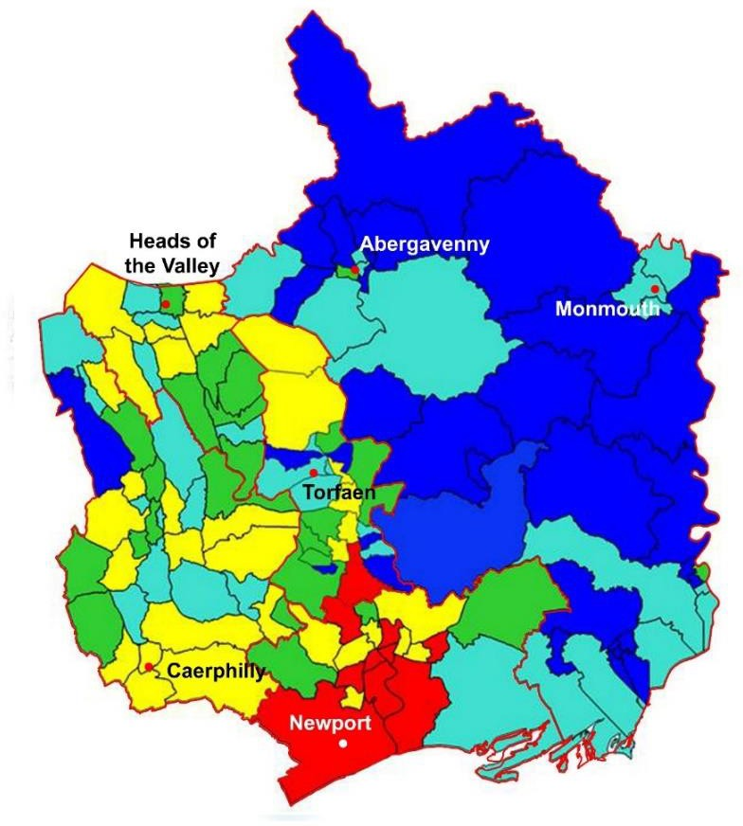
The demand for service (measured by the number of incidents on an annual basis) is presented in the following map.
High Density 3000 Incidents +
1500 - 2999 Incidents
1000 - 1499 Incidents
500 - 999 Incidents
Low Density 0 - 499 Incidents

The locations of each Hub will need to be subject to a full business case which will confirm the operational, service and financial benefits. Each Hub will need to be fit for purpose. There will be active communication and engagement with communities and the public during the development of the business cases and full assessment of options.
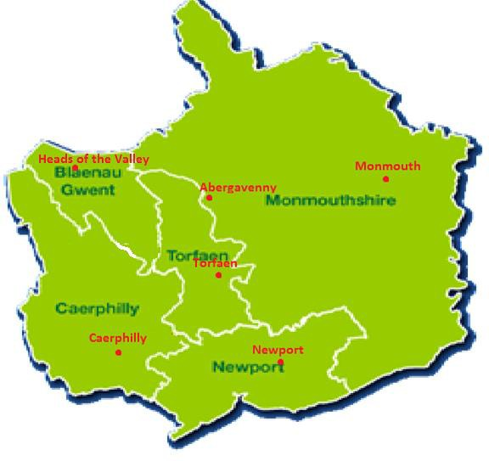

Monmouthshire
The large geographical area and poor road networks, combined with the demand profile, has informed the need for two smaller Hubs to meet operational response times. In these smaller Hub locations consideration has been given to shared accommodation to enable economies of scale. Bases on the road network of Abergavenny and Monmouth towns would be preferred to enable good response times whilst also enabling the neighbourhood team to be in close proximity to access these locations.

Newport
The preference for Newport is a purpose-built Hub on the outskirts to the East of the city. This will allow access to South Monmouthshire as well as allowing officers to access the motorway.

Blaenau Gwent
With the development of the Heads of the Valley road a Hub near Rassau would be the preferred location as it would provide support for the valleys south towards Caerphilly as well as offering support into Monmouthshire.

Caerphilly
Demand analysis suggests one Hub provided for the Caerphilly borough, with the North of the borough serviced by the Heads of the Valley Hub.

Torfaen
Torfaen is at the centre of the Gwent area from an operational perspective and it has fast roads to access all five local authority areas. It has also been identified as the preferable location for custody provision as well as providing a Hub for officers.

Spokes
Spokes are locations from which the police service is visible and accessible within local communities. The provision of Enquiry Office facilities provides the ability for the public to engage in face-to-face contact with police services, at identifiable police locations. Enquiry Office facilities are an integral part of delivery of service to those who due to a range of factors may not be digitally enabled, therefore providing a robust enquiry service is vital to deliver our priorities but also service all communities.

The force has also developed new methods of contact, including digital services providing opportunities for self-service which enhance the opportunity for the police to engage with the public.

Critical to all of these locations, however, is the need to ensure that they have corporate identity and are known within communities as locations operated by Gwent Police.

Decisions regarding these locations will be made through assessment of local need with models for delivery including partner-owned locations, independent premises or collaborative premises with partners. The location of Enquiry Office facilities should again be based on demand but also other measures from the census and our own confidence mapping.
The strategy presents the base in the local community as being one of two categories:

Category 1 spoke is a building that could be solely police owned or be shared with partners. It would have published opening hours and would be staffed by a Station Enquiry Officer. The service will be supported by the neighbourhood PC and PCSO and it would be accessible to significant numbers of residents in the community.

Category 2 spoke is a building that could be police owned or could be shared with partners. It will operate as a space for officers to meet members of public during surgeries or on a planned basis. Officers and PCSO’s will not be based at these locations but would visit on a regular basis. An example would be a community facility where officers have the ability to share a desk.

Spoke Locations
Category 1 - The PCC has committed that access to police services will remain in localities where demand for face-to-face contact remains evident, however, future provision may not necessarily be from existing premises and will require continuous review.

Category 2 – PCSOs and local Inspectors will be key to making recommendations in relation to category 2 provision. This will be determined on community engagement need and provided from community premises already used by partner agencies.

Assumptions
The modelling assumptions to be applied to all estate developments are aimed to improve the utilisation and efficiency of the facilities and improve the environmental footprint:

- A presumption for open plan as standard; design of any future office space should be open plan, not cellular. Individual offices should not be allocated purely on rank or grade; and the need should be clearly identified by job function.

- An average 70% desking provision for designated team/departments has now been adopted and is being implemented – representing seven workstations for every 10 members of staff. This is currently under review and initial findings are showing we will adopt a ‘five for every 10 members’ of staff. We have conducted a ‘Post Occupancy Evaluation’ survey at HQ and this is yet to be published. This will vary based on the number of staff who are classified as fixed, flexible or field workers in their role.

- Operational shifts and other organisational functions will be assessed to ensure appropriate desk provision.

- Workstation space standard to be targeted between 5 – 6m2; including office locker storage.

- Greater use of off-site storage for records management and equipment, and the use of electronic/digital filing on the force network.

- The mainstreaming of Flexible and Agile working practices in line with Policy.

Current Assessment
The estate has developed over the last century in response to the policing demands of the time, and properties do not necessarily match current or future requirements. The majority of police stations and offices pre-date modern technology, partnership working models and environmental factors, such as carbon management plans. Whilst changes in policing structures and demand has been constant, the pace has increased and although some of the estate is still well placed to meet current demand much of it is not. Some buildings fail to meet expected standards, many lack the flexibility expected of modern workplaces, and some are disproportionately expensive to occupy and maintain.

The police estate, at the time of writing this strategy, can be characterized as follows:

  - There are 47 assets that fall into the category of owned, leasehold and leased/licence.

  - The Police and Crime Commissioner (PCC) owns, under freehold (32) and leasehold
(3) arrangements, a total of 35 properties. A further 12 properties/spaces within properties are leased or licensed. Therefore, 70% of properties are owned.

  - The estate ranges from Victorian buildings to BREAAM approved new builds. Some 80% of properties pre-date the 1980s and just 20% are less than 20 years old.

  - The most recent condition profile of the overall estate highlights that just over 70% of the properties surveyed are in good or reasonable condition. This suggests that whilst the Commissioner retains a reasonably well managed estate, there are opportunities to improve and modernise through refurbishing or replacing parts of the portfolio. There has been a substantial refurbishment programme over the last 2 years. This will help to future-proof the estate with older premises having had significant upgrades to protect and aid reduced running costs for the future.

  - The larger properties in the estate account for a significant proportion of overall space and cost. Some of the largest properties are disproportionate to the number of officers and staff they house and therefore demonstrate a high running cost per capita/head count.

  - The Victorian premises, which are located throughout Gwent, have several similarities in design and construction. They can be considered to have been designed in line with policing delivery at the time of build (many accommodate decommissioned custody cells) and retained as stations recognisable within communities in Gwent. Some have been established within or adjacent to residential premises and each is generally of solid wall construction, with a collection of small rooms. They are relatively high cost to maintain and not situated with a view to modern transport requirements.

  - Premises falling into a category relating to construction within the 1960’s and 1970’s suffer with poor insulation and associated heating implications. They are also comprised of smaller designated spaces and incur higher maintenance costs for the organisation. Refurbishment works have been conducted and this will help to reduce the running costs of these older premises. Works have included a sustainable lighting program, energy efficient boilers, BMS (building maintenance systems) control systems and Photovoltaic (PV - Solar energy recovery) solar systems.

  - The most recently built premises are better insulated and located near to road links, however, building construction does limit the flexibility within each building. Ystrad Mynach and Newport Central, in particular, are limited to change of construction due to the custody provision in each.

  - The Commissioner has a number of lease agreements on premises within the Mamhilad Park Estate which houses a specialist crime function, a partnership team and also operational training. The Commissioner also has lease agreements on premises at the Vantage Point complex in Cwmbran which houses the Learning and Development Department.

  - Occupational Health is currently located within a semi-detached former police house in Llantarnam, which is independent from other support departments. The Occupational Health house has undergone major works within the last year, therefore safeguarding the property for the next 10 to 15 years.

  - Collaborative Arrangements

    - 101 House

This is a collaborative emergency centre supported through funding from Welsh Government and situated on the border between Gwent and South Wales Police. The space is shared with South Wales Police, South Wales Fire and Rescue Service and Welsh Ambulance Service Trust.

    - Joint Scientific Investigation Unit

Located at South Wales Police Headquarters, this two-force collaboration provides in- house forensic services and has UKAS accreditation. There is also a large presence of this team at Ystrad Mynach, accommodating the recently refurbished top floor.

    - Joint Firearms Unit

This tri-service collaboration provides the specialist firearms provision for Dyfed Powys, Gwent and South Wales. The Unit covering the Gwent area is located at Rumney Police Station, Cardiff, with the training delivered from Bridgend. We also have Gwent officers based at the Senedd at Cardiff Bay as part of the joint team.

    - Abertillery Joint Emergency Service Station

A collaborative emergency services station that sees the building used as a permanent base for Gwent Police, South Wales Fire and Rescue and the Wales Ambulance Service Trust.

Approach to Implementation
The future strategy and proposals seek to optimize the balance between retaining, improving and replacing both operational and support premises.

The fundamental principle within the strategy is that the force will improve visibility in communities to achieve the Commissioner’s vision for the estate:

A future-focussed sustainable estate which reassures the public, motivates and enables officers and staff to deliver an excellent service with partners, whilst being financially viable.

A key element will be the development of business cases which demonstrate the best approach to policing a geographic area, supported by robust evidence for the preferred option applied to each property. Future changes to the Estate will involve co-production with the community, to ensure community voices are heard. Equality Impact Assessments (EIA) will be undertaken, to understand the positive and negative impacts of any developments, which will allow the Commissioner to mitigate any negative consequences. The appraisal will include benefits assessment and be sequenced, taking into consideration the size and geographical spread of the property portfolio, the extent of possible change, existing opportunities for collaboration as well as the resource and capacity to meet demand.

This will mean implementing a strategy that will:

- Retain and more effectively occupy accommodation and sites where properties are well located, in good condition and support strategy.

- Redevelop or refurbish properties to improve those that are located in strategic locations, with potential to accommodate future requirements which are currently in poor condition.

- Replace property not in the right location, or properties in poor condition that cannot provide for future needs. Service provision will be enhanced through investment in better located accommodation, which could mean:

  - acquiring new accommodation, either new leasehold property or a new freehold build, or acquisition,
  - enhanced collaboration and co-location with partners in shared facilities.

- Recycle the estate in the spirit of the Wellbeing of Future Generations Act (Wales) 2015; working with communities, voluntary and third sector organisations to enable property to be used by relevant groups; or transfer ownership to support local improvements, initiatives and social enterprises.

- Regenerate in collaboration with partner agencies, seek opportunities to support local development in areas of deprivation where this may be appropriate (e.g. ongoing local regeneration initiatives).

The proposed models have been applied to a number of example areas to allow illustrative options to be developed. These options reflect the functional requirements and meet the established strategic parameters. They describe a range of opportunities including increased collaboration and co-location which provides greater challenge to the status quo and the application of more ambitious space standards.

The process indicates the extent of benefit which will be achieved, but each example would require further development by means of a business case to establish which level of ambition is most appropriate.

The range of options will be influenced by a number of factors including, but not limited to:
- Pace of change of enablers (Digital Programme, HR reform, Delivery Plan).
- Available funding (from existing budget, capital receipts and borrowing).
- Partnering and space sharing opportunities.

This Estate Strategy will require triennial review to reflect development and change.

Sustainability
The Estate must be environmentally friendly to ensure sustainability for future generations. The implementation of the strategy will recognise building standards to achieve the standards of the UK Committee on Climate Change (UKCCC) and the ambition for the Welsh Public Sector to be carbon neutral by 2030. We are now working with Greener Gwent to promote and develop our sustainability strategy. Further works within the Estate have been undertaken to include a full LED swap-out program, which will be fully completed at the end of 2023 and provide a life cycle of 10 years. An Electric Vehicle (EV) program is currently underway and again will be Estates-wide by the end of 2023. A PV program has been started to help improve the use of reusable energy as well as a BMS control program to enable better control and reduce energy usage in all stations. By adopting a high-level waste recycling program we are now operating at zero landfill and this has been achieved and maintained with close management and support from our contractor.

Sustainability will be achieved through initiatives to reduce the carbon footprint of our premises, such as improvements to our current building conditions and new constructions that meet required BREEAM ratings.

Financial Implications
More effective use of accommodation may result in Gwent Police being located in fewer premises but delivering a more accessible and visible service to the public. The current estate has an annual running cost of £6.4m.

Total
The total capital cost of this strategy is reflected through the Capital Programme. This is provided in the five-year Medium Term Financial Plan, which is updated annually as part of the budget setting process to provide an accurate reflection of planned costs in delivering the strategy. This is attached at Appendices 1a and 1b and includes the following assumptions.

Gwent Police Operational Facility
The previous version of this Estate Strategy considered the development of a Custody Unit, Operational Training Facility and Fleet Workshops, to service all of Gwent Police but co-located on one site. A number of potential sites to locate these Force-wide facilities were evaluated and the preferred site confirmed in its Strategic Outline Business Case was the now vacated old HQ site. As a result of this location, the Policing Hub for the Torfaen policing area would also be included at this site. The proposal to now bring these four policing facilities together on one site has since been collectively titled the Gwent Police Operational Facility (GPOF).

The cost of the new GPOF is a capital cost of £64m and an annual revenue cost of £xx. These costs are derived from the latest design stage driven by the Strategic Outline Business Case, which, which is still subject to approval.

Hubs
The cost of the Hub will be dependent on the number of officers that will be based from each location and will be influenced by whether it is new build, utilisation of a current police premise or collaborative premise.

Spokes
The cost of the xx potential spokes have been estimated determined on category 1 and 2 models for which individual needs assessments will inform the type of provision:

The Category 1 spoke is expected to cost a capital sum of circa £xx and annual running cost of £xx.

The Category 2 spoke in each location will cost a nominal contribution to a partner organisation.

These costs are fluid and therefore potential overall costs of the spokes have not been included in the financial plan for the Estate Strategy.

Affordability
In light of the current economic situation and the acute financial pressures Police Forces find themselves facing, the affordability of this Estate Strategy is a major constraining factor. The financing of the previous Estate Strategy was from Committed Funds set aside with reserves, with maintenance and minor refurbishments funded by a direct revenue contribution to capital. Although the direct revenue contribution to capital remains into the future, the major Estate developments into the future will be funded by public sector loans, as a consequence of the full utilization of previously set side Committed Funds. The funding of loans will be partly financed through the revenue savings achieved through the rationalisation of the estate and the lower running costs of new buildings compared to the current estate.

The financing for each development will be considered in the individual business cases to ensure the financial strategy is sustainable.

Delivery Timeline for Estate Review and Implementation
Delivery of the Estate Strategy will be planned and implemented as a programme over a fifteen-year period.

An outline implementation plan has been developed based on service priorities.

Current | Headquarters 2019 – 2022 | HQ and other Corporate Buildings
Phase 1 | Monmouthshire North 2017 – 2024 | Abergavenny, Monmouth, Usk
Phase 2 | Torfaen 2019-2025 | Blaenavon, Cwmbran, Garndiffaith, Pontypool, Trevethin
Phase 3 | Heads of the Valley 2024-2028 | Abertillery Fire Station, Blaina, (currently mothballed) Brynmawr, Ebbw Vale, Rhymney, Tredegar, Tredegar Stores
Phase 4 | Caerphilly 2027 - 2031 | Bargoed, Bedwas, Blackwood, New Tredegar, Risca, Ystrad Mynach
Phase 5 | Newport (New M4) 2030 – 2034 | Alway, Bettws, Caerleon, Caldicot, Chepstow, Magor, Maindee, Newport, Pill, Rogerstone

The headquarters development is complete, with the building being handed over in November 2021 and the conclusion of the ’defects period’ in November 2022.

Phase 1 of the strategy is being progressed with the design of the new Abergavenny police station.

In turn, the Category 1 spoke has been established in Abergavenny Town Hall in partnership with Monmouthshire County Council.

A programme approach will be adopted to meet organisational needs and re-shape the estate. The last review of the Estate strategy during 2022 provided the opportunity to review the prioritisation to ensure the strategy has flexibility through implementation to react to opportunities as they arise and to consider the significant financial constraints. Appropriate resources will be directed to deliver the individual projects in line with recognised project management methodology.

Communication Strategy – Internal and External
The Engagement and Communication Strategy has been developed to ensure effective communication and engagement at each stage of the estate programme with key stakeholders. The stakeholders will include elected representatives, communities and members of the public as well as Police Officers and Staff.

Through improved community engagement, we can develop communication approaches which service all our communities, particularly those from under-serviced groups.

Conclusion
The Estate Strategy highlights that the nature of the current police estate is both significant and diverse and that the potential opportunities arising from the implementation of the strategy are considerable.

It provides an opportunity to consolidate the footprint occupied by Gwent Police and rationalise the assets held without compromising on visibility and accessibility to communities. The intention of the strategy is to ensure that services are delivered consistently whilst having flexibility to evolve to meet emerging and future changes.

Collaboration at a local and regional level is integral to the strategy and builds on the vision of a modern, demand led and collaborative model of policing that is fit for the future. Furthermore there will be a greater emphasis on co-production with members of the community, to ensure that the services and facilities that we develop serve the communities that we serve.

In conclusion, the Estate Strategy provides the foundation for developing an estate that is fit for the future and adaptable to meet new challenges, meeting the demand for an effective public service that will be delivered in partnership at the heart of local communities.

