|  |
| --- |
| Fleet Management Strategy |
|  |
| Annual Report 2022/23 |
|  |

**1.** **PURPOSE AND RECOMMENDATION**

1.1 The report presents the annual outturn relating to the delivery of Fleet Services within Gwent Police.

1.2 There are no recommendations made requiring a decision.

**2. INTRODUCTION & BACKGROUND**

2.1 This report is to present the fleet services department provision for financial year 2022/23 which seeks to provide services that are fit for purpose, safe, reliable, and cost effective, enabling Gwent Police to deliver optimum policing services.

2.2 The services provided by the fleet services department include:

* Vehicle procurement and disposal
* Vehicle conversion, commissioning, and decommissioning
* Vehicle recovery
* Pool and hire vehicle provision.
* Associated fleet administration.
* Through life vehicle service, maintenance, and repair

|  |
| --- |
| 2.3 Fleet services forms part of the resource directorate and provides service to the force in the form of marked and unmarked vehicles as well as pool vehicles which were introduced in 2012 as a cost saving opportunity to reduce business mileage**.** |
| 2.4 The department has worked to deliver value for money by seeking to reduce the costs associated to the services it provides, develop collaborative opportunities and to introduce new and innovative ways of working including ways to support sustainability and carbon reduction.  2.5 The Gwent Police fleet strategy was approved at the Strategy and Performance Board (SPB) in April 2021 and provides a three-year framework upon which the fleet department delivers effective service provision to the force.  **AREAS FOR CONSIDERATION**  **3**. **HEALTH AND SAFETY**  3.1 The fleet services department had and accident-free year ending March 2023 (excluding force vehicle accidents). The department was subject to an audit from which a plan was put in place to correct any identified observations. |

**4. VEHICLE PROVISION**

4.1 The provision of vehicles to support both operational and non-operational requirements of the force continued to be reviewed through year ending March 2023 following the operational restructuring of the force. This process enables scrutiny of the current vehicle provision. A summary of fleet provision since 2019 to date is detailed within Table A.

**Table A**

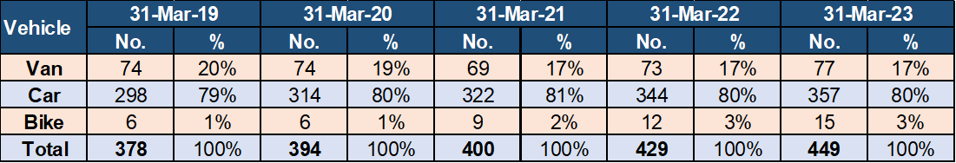

4.2 In the year to March 2015 the fleet footprint stood at 458 vehicles, this reduced by 90 vehicles in 2016 to a total of 368 vehicles. For 2022/23 the fleet footprint stood at 449 vehicles.

4.5 The fleet footprint has increased year on year since 2016, most notably to support the Police Officer uplift initiative that resulted in more than two hundred additional Police Officers joining the force. The fleet footprint will be reassessed on completion of vehicle telematic implementation project that will allow users to identify potential efficiencies.

4.6 Vehicle users’ ability to monitor the utilisation of vehicles will be improved with the introduction of the telematics solution that will enable scrutiny of daily use of the vehicles within their control. The contract for a telematic solution was awarded under a joint tender exercise through the collaborative Digital Services Division.

4.7 The installation of telematic units into the Gwent Police vehicle fleet was successfully completed during the year with baseline data being made available to users.

**5. MILEAGE COVERED**

5.1 The distance covered by vehicles is dictated by force operational requirements. An increase in distance covered impacts all areas of the fleet services department resulting in increased fuel expenditure and more frequent servicing. The mileage of every vehicle is monitored and recorded by the fleet services department through the monthly analysis of the fuel card system.

Table B which follows, summarises the distance travelled in the last five financial years.

**Table B**

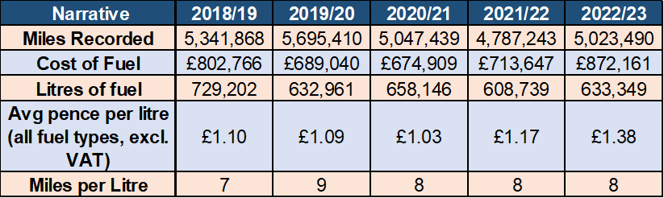

5.1 The table details the total distance travelled by the force to the year ending March 2023 was 5.023k miles, an increase of 236k miles on the previous year.

5.3 The cost of fuel to year ending March 2023 was £872k, an increase of £159k on the year ending March 2022. There was a 25k litre increase of fuel purchased to year ending March 2023 compared to the previous year, with the average pence per litre of fuel costing £0.21 more than the previous year.

5.4 With the relaxation COVID 19 guidelines, the number of miles travelled, by more vehicles and litres of fuel used increasing all impacting the fleet services department cost base.

5.5 The force continues to promote initiatives whereby officers and staff are encouraged to refuel at fuel outlets that offer best value.

**6. MILEAGE CLAIMS**

6.1 Relating to travel undertaken by officers and staff in their own vehicles whereby the costs are reclaimed through expenses. There are two types of travel expenses for those reimbursed when an individual uses their own car:

1. the casual user and
2. the essential user arrangements.

**Table C**

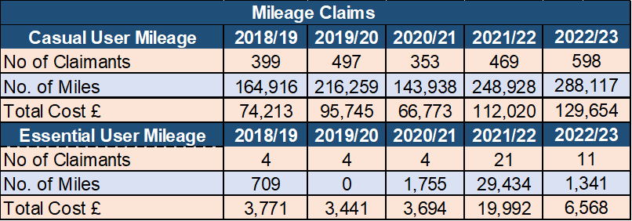

6.2 The use of business mileage is monitored by the finance department to ensure the force is maintaining control over the costs of service. To year ending March 2023, 598 officers and staff claimed casual user travel reimbursement an increase of 129 over the previous year. The number of miles claimed and the subsequent cost of the reimbursements for year ending March 2023 was also higher than the previous year.

6.3 This increase is due to the new business travel policy implemented by National Police Chief Council (NPCC) during year ending March 2021 which changed the mileage calculation between a commencement at home and the destination.

6.4 In respect of the essential car users, there were eleven claimants for year ending March 2023 the overall cost of those claims was £13k less than the previous year.

**7. SERVICE, MAINTENANCE, REPAIR & INSPECTION**

7.1 The force seeks to maintain a cost-effective timely process for repair and maintenance of the vehicle fleet which involves the servicing of cars and vans every 12,000 miles and motorcycles every 6,000 miles, or every 12 months, depending on which occurs first. High performance vehicles are serviced every 10,000 miles or condition-based servicing (CBS), whichever occurs first.

7.2 Vehicle maintenance repair arrangements are provided by the fleet services department maintenance facility using the Tranman fleet management database to record all activities. Table D details the volume of jobs processed through the Fleet Services maintenance facility from year ending March 2019 to year ending March 2023.

**Table D**

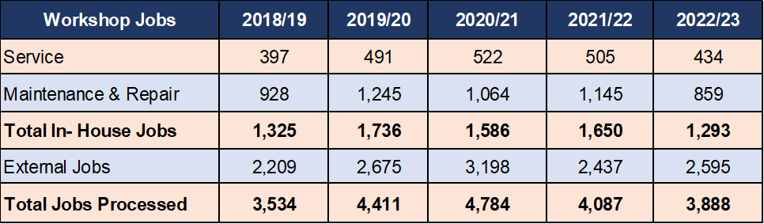

7.3 The table details the total number of jobs completed by the maintenance facility to year ending March 2023 was 1,293, of which 434 were services. It is normal practice for vehicles to have other maintenance or repair work conducted while being serviced as this minimises downtime and maximises vehicle operational availability. This confirms that most of the jobs undertaken by the workshop involve elements of repair and maintenance over and above the cyclical service arrangements.

7.4 2,595 Jobs were passed to external suppliers to exploit the benefit of any vehicle manufacturer warranty terms. The total number of jobs processed through the Tranman fleet management database by the admin staff to year ending March 2023 was 3,888.

7.5 The total number of in-house jobs decreased to year ending March 2023 and external jobs increased because of the vehicle age profile and job type.

7.6 Due to identified issues with high-performance BMW vehicles fitted with N57 engines, Gwent replaced all its BMWs fitted with N57 engines with alternative products including Volvo and Skoda.

7.7 The conversion of the replacement high-performance vehicles was completed by our in-house technicians. Due to the length of time a full conversion takes to complete; fewer overall jobs were recorded for the year. Some jobs that may previously been completed by outside contractors are now, where possible completed in-house. This initiative will result fewer job records overall.

7.8 Table E details the number of vehicle accidents incurred together with the associated cost of repair although not all accidents are deemed economical to repair when assessed.

**Table E**

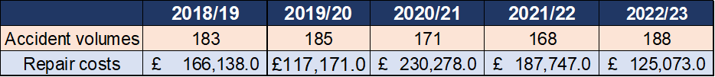

7.9 The total number of accidents to year ending March 2023 was 188 with an associated cost of £125,073. There were six vehicles that had damage which when assessed were not economic to repair and were subsequently written off.

7.10 During the current financial year further analysis of vehicle accidents was undertaken to assess options for reducing vehicle accidents and reduce associated costs. This has led to improved governance of vehicle accident monitoring through the Uniform, Equipment and Fleet User Group forum, referral of vehicle accident data to the driver training school to enhance needs-based training delivery and improved engagement with force area leads for appropriate management action to reduce vehicle accidents.

7.11 A few external garages are used for warranty work and can be used as contingency should the need arise. Accident damage is completed at approved vehicle body shop repair facilities with all completed repairs checked by Fleet Services technicians for quality standard and compliance.

7.12 High performance vehicles and specialist vehicles are converted within the Fleet Maintenance facility; however, many new vehicles are turnkey vehicles with the heavier conversion work outsourced to manufacturer-based specialists to gain product liability cover and warranty. All vehicles are commissioned through Gwent Police Fleet Services maintenance facility for the fitment of telematic units, number plates, police equipment, livery and equipment checks.

7.13 Where possible, police equipment such as blue lights, switch panels and relays are re-cycled, to reduce both cost and waste. The use of Gwent Police Radio Engineers to install ancillary equipment is a cost-effective solution supporting in-house commissioning ensures that the costs, security implications and logistics associated with transferring police equipment to external firms is minimised.

**8. NOTICES OF INTENDED PROSECUTION**

8.1 The Fleet Services Department processes all notices of intended prosecution (NIPs) received by the force the Table F details the volume of NIPs processed since year ending 2019.

**Table F**

Table to explain data

**9. PROCUREMENT**

9.1 Vehicle procurement is completed in accordance with the Vehicle Replacement Policy and conforms to Contract Standing Orders. Fleet Services department takes advantage of the National Police Procurement arrangements.

9.2 Fleet Services department strives to achieve economies of scale delivering savings by using national contracts where possible taking advantage of preferential purchasing terms and will participate in mini tenders within the framework using regional collaborative agreements and by standardising vehicle requirements where possible.

9.3 The COVID-19 Pandemic resulted in a severe delay in the renewal of Vehicle Purchasing Frameworks. Delivery lead times are yet to improve with some manufacturers cancelling orders and others having periods where they have not accepted new orders. Supply chain has not fully recovered and have been further affected by BREXIT, war in Ukraine and global shortage of certain components we expect these challenges to continue though out year ending March 2024.

**10. VEHICLE PROCUREMENT & DISPOSAL**

10.1 Vehicle procurement, utilisation and disposal policies follow best practice encompassed within the Asset Management Strategy to ensure Gwent Police provides value for money.

10.2 The annual Vehicle Replacement Programme is based on forecasted vehicle demand. Vehicles that reach the vehicle replacement criteria based on mileage and age are listed for replacement and the results checked and collated to form the Capital Bid. The criteria ensures that the optimum combination of age and mileage is reached, taking account of the cost of repair and maintenance and level of conversion to obtain best value.

10.3 Changes to specification are considered in the replacement programme to ensure that the latest technical and safety features are included where necessary. Changes in operational requirements are programmed into the following year’s plans for acquisition via Commissioner approval of the Capital Bid.

10.4 End of life vehicles are decommissioned and disposed of through an auction house via a national framework safeguarding Gwent Police from risk associated with the disposal of vehicles.

10.5 Table G details the value of vehicle purchased to year ending March 2023 being £1.5m with receipts through vehicle sales of £74k.

**Table G**

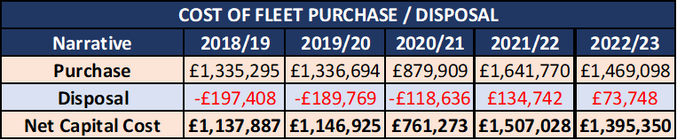

10.6 Disposals were low due to resource being focused on the conversion and commissioning of new high performance and specialist vehicles together whilst the department had staff vacancies during the year.

**11. ENVIRONMENTAL CONSIDERATIONS**

11.1 Fleet Services Department seeks to reduce any potential adverse environmental impact of our activities, including air, land, water pollution and noise. We aim to encourage the efficient use of resources through the minimising of waste and through the conservation, re-use, and recycling of resources wherever possible.

11.2 Fleet Services Department consults with vehicle manufacturers to keep abreast of advances in technology and alternative fuels. The evaluation of new developments in vehicle technology will be assessed in terms of operational fitness for purpose, ease of maintenance, ease of use and environmental impact.

11.3 There are 18 electric vehicles currently in operational service: an increase of 15 from 2021/22. This will increase by a further twenty-nine to year ending March 2024 as the new electric charging points are installed throughout the Gwent Police estate.

11.4 There are currently 24 chargers within the Gwent Police estate; a further 78 chargers will be installed across the estate in the next twelve months. The force is also able to use the Allstar charging network for charging.

**12. VEHICLE RECOVERY**

12.1 The vehicle recovery scheme, which involves the collection of police vehicles and public vehicles is delivered through a collaborative arrangement with Dyfed Powys Police, with overall responsibility assumed by the Fleet Services manager, Gwent Police with both Governance and Operational meetings held regularly.

12.2 Table H details the number of the recoveries of both public and police vehicles from year ending March 2019 through to year ending March 2023. The service is provided by private contractors through a collaborative contract which includes South Wales Police and Dyfed Powys Police.

**Table H**

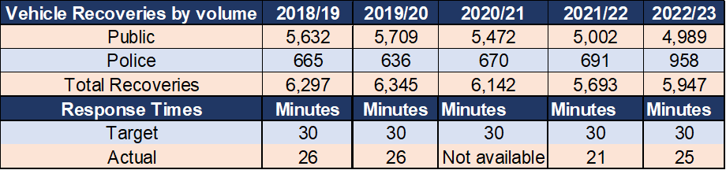

12.3 The table illustrates that the number of recoveries to March 2023 of public vehicles has decreased but the number of recoveries for Police vehicles has increased. The increase in police vehicle recoveries is due to the increase in number of police vehicles in operation together optimising the benefits of the vehicle recovery provision that is available for vehicle movements, reducing fleet staff and police officer extractions.

**13. CHALLENGES**

13.1 Fleet services department have navigated several challenges to year ending March 2023 summarised below:

13.2 The high-performance vehicle fleet was impacted by limitations due to issues with BMW N57 engine which affected aspects of operational delivery. Fleet services Department implemented national guidelines to identify and classify all affected vehicles. Service continuity was achieved by rapidly redeploying vehicles from other areas of the force, installation of new alternative engines, purchase and converting pre-registered vehicles and the utilisation of manufacturer demonstration vehicles. The force successfully navigated this challenging period and now have the required number of vehicles in circulation to deliver the operational capability.

13.3 Fleet service department have experienced supply chain issues and extended lead times across all areas of the department mitigated by carrying increased vehicle part stock levels, engaging with National Association of Police Fleet Managers (NAPFM), Blue Light Commercial, Procurement Department and force Planning Department so that we can anticipate supply issues and take appropriate action. utilising alternative sources where appropriate.

**14. COLLABORATION**

14.1 Fleet services department makes use of collaborative opportunities through National Association of Police Fleet Managers (NAPFM) to improve standards and standardisation between all forces and reduce costs through economies of scale wherever possible.

14.2 Collaboration with training, contracts and workshop issues are current examples of successful on-going projects. Compliance and assistance with NAPFM/Home Office contracts enhance collaboration, reduces costs and improves safety and conformity through nationally agreed specifications.

14.3 The single shared fleet management data base has enabled improved collaborative working between the Welsh forces in several ways:

* Consistency in reporting between Gwent, South Wales and Dyfed police means Fleet Managers can analyse a wide range of data and compare performance to enable better decision making.
* Access to data on the type of vehicle repairs being undertaken at the other forces has enabled discussion among technicians for best practise sharing and a more efficient service delivery.
* Officers are provided with more maintenance locations, as servicing, maintenance and repairs can be undertaken at any Gwent, South Wales, or Dyfed Police force maintenance facility regardless of the home force. This is enabled by immediate access to vehicle history and improves service delivery timescales.

14.7 Gwent Police fleet services department forms part of the All-Wales Fleet Joint Advisory Group working on collaborative projects such as standardisation of vehicle types, police equipment and IT service providers, framework contracts and shared resources.

14.8 Fleet services department work closely with the Joint Firearms Unit, South Wales Police Fleet Services and Dyfed Powys Police Fleet Services to achieve continuity in vehicle design and service delivery.

**15. FORWARD LOOK**

15.1 Fleet services department continue to provide an effective service for the force delivering effective customer service. Fleet service department are actively engaged in the Gwent Police Operational Facility Programme Board at both the working group and stakeholder workshops, to ensure the design of the future fleet provision is fit for purpose and can accommodate future vehicle developments and technologies.

15.2 Fleet services department regularly attends the Emergency Services Network (ESN) Project Board to ensure there will be a smooth transition to the new communication technology.

15.3 Fleet service department is fully engaged with the project team responsible for designing and delivering the temporary fleet services department maintenance facility located at Llantarnam to enable the old headquarters site to be decommissioned. Ensuring that the design is both fit for purpose and future proof. The department is scheduled to occupy the new facility during the second quarter of 2023/24 financial year with the emphasis on minimising any potential impact to the services provided.

**16. FINANCIAL CONSIDERATIONS**

16.1 The overall cost of delivering the fleet services is summarised in Table I which follows:

**Table I**

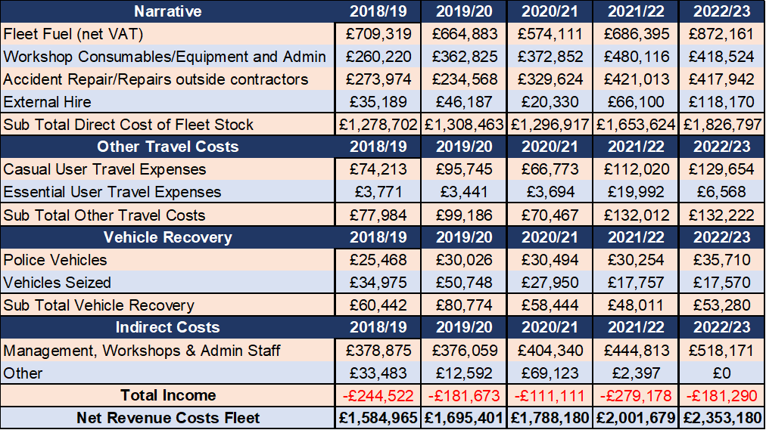

16.2 The overall revenue cost of the fleet services department for year ending March 2023 totals £2.4m, an increase of £352k on the previous year. Fuel spend has increased by £186k due to more miles being driven by more vehicles together with an increase in the price at the pump. Consumable spend has decreased due to increased stock levels to year ending March 2022 resulting from supply chain challenges and the number of vehicle conversions completed within the year.

16.3 External vehicle hire spend has increased due to numerous long-term hires to support operational requirements in advance of new vehicle deliveries and 4x4 vehicles over the winter period.

**17. Value for Money**

17.1 Customer feedback is provided through customer comments (both positive and negative), and performance indicators regarding establishment, fuel use and accident statistics are also communicated to management. The Fleet User Group forum has been re-constituted into the Uniform and Fleet Users Group to ensure operational requirements are embedded in the force governance arrangements.

17.2 The fleet management data base approved and implemented year ending March 2017 allows for the development of performance indicators and service level agreements between the fleet services department and our internal customers. This also provides a basis for feedback and review within the continuous improvement cycle.

17.3 The fleet management data base is a collaborative provision shared with South Wales Police and Dyfed Powys Police which enables interoperability together with the opportunity for other force workshops to work on each other’s vehicles; a flexibility that provides for further sound business continuity management. A variety of KPIs are used for monitoring of vehicle downtime, frontline vehicle availability and vehicle utilisation. KPIs are reviewed to stay abreast of changing demands such as the need for more sophisticated environmental indicators which are being developed.

17.4 Direct access to the computerised fleet management system through a web portal allows specific users to have direct access to view vehicle accident details. The web portal is also used to report accidents and is an improved and enhanced tool for recording and monitoring. This has continued to be upgraded to include the reporting of vehicle defects and the recording of vehicle checks.

**18. PERSONNEL CONSIDERATIONS**

18.1 The fleet services staffing has developed to support operational demands and is detailed in Table J.

**Table J**

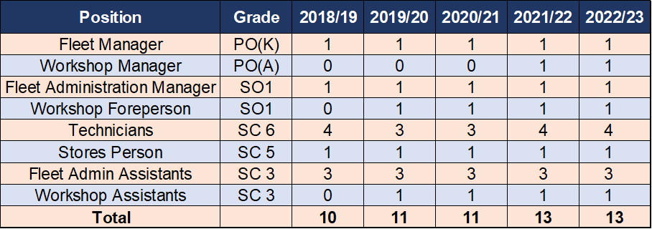

18.2 Fleet services department staff stability proved challenging during the year ending March 2023.

18.3 The position of fleet services manager was filled during the last quarter of financial year 2023. This resulted in two members of staff who had stepped up to support the role to resume their positions.

18.4 As at the end of March 2023 the fleet services department had three vacant positions which we hope to be filled by the end of the financial year ending March 2024 subject to candidate suitability and employment market challenges.

18.5 The departments vacancies provide an opportunity for the development of internal candidates and effective succession planning.

18.6 A training programme is in place to ensure that staff are proficient with ever evolving technology and able to operate the latest equipment built into vehicles and the fitted ancillary equipment. Staff are trained to cover first aid, health & safety and fleet management, along with the technical training of the vehicle mechanics, including MOTs.

**19. LEGAL IMPLICATIONS**

The contracts arrangements are progressed in line with legal requirements.

**20. EQUALITIES AND HUMAN RIGHTS CONSIDERATIONS**

This report has been considered against the general duty to promote equality, as stipulated under the Single Equality Scheme and has been assessed not to discriminate against any group.

In preparing this report, consideration has been given to requirements of the Articles contained in the European Convention on Human Rights and the Human Rights Act 1998.

**21. RISK**

None identified.

**22. PUBLIC INTEREST**

In producing this report, has consideration been given to public confidence? **Yes**

Are the contents of this report, observations, and appendices necessary and suitable for the public domain? **Yes**

If you consider this report to be exempt from the public domain, please state the reasons: **N/A**

Media, Stakeholder and Community Impacts: **None**

**REPORT AUTHOR**

Ken Peart; Fleet Services manager

**LEAD CHIEF OFFICER**

Nigel Stephens; Assistant Chief Officer – Resources

**ANNEXES**

There are no annexes to this report.

**CHIEF OFFICER APPROVAL**

I confirm thisreport has been discussed and approved at a formal Chief Officers’ meeting.

I confirm this report is suitable for the public domain.

**Signature:** A close-up of a signature

 **Date: 21.08.2023**