Gwent Police Estates Register
Blaenau Gwent
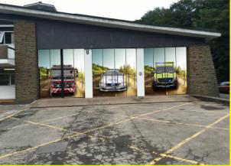 | Abertillery Fire Station | Neighborhood police officers are based at these premises as a place of work and are available to meet visitors who attend the premises if they are not out on duty. There is a doorbell and yellow telephone outside for telephone access.  This premises is shared by the fire, police and ambulance services.
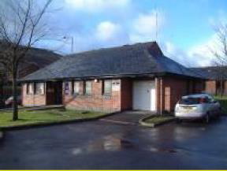 | Blaina | Neighborhood police officers are based at these premises as a place of work and are available to meet visitors who attend the premises if they are not out on duty. There is a doorbell and yellow telephone outside for telephone access.
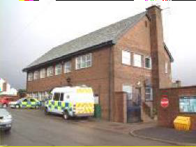 | Brynmawr | Neighborhood police officers are based at these premises as a place of work and are available to meet visitors who attend the premises if they are not out on duty. There is a doorbell and yellow telephone outside for telephone access.
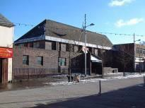 | Ebbw Vale Police Station, Bethcar Street, Ebbw Vale.  NP23 6UY | Police officers are based at these premises as a place of work and the front office and enquiry counter is open to the public 9am-5pm, Monday-Friday. There is a doorbell and yellow telephone outside for when the front office and enquiry counter is closed.
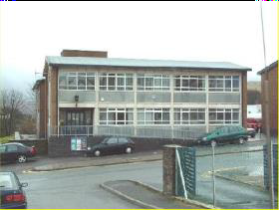 | Tredegar | Neighbourhood and response police officers are based at these premises as a place of work and are available to meet visitors who attend the premises if they are not out on duty. There is a doorbell and yellow telephone outside for telephone access.

Gwent Police Estates Register
Caerphilly Borough Gwent Site Information
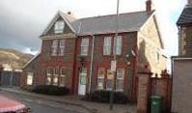 | Bedwas | Neighborhood and response police officers are based at these premises as a place of work and are available to meet visitors who attend the premises if they are not out on duty. There is a doorbell and yellow telephone outside for telephone access.
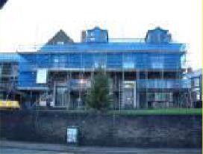 | Bargoed | Neighborhood and response police officers are based at these premises as a place of work and are available to meet visitors who attend the premises if they are not out on duty. There is a doorbell and yellow telephone outside for telephone access.
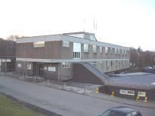 | Blackwood Police Station, Blackwood Road, Pontllanfraith NP12 2XA | Police officers are based at these premises as a place of work and the front office and enquiry counter is open to the public 9am-5pm, Monday-Friday. There is a doorbell and yellow telephone outside for telephone access when the front office and enquiry counter is closed.
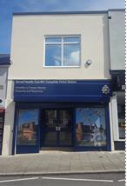 | Caerphilly Town Centre | Neighbourhood and response police officers are based at these premises as a place of work and are available to meet visitors who attend the premises if they are not out on duty. There is a doorbell and yellow telephone outside for telephone access.
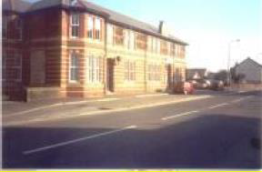 | Risca | Police officers are based at these premises as a place of work and are available to meet visitors who attend the premises if they are not out on duty. There is a doorbell and yellow telephone outside for telephone access.
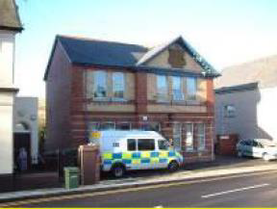 | Rhymney | Neighbourhood and response police officers are based at these premises as a place of work and are available to meet visitors who attend the premises if they are not out on duty. There is a doorbell and yellow telephone outside for telephone access.
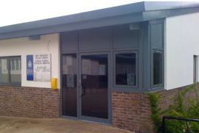 | White Rose Resource Centre, New Tredegar | Neighbourhood and response police officers are based at these premises as a place of work and are available to meet visitors who attend the premises if they are not out on duty. There is a doorbell and yellow telephone outside for telephone access.

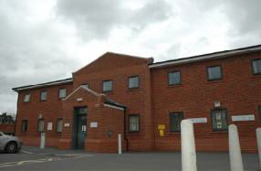 | Ystrad Mynach | Neighborhood and response police officers are based at these premises as a place of work and are available to meet visitors who attend the premises if they are not out on duty. There is a doorbell and yellow telephone outside for telephone access.

Gwent Police Estates Register
Monmouthshire Gwent
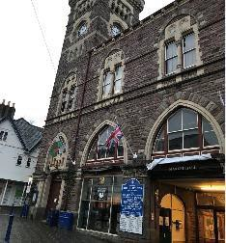 | One Stop Shop, Town Hall, Cross Street, Abergavenny NP7 5HD | The Abergavenny police enquiry office has now moved to shared premises with Monmouthshire County Council in the One Stop Shop at Abergavenny Market. When  the front enquiry office is closed, there is a yellow external phone to contact officers if required.
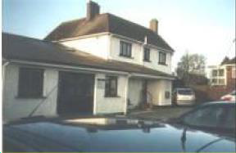 | Caldicot | The premises is a base for the neighbourhood team. Police officers are based at these premises as a place of work and are available to meet visitors who attend the premises if they are not out on duty. There is a doorbell and yellow telephone outside for telephone access.
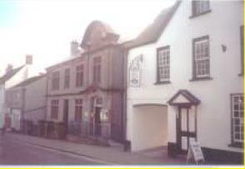 | Chepstow | Police officers work from these premises and are available to meet visitors who attend the premises if they are not out on duty.  There is a doorbell and a yellow telephone outside the building for telephone access.
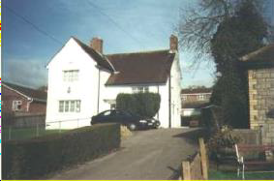 | Magor | The premises are a base for the neighbourhood team, the schools liaison officer is regularly based there and there is also a victims’ suite.  Police Officers are based at these premises as a place of work and are available to meet visitors who attend the premises if they are not out on duty. There is a doorbell and yellow telephone outside for telephone access.
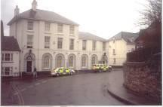 | Monmouth Police Station, Glendower Street, Monmouth NP25 3DG | Police officers work from these premises and are available to meet visitors who attend the premises. The front enquiry office to the public is open from 9am-5pm, Monday-Friday.  When the front enquiry office is closed, there is a doorbell and a yellow telephone outside the building for telephone access.
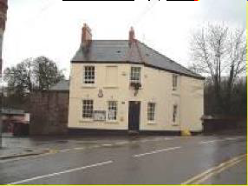 | Usk | Neighbourhood police officers are based at these premises as a place of work and are available to meet visitors who attend the premises if they are not out on duty. There is a doorbell and yellow telephone outside for telephone access.

Gwent Police Estates Register
Newport City & County Gwent
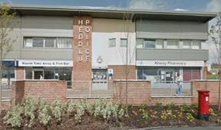 | Alway | Police officers are based at these premises as a place of work and are available to meet visitors who attend the premises if they are not out on duty. There is a doorbell and yellow telephone outside for telephone access.  The premises is used as a base for the neighbourhood policing team.
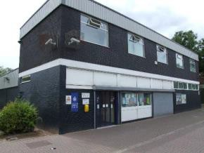 | Bettws | Police officers are based at these premises as a place of work and are available to meet visitors who attend the premises if they are not out on duty. There is a doorbell and yellow telephone outside for telephone access.  The premises are used as a base for the neighbourhood policing team and response officers.
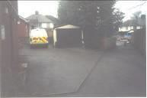 | Caerleon | Police officers work from these premises and are available to meet visitors who attend the premises if they are not out on duty. There is a doorbell and yellow telephone outside for telephone access.
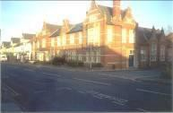 | Maindee | Police officers are based at these premises as a place of work and the premises is used as a response hub. Police officers are available to meet visitors who attend the premises if they are not out on duty. There is a doorbell and yellow telephone outside for telephone access.
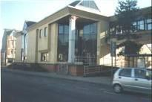 | Newport Central, Cardiff Road, Newport  NP20 2EH | Police officers are based at these premises as a place of work and are available to meet visitors who attend the premises if they are not out on duty.  The front office and enquiry counter is open to the public seven days-a-week from 8am until 10pm.  There is a doorbell and yellow telephone outside for when the front office and enquiry counter is closed.
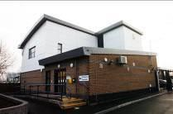 | Pill | Police officers are based at these premises as a place of work and are available to meet visitors who attend the premises if they are not out on duty. There is a doorbell and yellow telephone outside for telephone access.  The response and neighbourhood teams use it as a base.
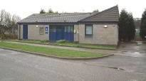 | Rogerstone | Police officers are based at these premises as a place of work and are available to meet visitors who attend the premises if they are not out on duty. There is a doorbell and yellow telephone outside for telephone access.  The neighbourhood team use it as a base.

Gwent Police Estates Register
Torfaen Gwent
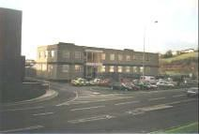 | Cwmbran Police Station, Tudor Road, Cwmbran NP44 3XH | Police officers work from these premises and are available to meet visitors who attend the premises. The front office and enquiry counter at Cwmbran Police Station Police Station is open to the public 9am-5pm, Monday to Friday. When the front enquiry office is closed, there is a doorbell and a yellow telephone outside the building.
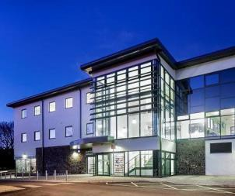 | Blaenavon Primary Care Resource Centre | Neighbourhood police officers are based at these premises as a place of work and are available to meet visitors who attend the premises if they are not out on duty. There is a doorbell and yellow telephone outside for telephone access.  These premises are leased from Torfaen County Borough Council.
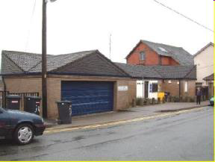 | Garndiffaith | Neighbourhood police officers are based at these premises as a place of work and are available to meet visitors who attend the premises if they are not out on duty. There is a doorbell and yellow telephone outside for telephone access.
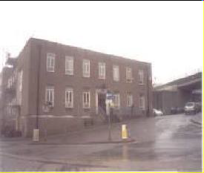 | Pontypool | Neighbourhood & response police officers are based at these premises as a place of work and are available to meet visitors who attend the premises if they are not out on duty.  There is a doorbell and yellow telephone outside for telephone access.
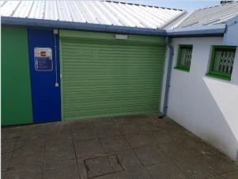 | Trevethin | Neighbourhood police officers are based at these premises as a place of work and are available to meet visitors who attend the premises if they are not out on duty. There is a doorbell and yellow telephone outside for telephone access.  This building is shared with Bron Afon Housing Association.

The Gwent Police estate that is owned by the Office of the Police and Crime Commissioner for Gwent also consists of the following premises that do not have general public access and are used for a mix of administration and operational purposes:
- Gwent Police Headquarters, Cwmbran. Built
- Mamhilad Business Park, Pontypool Owned by Johnsey Estates
- Vantage Point Offices, Cwmbran
- Occupational Health and Welfare Facilities, Cwmbran
- Operational Training, Mamhilad, Pontypool. Radio Mast Site, Newport.
- Radio Building, Chepstow.
7. Victims of Crime Support Buildings at Risca, Brynmawr and Llanbradach.
8. Evidence and Property Stores – undisclosed.

